Data Collection USER GUIDE

The Victorian Government has vested the Victorian Public Sector Commission with functions designed to enhance the performance of the public sector – fostering the development
of an efficient, integrated and responsive public sector which
is highly ethical, accountable and professional in the ways it delivers services to the Victorian community.
The key functions of the Commission are to:
- strengthen the efficiency, effectiveness and capability
of the public sector in order to meet existing and emerging needs and deliver high quality services; and
- maintain and advocate for public sector professionalism
and integrity.

© State of Victoria (Victorian Public Sector Commission) 2020
This work is licensed under a Creative Commons Attribution 4.0 licence. You are free to re-use the work under that licence, on the condition that you credit the State of Victoria (Victorian Public Sector Commission) as author, indicate if changes were made and comply with the other licence terms. The licence does not apply to any branding, including the Victorian Government logo and the Victorian Public Sector Commission logo.
Copyright queries may be directed to info@vpsc.vic.gov.au

Currency
This is Data Collections User Guide, version 1.0 published in September 2018.
Subsequent versions may be published from time to time.
Inquiries
3 Treasury Place
Melbourne 3002

Email: info@vpsc.vic.gov.au
Phone: (03) 7004 7230
Operating hours: 9am - 5pm
www.vpsc.vic.gov.au

Contents

1. BACKGROUND 2
1.1 VPSC Data Collections 2
1.2 Online Data Collection Tool 2
2. PORTAL@VPSC 3
2.1 Introduction 3
2.2 1BNew users 3
2.3 1BResetting passwords 3
2.4 Logging in to https://portal.vpsc.vic.gov.au/ 4
2.5 Updating your profile and settings 4
3. SUBMITTING DATA 5
3.1 Invitation email and Data Collection list 5
3.2 Data Collection Page steps 6
A1 EXAMPLES OF INVALID RECORDS, ERRORS AND WARNINGS 10

- BACKGROUND
This guide is intended to outline the process to be followed by data providers when submitting data to the Victorian Public Sector Commission (VPSC).
  - VPSC Data Collections
The VPSC currently collects a range of workforce information from public sector organisations. Collections include:
- the Workforce Data Collection - an annual census of remuneration, employment and demographic data
- the Executive Data Collection - an annual census of executive remuneration data
- the Progression Collection - an annual census of progression outcomes from Victorian Public Service organisations
More information on the VPSC’s data collections can be found at www.vpsc.vic.gov.au
  - Online Data Collection Tool
The VPSC has developed Portal@VPSC (https://portal.vpsc.vic.gov.au/) to securely collect data from public sector organisations.
This guide is to assist new portal users to complete the data collections using the new portal.
- PORTAL@VPSC
  - Introduction
Portal@VPSC (https://portal.vpsc.vic.gov.au/) is a secure, cloud based environment that public sector data providers can log into to submit data to the VPSC.
Users will be able to access data collections that their Organisation Head or Human Resources Director has nominated them to have access to.
Important tip – Don’t use Internet Explorer
Use Chrome, Safari, Edge or Firefox to log in to the portal. Internet Explorer will not work.
  - 1BNew users
All new users are emailed a link to the portal when their account is first created.
When following this link, you will set up your password and enable your use of the system.
  - 1BResetting passwords
If you are an existing user of the portal and are unsure what your password is, click the ‘Forgot Your Password?’ link at the bottom of the log in screen and you will be able to reset it.
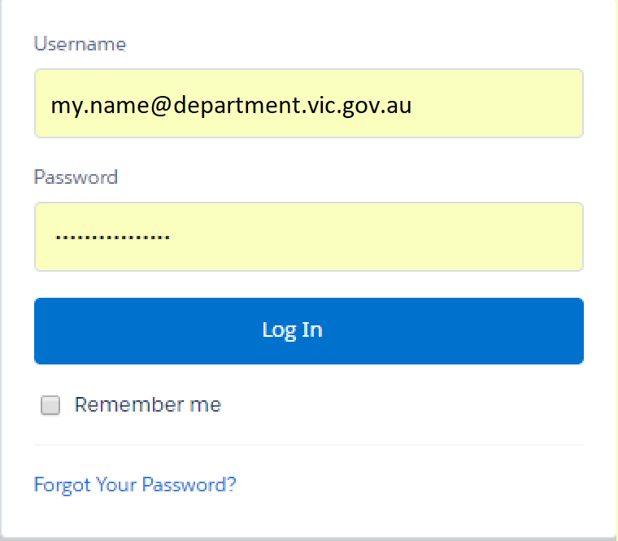

  - Logging in to https://portal.vpsc.vic.gov.au/
When you use the above URL to access the portal, select Data Collections to view active and historic data collections available to you.
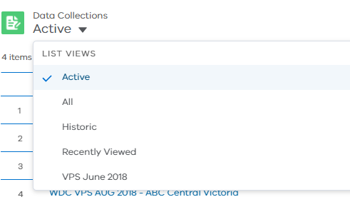
  - Updating your profile and settings
When you are logged into the portal you can select your name (in the top right corner of the portal) to:
- update your profile or
- update your settings (password).
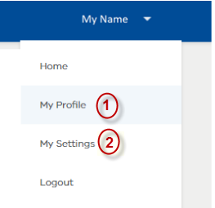
    - My Profile
Please choose this option to update your details.
- Click the Edit button 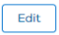 in the top right of the profile screen to display the editable form. You can add or edit the information on your profile.
- Click Save to complete the changes.
Please note: do not try to use this option to set up an account for your colleagues. If your colleague needs to provide workforce data, please contact VPSC so that an account can be created for them.
    - My Settings
Please choose this option to update your password.
- Click on Change password. This will display a dialog box to update your password.
- Click Save to finish changing your password.
In addition to the above items, this menu also has options to return to the Home screen and to log out of the portal.
- SUBMITTING DATA
  - Invitation email and Data Collection list
The VPSC will send you an email with a link to newly activated data collections.
When you click on the link and log into the portal, a list view will show all the active data collections that you need to submit data for.
If you are responsible for completing data collections for more than one organisation, you will have a collection listed for each organisation. The data collection table shows the name of each collection and its associated organisation. 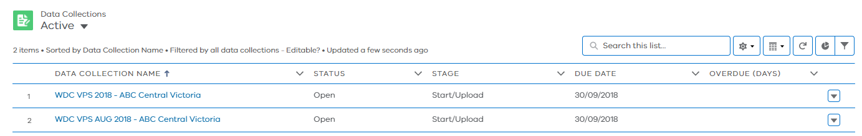
To begin the process of submitting data, select an ‘Active’ collection from the list, this will take you to the data collection page, where you can download the template for your organisation and prepare your workforce data file. You will need to upload and validate your file before you can submit it.

  - Data Collection Page steps
Follow the steps on each chevron to submit data for the data collection selected in step 3.1.

    - Start/Upload chevron – Data template and Data Requirements
Use the buttons on this chevron page to:
- access Data Requirements (on the VPSC website) that describe the information required for the collection
- Download a Blank Template file that you will need to populate with your organisation’s data described in Data Requirements
- Upload your populated data file
Important Note: Don’t remove or alter template headers
When you download the template, it will have headers of data we require. Please make sure you include the headers when you upload your workforce data file.

    - Start/Upload chevron – Upload your data file
- Once you have prepared your file in accordance with the data requirements and the template provided, you are ready to upload the file by either:
- Clicking on the ‘Upload Files’ button then choose/open the file you have prepared, or
- Dragging and dropping your file into the ‘drop files’ area.
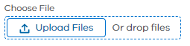
- A dialog box will appear and the file will start to upload. Once the file has finished uploading, click on ‘Done’.
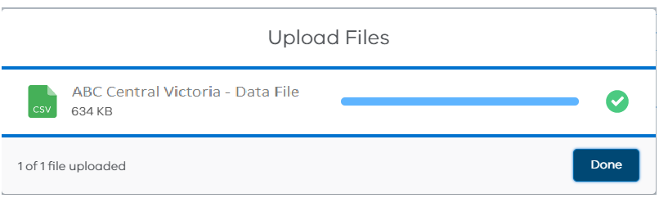

- A message will appear on the top of your screen ‘Import in Progress’. At this point,the data import and validation will begin.
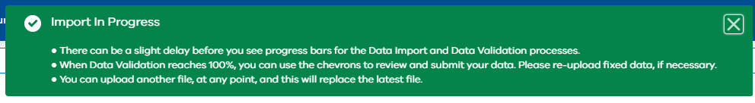
- Once the Data Import and Data Validation has progressed to 100% as shown in the figure below, your file has been successfully uploaded. This step may take a little longer depending on the size of the file you are uploading.
Important note: Progress bars can take a few seconds to appear
If you do not see the Data Import or Validation progress pane, please refresh your page (use the F5 key) to see the updated status.

    - Review imported and validated data
Once you have uploaded your data file, you will be able to see if there are any warnings, invalid records, or errors in your data file.
Important Note: Validation messages
To complete the data collection, make sure your file is free from errors or invalid records. Otherwise, the system will not let you submit your data file and will give a ‘Validation Error’ as shown below.

Review all ‘Warnings’ and make sure are correct. These will not stop you from submitting your data file, but they can highlight issues that you should review.
In the example below, the file has 1 invalid record, 7 Errors and 10 warnings.

Use the ‘Invalid Records’, ‘Errors’, and ‘Warnings’ chevrons to review any validation issues.

In the example below, the ‘Error’ page has a list of error types that exist in the data file and the number of times it occurs.
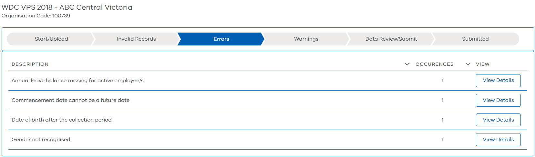
Click on the ‘View Details’ button on the right of each item to view the details of where it exists in the data file. Please see example below.
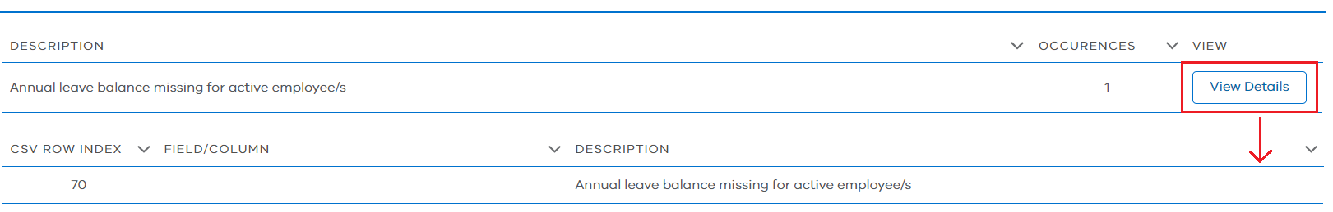
This will provide you the row number, field/column it occurs in and a description. Please note these details.
    - Fix and re-upload data if necessary
Open the file you have uploaded and correct:
- all the errors
- all invalid records
- all warnings, if the data is actually incorrect
You can use the ‘Download latest File’ button on the Start/Upload chevron to download the latest uploaded file. This may be useful if you have accidently deleted the file from your local drive or you have submitted the data file and wish to look at the final version.

    - Submit data
Once you have corrected the Errors/Invalid Records and reviewed all the warnings, go to the Data review/Submit page.
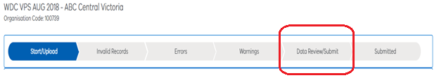
If you are certain that the data is correct, use the ‘Submit’ button to submit the workforce data for your organisation.
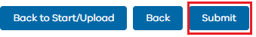
    - Start/Upload chevron – Download latest file
To view the most recent file you have uploaded into the system (historic or active data collections), use this button.

- EXAMPLES OF INVALID RECORDS, ERRORS AND WARNINGS
Type | Description
Invalid Record | Value must be a number – remove any text, commas or other symbols
Error | ANZSCO Code is not recognised
Error | Commencement type is missing
Error | Too many columns of data. Review your file in relation to the data specification.
Error | Gender not recognised
Warning | The total number of active employees has changed by X% on last year. Please check that this is within expectations and correct
Warning | Employment Type is missing

