Victorian Public Service Executive Performance Management Framework

Summary of performance management framework
- The performance management framework for executives within the Victorian Public Service (VPS) outlines six foundation principles to drive high performance, support career development and help foster a positive workplace culture.
- The six principles are:
- clear performance expectations - strategic alignment to outcomes through specific, measurable, attainable, relevant and timely (SMART) goals;
- focus on outcomes - achieving organisational and government priorities;
- focus on leadership behaviours - effective leadership behaviours, underpinned by the VPS Leadership Capability Framework;
- promote and apply public sector values - demonstrating commitment;
- evidence based decision making - reward, recognition and re-appointment are driven by data; and
- equity through consistency - performance goals informed by work level standards and measured by a common rating scale.

Key elements
- Through a principles based approach, the framework encourages consistent executive performance management across organisations, where executive performance outcomes and expectations align with Government priorities, public sector values and leadership capabilities. The framework is intended to contribute to building public trust through the setting of clear performance expectations.
- As the framework is designed as a principles based approach, organisations would be able to adapt its elements to their specific operational context. It is an expectation that all executives would have a performance plan, however a mandated approach is not proposed.
- The framework is supported by a number of resources that are designed to be a guide to organisations in applying the performance principles.

Implementation and application
- The performance management framework will be implemented at the commencement of an organisation’s next performance cycle (i.e. 2020 for calendar year or 2019-20 for financial year cycle).

Governance
- The Commissioner, Victorian Public Sector Commission (VPSC) will continue to monitor and report to Victorian Secretaries Board on the application of this framework.

Advice and assistance
- A dedicated resource at the VPSC will be available for ongoing support on the Executive Performance Management Framework.

Victorian Public Service Performance Management Framework

1 Introduction and foundation principles

1.1 Purpose
The Victorian Public Service (VPS) executive performance management framework provides foundation principles that shape and drive executive performance and behaviours. The framework:
- supports organisations to clearly link executive work to overarching strategic goals;
- provides a means by which individual executive career development can be of focus in order to foster future talent;
- links the performance objectives of executives with organisational and government priorities in a meaningful way; and
- provides a means by which individual executive performance expectations can be assessed and recognised.

1.2 Scope and design
The performance management framework applies to all executives within the VPS. VPS departments and connected service entities are to apply the foundational principles to underpin high performance within the VPS. This framework is designed to encourage a consistent application of performance management within the workplace, where outcomes and expectations align with organisational and government priorities, public sector values and leadership capabilities.
The framework has inherent flexibility to enable organisations to adapt as required to their operational requirements and existing systems.
The design of the framework was informed by expert research, frameworks applied across other jurisdictions (private and public, nationally and internationally), and broad consultation.
An overview of the process is depicted in Figure 1, noting that the process is interconnected with foundation principles and roles and responsibilities.
Figure 1: Executive performance management process overview
Executive employee performance expectations
Performance plan
Regular performance conversations
Consistent application
Performance outcomes

1.3 Performance management foundation principles
Research and practice indicate that executives are more likely to be high performing in workplaces that exhibit strong organisational principles and that place a focus on how progress is being made towards the achievement of objectives.
The setting of foundation principles enables a minimum standard of expected behaviours of executives to be achieved.
The performance management foundation principles has been developed with the purpose of supporting high performance while fostering a positive workplace culture. The foundation principles are:
Clear performance expectations
Strategic alignment to outcomes through specific, measurable, attainable, relevant and timely (SMART) goals.
Focus on outcomes
Achieving organisational and government priorities.
Focus on leadership behaviours
Effective leadership behaviours, underpinned by the VPS Leadership Capability Framework.
Promote and apply public sector values
Demonstrating commitment.
Evidence based decision making
Reward, recognition and re-appointment are driven by data.
Equity through consistency
Performance goals informed by work level standards and measured by a common rating scale.
The principles are depicted in Figure 2.
Figure 2: Performance management foundational principles
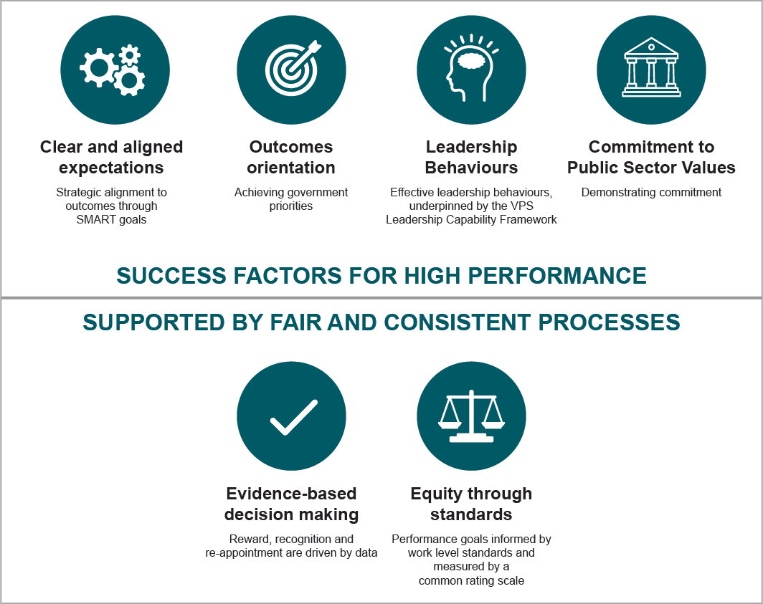

1.4 Integrating the principles with culture
VPS employers may expand on the above six principles to adapt the framework to their operating environment, where the principles are integrated with culture to foster:

A shared objective of high performance
Setting clear performance expectations through alignment with organisational and government priorities, organisational strategy and work level standards. Aspiring to higher levels of performance and evaluating outcomes through a consistent approach.

Ongoing, regular feedback and discussion
Maximise the impact of regular performance conversations through maintaining awareness of how and when to shift between different purposes which include: performance; development; and career management.

Ethics and trust
Executives hold themselves accountable by role-modelling leadership behaviours underpinned by the VPS leadership capability framework and by demonstrating commitment to Victorian public sector values.

Organisations that apply these foundation principles will foster high performing
executives who:
- focus on outcomes and performance expectations that reflect desirable leadership behaviours;
- deliver outcomes aligned to performance expectations;
- demonstrate public sector leadership capabilities;
- role model public sector values;
- engage in regular performance discussions and achieve performance expectations; and
- participate in a fair and consistent process, as both a manager and employee.

2 Guidance for performance setting

2.1 Performance expectations
Taking into consideration the foundation principles, organisations are accountable for setting clear performance expectations that are:
- related to individual performance requirements and higher-level objectives, including whole of government priorities;
- based on the requirements of the executive role, including the role’s work value; and
- are specific, measurable, agreed, realistic and timely (SMART).
All executives work within a complex operating environment and are subject to both formal and informal performance requirements, with only some requirements specified in a performance plan.
All performance requirements should be developed in collaboration between an executive and their manager.

2.2 Executive performance plan
An executive performance plan should document specific expectations, behaviours and goals for an executive for a given performance plan cycle. It is good practice to include the six core elements outlined in Table 1 within a performance plan. These elements are designed to promote a consistent and robust approach to performance management and development of VPS executives and support a fair and transparent process that will assist ease of mobility across government.
Table 1: Good practice core elements of a performance plan
Core Elements | Definition
Victorian public sector values and behaviours | The Victorian public sector values and behaviours provide the foundation of the integrity and accountability framework for all public sector employees.  The Code of Conduct outlines and reinforces the Victorian public sector values by describing expected standards of behaviour. The values and behaviours underpin an executive’s interaction with the government, community, suppliers and other employees.
Key result areas | With a focus on outcomes, the key result areas provide explicit links between individual result areas and broader organisational and whole of government priorities.  Key result areas also take into account the executive’s position description.  Suggested key result areas:  - Stakeholder management  - Resource management and compliance  - People management and capability development  - Strategic planning and implementation
Expectations | Performance expectations are observable behaviours and actions which explain how outcomes are to be achieved. Expectations must be clear and precise to everyone responsible for meeting them.  Performance expectations vary based on the role and the organisation’s operating environment and therefore must be determined collaboratively by the individual, manager and organisation.
Measures | Measures are indicators that help assess achievement of outcomes against performance standards.
Targets | Targets are specific, planned results to be achieved against measures.
Four-point rating scale | A rating scale guide will assist the employer in identifying the level of accomplishment or fulfilment of targets.  A fourpoint rating scale is recommended:  - Does not meet expectations  - Meets most expectations  - Meets all expectations  - Exceeds expectations
An example of how to create a performance plan using the key result areas is provided at Appendix 1.

2.3 Performance conversations
A coaching approach to performance management conversations enables organisations to retain employees and develop talent. Leaders who coach, develop and hold others accountable, are three times more effective at producing improved business and talent results than those who do not. Guiding resources are at Appendix 2.
It is the responsibility of the collective leadership cohort in an organisation to recognise the impact of unconscious bias in processes, and to collectively commit to mitigating it. Guidance on managing unconscious bias in executive performance conversations is provided at Appendix 3.

3 Guidance for performance assessment

3.1 Consistent application
Organisations should aim to apply a set of standards to support a consistent application of final performance ratings.
A good practice process that could be applied is as follows (additional guidance at Appendix 4):
- Performance feedback is provided by a manager to an executive on an ongoing basis that incorporates feedback from a range of sources.
- A formal annual performance review process occurs between each executive and their manager. Through this process, ratings are discussed by managers and moderated by People and Culture, or the equivalent, at every executive level to ensure consistency.
- Once ratings are finalised by managers, performance outcomes and insights are collated centrally and provided to the relevant public sector body Head and/or Executive Remuneration Committee for review and approval.
- After the internal collation and review process occurs and is approved by the public sector body Head, final performance outcomes are communicated to executives.

3.2 Performance outcomes
Executive performance expectations should be assessed against a defined rating scale to identify the level of accomplishment or fulfilment of target performance outcomes.
Target performance outcomes need to be specific, with planned results to be achieved against defined measures. As a guide, the four-point rating scale is outlined in Table 2.
Table 2: Good practice four-point rating scale
Four-point rating scale | Definition
1. Does not meet expectations | The executive consistently fails to meet agreed expectations
2. Meets most expectations | The executive meets most agreed expectations
3. Meets all expectations | The executive meets all agreed expectations
4. Exceeds expectations | The executive always meets and sometimes exceeds agreed expectations

3.3 Confidentiality
It is a requirement of all managers and employees, including human resources, to maintain confidentiality when discussing performance of executives and any possible interventions.

4 Roles and responsibilities

4.1 Public service entities

Public sector body Head
The public sector body Head will have the authority to endorse final performance outcomes and collect internal performance outcomes to undertake strategic workforce planning and support executive performance development and leadership.

Human Resources
Human resources promote and manage the performance process within their organisation, while maintaining records of performance plan progress and completion. As required, human resources will provide guidance and support and participate in discussions about collated performance results.
Human resources have the ability to train managers on the performance management process, share new information as it becomes available and contribute to strategic organisational initiatives. With such involvement, the human resources function is able to play a pivotal role in workplace culture, capability development and workforce planning.

4.2 Victorian Public Sector Commission
The VPSC will maintain relevancy of this performance management framework, guiding tools and resources.
The VPSC will meet with VPS Secretaries to discuss the key outcomes and themes from the application of the performance management framework. The VPSC will report to the Victorian Secretaries Board at the conclusion of the performance cycle.
The VPSC is committed to executive leadership development and equipping executives with the skills they need to lead effectively in a complex and changeable environment.
The importance of performance management will be supported in the VPS executive induction program (currently being developed) and reinforced through relevant sessions included within the executive leadership and development calendar of events.

4.3 Application of framework to broader
public sector
The recent Industry Sector Reviews (ISRs) found that public entities would benefit from clear central policy direction as to the minimum standards for good practice in performance management.
Due to the sequencing of projects, the ISRs did not extensively test the suitability of the VPS performance management framework for adoption in public entities. However this resource suite is available on the VPSC website, and public sector entities are encouraged to consider how the best practice principles and processes can be adopted and incorporated into their systems.

Executive Performance Management Framework Resources

A1 Performance Plan examples

Key result areas
Performance needs to be specific, measurable, agreed, realistic and timely (SMART). Performance should align to higher government objectives and be outcome oriented beyond simply outputs or activities. Figure 3 outlines how the SMART tool can be applied to a specific performance goal within a performance plan.
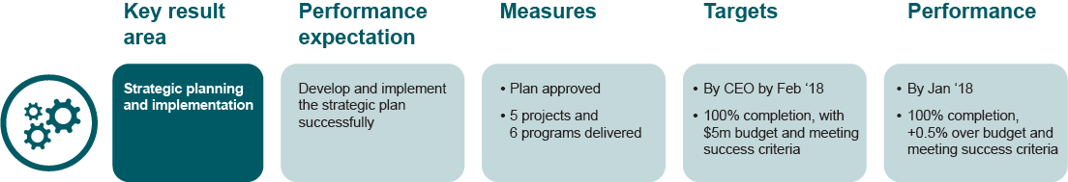
Figure 3: Applying the SMART tool to specific performance goals.

Performance expectations
Expectations must be clear and precise to everyone responsible for meeting them. An example of how to apply the four key result areas against performance expectations is shown in Figure 4.

Figure 4: Applying the key results areas against performance expectations

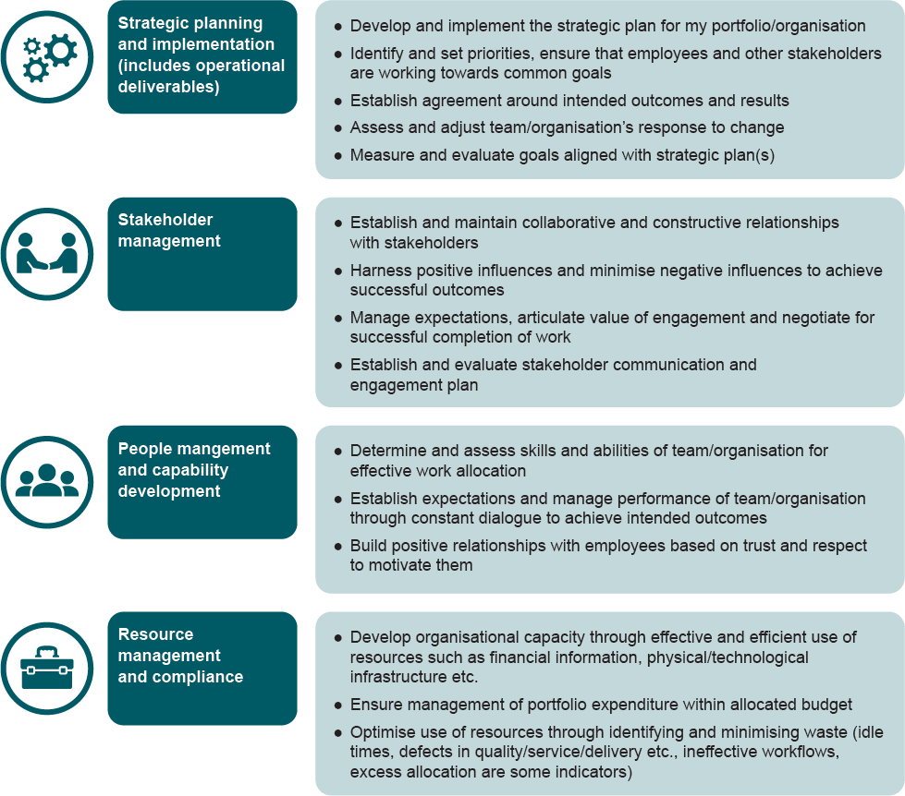

Performance measures
The four key result areas assist with measuring performance. Figure 5 outlines an example of key result areas and performance measures that can be incorporated in a plan.
Figure 5: Incorporating key results areas into a performance plan
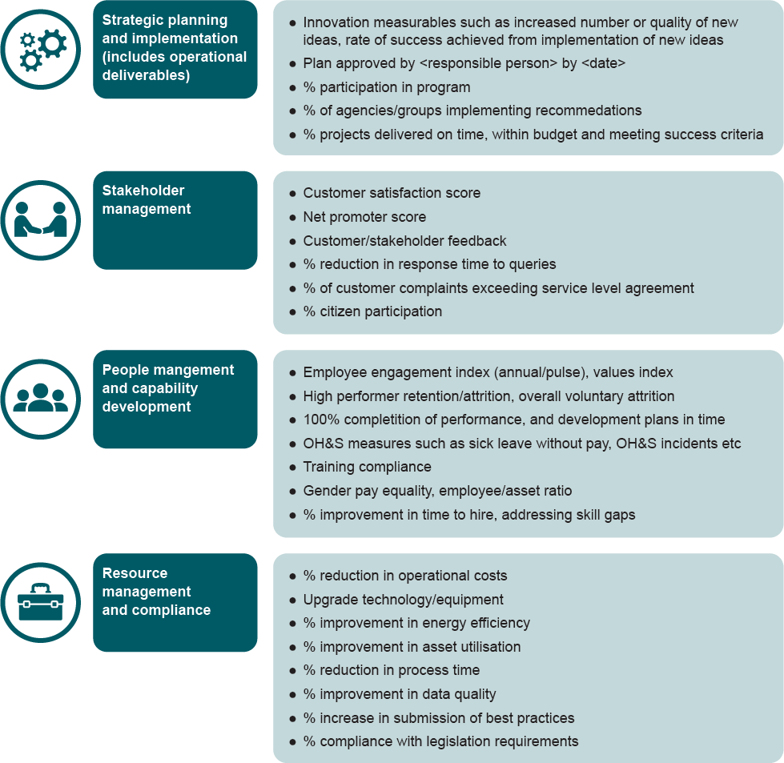

A2 Performance conversations
The following table provides an overview of some considerations when preparing, holding and reflecting on performance conversations with executives.
Stage | Performance conversations | Difficult conversations
Preparation | - Define the purpose, approach and ideal outcome.  - Gather information, looking at facts and feedback from various sources including peers.  - What do you want to achieve?  - What assumptions might you have?  - What is the ideal outcome?  - Determine the future opportunities. |  | - Identify the issue that needs to be addressed.  - What do you want for yourself/ the individual/work relationship?  - What are the facts and questions?  - Consider the logistics.  - What does a resolution look like?  - Consider individual/your reactions?  - Consider supports – HR, manager, support person.
Conversation | - Highlight examples of individual’s good performance.  - Provide constructive feedback on further improvement areas.  - Explore and identify the challenges (personal/work).  - Agree on individual’s performance goals and confirm your performance expectations.  - Describe how you will measure their success.  - Discuss additional resources that the individual may need (e.g. training, job shadowing, etc.).  - Share own personal relatable experiences if of interest to individual (personal and/or professional).  - Set the date for the next meeting. |  | - Start discussion with shared goal.  - Share your facts.  - Relate feedback to a business issue. Provide corrective feedback.  - Communicate ideas in a calm and logical manner.  - Demonstrate strong positive nonverbal communication cues.  - Listen and give individual opportunities to respond.  - Confirm the need for a follow-up discussion.  - Set a date to review progress.  - Document agreements, disagreements and action items.  - Document changes as applicable e.g. through a performance plan.
Reflection | - What did you learn?  - What surprised you in the conversation?  - What were the benefits of having this conversation?  - What aspects were challenging?  - What would you do differently next time, if anything?  - How will you maximise the possibilities of this conversation? |  | - What did you learn? What surprised you in the conversation?  - Do you feel proud of how you managed the conversation? Or do you feel let down?  - What were the benefits of having this conversation?  - What aspects were challenging? How did you improve?  - What would you do differently next time, if anything?

A3 Guide to removing unconscious bias

What is unconscious bias?
Unconscious bias, also known as implicit bias, can be defined as the influence of mental processes over which the individual does not have conscious control.
Unconscious biases may be based on preconceived attitudes and impressions, stereotypes, and social perceptions. They can influence how an individual interprets information and thereby impede their ability to make objective decisions and accurate assessments.

Why we need to remove unconscious bias from performance conversations
Unconscious bias can impede a manager’s ability to objectively evaluate the performance of other employees by allowing the evaluation to be influenced by factors unrelated to performance. As a result, managers may unintentionally discriminate against people and rate their performance higher or lower than they deserve based solely on their performance.

Common types of biases
Bias can be present in various forms as illustrated in the below diagram

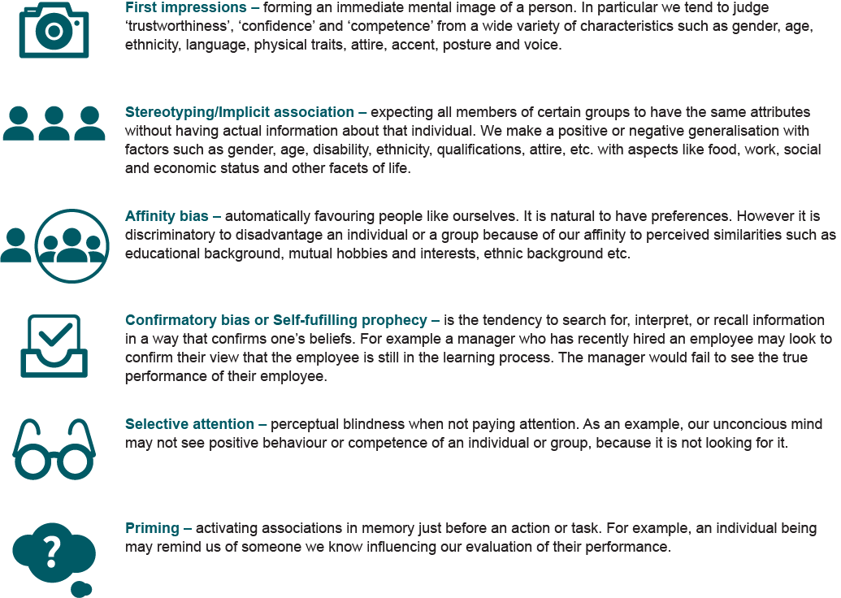
Holding a good performance discussion
The manager must introspect and recognise any potential bias before any performance conversation, whether it involves providing ratings, providing feedback or engaging in a career development conversation.
Repeated performance of an action helps the brain create a pattern and form habits. Through regular introspection we shift a less biased review process to the automatic part of our brain, ensuring our commitment to a more consistently objective process for holding performance conversations.
Some questions for introspection are:
- What kind of biases have I experienced myself and how has that affected me?
- Does this decision have an impact on serving my own agenda?
- Are there differences in work styles between me and the employee I am having a conversation with? Are they wrong or just different styles? Can these differences influence my rating?
- What strategies can I put in place to completely engage myself in the discussion?

A4 Consistent application
Application questions | Answers
What does it involve? | A meeting with managerial peers facilitated by a neutral expert (typically an HR representative) where every individual direct report’s performance rating is assessed.
What is discussed? | Initial performance ratings.  Quality of evidence provided by manager.  Any feedback from other managers.  Agreement on final ratings based on discussion.
When should the meeting be held? | At the end of the performance year.
How long is a typical discussion? | Approximately 90 minutes to 2 hours depending on the size of the employee population to be discussed.
How do we record the output of the discussion? | The facilitator documents any changes or outcomes to ratings and shares the notes from the meeting with the managers who can add/modify as necessary.
When do I communicate the performance rating to my direct report(s)? | After completion of the assessment process across the organisation, you may communicate the performance rating to your team.

