Title The State of the Public Sector in Victoria 2018–2019

Commissioner’s foreword
I am pleased to present the State of the Public Sector in Victoria report 2018–2019.
Victoria’s public sector delivers a wide range of services and support for the community. Its workforce includes 323,220 people, employed by Victorian Government departments and agencies. That’s around 9% of the total Victorian labour force. They provide health, education, transport, emergency services and more.
The community trusts the public sector to serve them effectively, help grow the economy and keep people safe. The public sector needs high-performing leaders, and capable, engaged employees. It needs safe workplaces and diverse, inclusive teams.
The State of the Public Sector in Victoria report provides the information needed to help make the public sector a better place to work. It combines facts and figures about the structure and composition of the public sector workforce with insights from the People Matter Survey. Case studies are included to share good practice among employers. This information is used to improve the way employees are managed and led.
This year we discuss developing workforce capability, strengthening senior leadership, mental health and wellbeing, and our values-based culture.
I draw your attention to three key areas.
First, the importance of having a values-based culture to foster safe and respectful workplaces. People Matter Survey results show a strong association between application of the public sector values and higher reported job satisfaction and employee engagement. A positive values-based culture is also associated with lower reported negative behaviours such as bullying, sexual harassment and discrimination. There is scope to intensify our efforts to create workplace cultures that are strongly aligned with the public sector values.
Second, the reforms we’ve made to unify leadership in the public service. There is a new classification structure for executive roles. It supports consistency and mobility between employers and clarifies performance expectations. Remuneration is now determined by the Victorian Independent Remuneration Tribunal.
The Victorian Leadership Academy continues to connect and develop our senior leadership team, developing capabilities that enable executives to think, lead and work differently in delivering services that meet the needs of Victorians. Academy programs build capacity to provide contemporary leadership.
Third, the importance of promoting positive mental health and wellbeing. We know the workplace environment can have a significant impact on a person’s wellbeing. Employees with higher levels of job control, manager support and more meaningful work report lower levels of stress and its negative consequences.
I trust the evidence in the State of the Public Sector in Victoria report 2018–2019 will assist efforts to continuously improve the work environments we provide.
The Victorian Public Sector Commission will keep working collaboratively with departments and entities toward our strategic outcomes:
- an integrated and future-focused public sector
- an inclusive, high-performing and engaged workforce
- empowering and engaged leaders
- a public sector that is trusted by Victorians.
Julia Griffith PSM Acting Victorian Public Sector Commissioner

About this report
The 2018–2019 State of the Public Sector in Victoria report provides a profile of the Victorian public sector, its workforce, executives and boards of governance.
The report’s purpose is to promote further improvements to the performance of Victoria’s public sector workforce, aid the Government’s public sector reform agenda, and help drive improvements in the way public sector workers are managed and led.
Published annually since 2006–2007 it fulfils the Victorian Public Sector Commission’s duty to report on whole of government data, as set out in sections 39(1)(b) and (c) of the Public Administration Act 2004.
Building on the more comprehensive approach to reporting implemented in 2017–2018, this year’s report includes insights from the recently reformed People Matter Survey. The People Matter Survey is the Victorian public sector employee opinion survey. Undertaken annually, the survey seeks to improve the working lives of employees and measure how well the public sector values are being applied, so the workforce is better equipped to deliver for the Victorian community.
In 2019, to strengthen the survey’s relevance and utility, the Victorian Public Sector Commission began a program of improvements. To help employers act on their organisation’s survey results, the enhancements included establishing a new theoretical framework, improving accessibility and reformulating survey questions on the public sector values to better capture the substance of each value and promote their active application. Questions were also added to inform gaps, such as political impartiality and occupational violence, and to better understand innovation, collaboration and manager support.
While these changes were generally minor, in some cases it is apparent they may have materially influenced the measured agreement rates contained in this report. Consequently, a degree of caution should be exercised in making time series comparisons from earlier years to 2019.
The data provided in this report is listed on Data Vic and is available in an accessible digital format on the Victorian Public Sector Commission’s website.

The Victorian public sector
The Victorian public sector is diverse. It includes 323,220 people, employed by Victorian Government departments and agencies.
It provides a wide range of services and support for Victorians. These services span health, education, water and land management, transport, finance, emergency services, arts, sports and recreation, and regulation.
Throughout the report, the term ‘public sector workforce’ refers to the entire workforce. The sector comprises the Victorian Public Service and public entities, which are, in turn, categorised across six industry groups (Figure 1 below).
Each key topic explored in this report contains general observations about the whole public sector. The report also provides detailed analysis on the Victorian Public Service (public service) and on the various public entities, by their industry group.

Figure 1 Composition of Victoria’s public sector

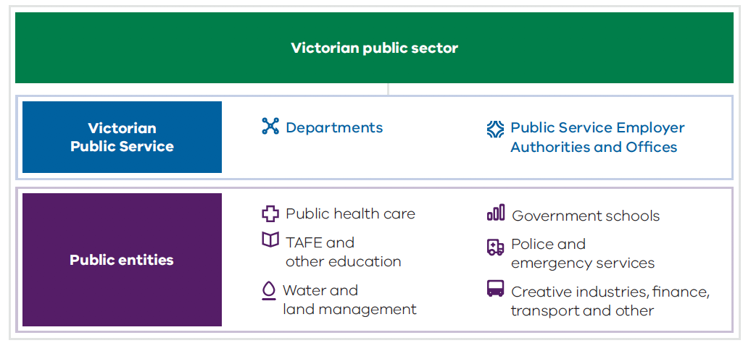

Report structure
The report is presented in six chapters with accompanying appendices:

Chapter 1
The public sector workforce: key facts and figures on the composition of the public sector workforce.

Chapter 2
Insights from employee perceptions: key facts and figures on the opinions of the public sector workforce from the People Matter Survey.

Chapter 3
Building workforce capability: initiatives affecting the Victorian public sector and its workforces.

Chapter 4
Strengthening senior leadership: reform initiatives affecting Victorian public sector executive employment.

Chapter 5
Workplace mental health and wellbeing: levels reported by Victorian public sector employees.

Chapter 6
Perceptions of workplace culture and the application of the public sector values and employment principles.

Appendix 1
Composition of Victoria’s public sector: how the sector is structured.

Appendix 2
Employee organisations by industry group: each public sector employer with their staff numbers as at June 2019.

Appendix 3
Composition of department portfolios: employer bodies under each department portfolio grouping as at June 2019.

Appendix 4
Diversity inclusion indicators by industry group.

Appendix 5
Glossary.
- The public sector workforce
At June 2019, the Victorian public sector employed 323,220 people (263,696 full time equivalent (FTE) staff), representing nine per cent of the Victorian labour force.
The 1817 agencies that make up the Victorian public sector include 47 public service departments and offices, 1544 school councils and 226 other public entities. These agencies include public health care services, schools, emergency services, regulators, transport agencies, and a range of other organisations that deliver services and manage public assets.
Public entities employed 84% of all public sector employees and the public service accounted for 16%. The public service comprises the staff of the 8 public service departments and 39 associated Authorities and Offices who are employed by the Crown under the Public Administration Act 2004. Public entities comprise the statutory authorities and state-owned corporations that are established outside the public service and deliver services for the Victorian community.
FTE employment in the public sector grew by 4.9% from June 2018 to June 2019, with significant growth occurring in health services, Government schools and Police and emergency services.
The Transport and Health and Human Services departments underwent significant change in 2018–2019. Machinery of government changes resulted in the transfer of 2628 FTE staff from the public entities VicRoads and Public Transport Victoria (the Public Transport Development Authority) to the Department of Transport and the Major Transport Infrastructure Authority. Disability direct care staff in the Department of Health and Human Services reduced by 2306 FTE when compared to June 2018 as staff were transferred to external service providers as part of the implementation of the National Disability Insurance Scheme.
Two-thirds of the Victorian public sector workforce identified as women, and 70% were based in metropolitan Melbourne. The proportion of the workforce who identified as Aboriginal and/or Torres Strait Islander was similar to the Victorian population (1% compared to 0.8%). However, other diversity groups were underrepresented in the public sector workforce compared to the community.
A large majority of jobs were in professional occupations, with 68% of the public sector workforce holding a bachelor degree or higher. The median salary for public sector employees at June 2019 was $87,281. The Australian Bureau of Statistics figure for Victorian average full time adult ordinary time earnings at May 2019 was $83,932. Outside the public service, the most common occupations were school teachers (20% of public entities FTE), midwifery and nursing professionals (15%), and carers (15% – carers and aides combined with health and welfare support workers). 74% of employees were employed on an ongoing basis and 55% work full time.
The workforce was reasonably evenly distributed across the age ranges from 25 years to 64. The proportion of staff aged less than 25 years was low compared to the Victorian labour force (5% compared to 15.9%), reflecting the professional and welfare support occupational profile of the sector. Employees were most commonly aged 25 to 35 years (26%), and 42% of people commencing in public sector agencies were in this age group.
The following charts and tables illustrate the composition and profile of the public sector workforce. Unless otherwise stated, the data is sourced from the annual Workforce and Executive data collections.

1.1. About the public sector

Employee numbers, June 2019
Total public sector 9% of the Victorian labour force.

Employees
323,220

Employer agencies
1817

Full time equivalent staff
263,696

Comprises
Victorian Public Service 16% of public sector employees.

Employees
50,416

Full time equivalent staff
47,193
The Victorian Public Service is a single workforce for which employment is governed by Part 3 of the Public Administration Act 2004 deployed across the 8 public service departments and 39 authorities and offices.Public entities

Employees
272,804

Full time equivalent staff
216,503
Public entities include statutory authorities, state-owned corporations and advisory bodies that exercise a public function (established outside of the public service, for a specific purpose with defined functions). Public entities operate with varying degrees of autonomy and are ultimately accountable to a Minister for their performance. These agencies are generally governed by a board of directors and have authority to employ their own staff separately from the public service.

Public entity industry groups
Percent of public sector employees | Employers | Employees | FTE
37% Public health care

Health services | 84 | 119,611 | 87,916
Other health organisations | 4 | 277 | 240
- Total | - 88 | - 119,888 | - 88,156
27% Government schools

Teaching service | 1 | 75,010 | 64,315
School councils | 1544 | 13,526 | 6394
Total | 1545 | 88,536 | 70,709
9% Police and emergency services

Victoria Police |  | 17,201 | 16,881
Ambulance Victoria |  | 5722 | 4950
Metropolitan Fire and Emergency Services Board |  | 2387 | 2371
Country Fire Authority |  | 2614 | 2483
Emergency Services Telecommunications Authority |  | 962 | 894
Victoria State Emergency Service |  | 221 | 206
Total | 6 | 29,107 | 27,785
5% Creative industries, finance, transport & other

Transport agencies | 6 | 3556 | 3441
Finance/insurance agencies | 7 | 3098 | 2923
Creative industries | 9 | 2733 | 1977
Sport and recreation agencies | 12 | 2544 | 1887
Facilities management | 9 | 923 | 876
Cemetery trusts | 5 | 604 | 559
Regulators | 13 | 723 | 698
Miscellaneous | 9 | 1291 | 1150
Total | 70 | 15,472 | 13,511
3% TAFE and other education

TAFE institutes | 12 | 9717 | 7034
Other education employers | 3 | 709 | 593
Total | 15 | 10,426 | 7628
3% Water and land management

Water corporations | 20 | 6411 | 6085
Land management and planning | 20 | 2144 | 1938
Catchment management authorities | 10 | 406 | 358
Alpine resorts | 4 | 414 | 334
Total | 54 | 9375 | 8715

Numbers over time

Headcount
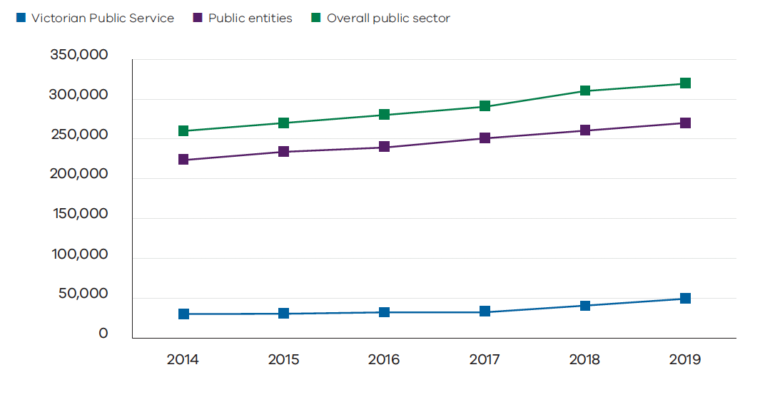
 | 2014 | 2015 | 2016 | 2017 | 2018 | 2019
Victorian Public Service | 36,435 | 37,938 | 39,807 | 43,488 | 47,458 | 50,416
Public entities | 228,748 | 239,679 | 245,616 | 253,529 | 263,895 | 272,804
Overall public sector | 265,183 | 277,617 | 285,423 | 297,017 | 311,353 | 323,220

Full time equivalent
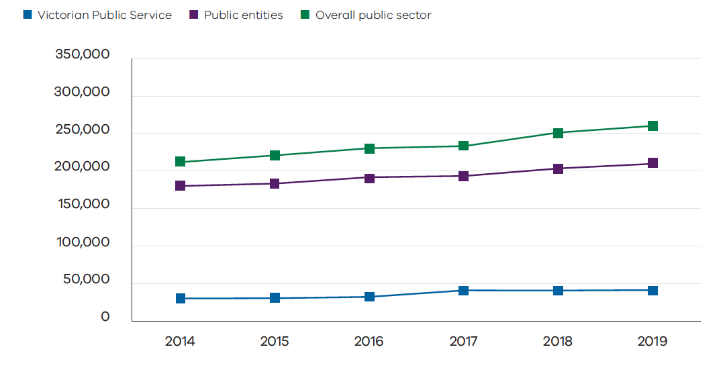
 | 2014 | 2015 | 2016 | 2017 | 2018 | 2019
Victorian Public Service | 33,396 | 34,794 | 36,567 | 40,107 | 43,862 | 47,193
Public entities | 183,237 | 188,127 | 192,811 | 198,866 | 207,450 | 216,503
Overall public sector | 216,633 | 222,921 | 229,379 | 238,972 | 251,312 | 263,696

The change in employee numbers (FTE) between 2018 and 2019 includes:
- an increase in school council employees of 1289 people and 2976 FTE which is due to improved accuracy of reporting arising from 2019 data being sourced from a new central payroll system rather than a survey of schools
- 2709 people (2628 FTE) transferring from the public entities VicRoads and Public Transport Victoria into the public service (Department of Transport and Major Transport Infrastructure Authority)
- the transfer of direct care staff out of the public service Department of Health and Human Services to National Disability Insurance Scheme providers, resulting in a reduction of 2887 (2306 FTE) direct care staff as at June 2019 compared to June 2018.

Growth in employment, June 2018 to June 2019 (FTE)
Public sector employment grew by 4.9% in full time equivalent (FTE) staff terms (12,384 FTE) between June 2018 and June 2019.
The largest changes were:
Public health care
↑ 4062

Monash Health expansion  ↑ 873 | Other Health Services  ↑ 3181
Nurses  375 | Nurses  1254
Doctors  146 | Doctors  540
Ancillary support  150 | Medical and Ancillary support  554
Administration  117 | Administration  958
Government schools (Teaching Service)
↑ 1818

Teachers
780

Education support
921

Police and emergency services
↑ 1224

Sworn police
844

Ambulance Victoria
148

Country Fire Authority
108

Victorian Public Service
↑ 3332

2628
Transfer of staff from VicRoads and Public Transport Victoria to Department of Transport and Major Transport Infrastructure Authority

588
Department of Justice and Community Safety primarily related to initiatives in correctional services including management of serious offenders, expansion of prison capacity, and community correctional services

500
Major Transport Infrastructure Authority for infrastructure project delivery – additional to transfers from VicRoads

337
Department of Environment, Land, Water and Planning to support planning initiatives in landscape protection and building safety; energy sector reforms; and initiatives in environment, forest management and water security

245
Victoria Police (public service) to support recruitment of police and other specialist personnel

220
Department of Education and Training associated with the school building program and other Education State initiatives

171
Court Services Victoria associated with continued implementation of Family Violence Royal Commission recommendations and expansion of the Assessment and Referral Court and Court Integrated Services

↓2057
Department of Health and Human Services net reduction influenced by the transfer of direct care staff to National Disability Insurance Scheme providers

Machinery of government changes
Multiple changes to administrative arrangements were implemented in 2018–2019. These changes realign functions around priorities of economic development, growing industries and sustainable and liveable communities. They help to deliver transport infrastructure, improve community safety and foster social inclusion. Integrated education and health and welfare services are also supported.
The next figure summarises the changes.

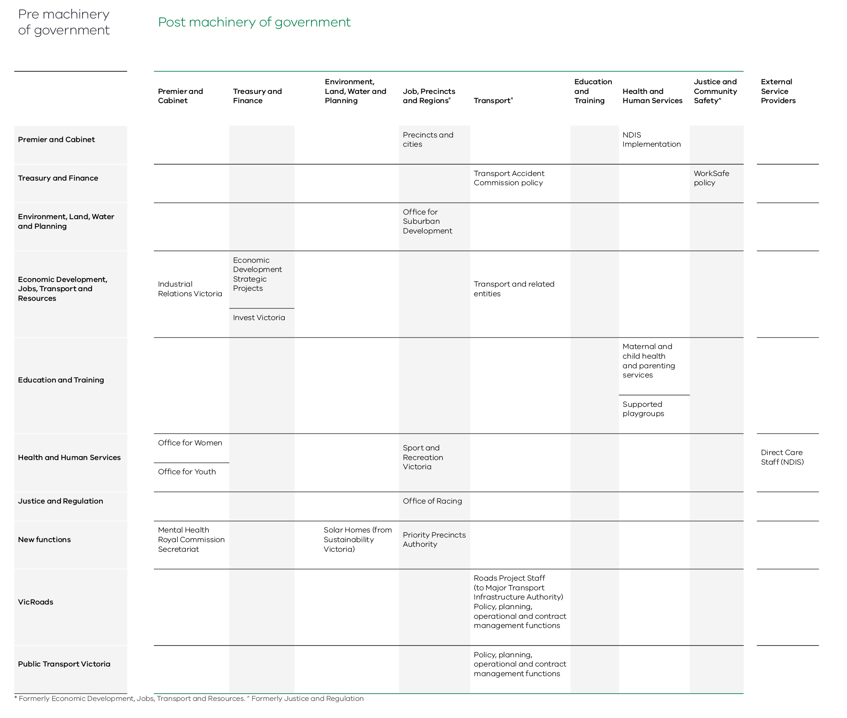

Following these changes, as at June 2019 public service employers comprised:
- eight departments
- 13 Administrative Offices
- the Victorian Public Sector Commission
- 25 authorities comprising bodies and offices designated as public service employers by specific legislative reference.

Implementing these changes involved the transfer of 7648 employees into new or revised agency structures.
Key changes include:
- The restructure of the Department of Economic Development, Jobs, Transport and Resources into two separate departments. The Department of Transport (DoT) will deliver the Government’s transport infrastructure agenda. The Department of Jobs Precincts and Regions will focus on continuing Victoria’s economic performance by growing industries and regions.
- The policy, planning, operational and contract management functions of the public entities VicRoads and Public Transport Victoria were merged into DoT effective from 1 July 2019. This will integrate road and rail planning and operations to facilitate one integrated network.
- The road projects functions of VicRoads were transferred into the Major Transport Infrastructure Authority in September 2018.
- These changes added 2709 employees to the public service and increased the Department of Transport from 685 employees to 3140 employees (headcounts).
- The transfer of Department of Health and Human Services (DHHS) disability direct care staff to five non-Government service providers began in March 2019. This transfer enables the Government to foster a strong non-Government disability sector. It will offer greater choice and high-quality flexible support to people with disability. It is part of the implementation of the National Disability Insurance Scheme.
This reform reduced the direct care workforce in DHHS by 2887 employees (headcount) as at June 2019 compared to June 2018.
These changes have had the following small but noticeable impacts on the public service workforce profile:
Gender mix | The proportion of employees who were women fell | From 61.2% to 59.7%
Age profile | The proportion of employees aged 25 to 44 increased | From 50.5% to 52.0%
Employment status | Casual employees fell  Part time employment fell | From 4.1% to 2.7%  From 21.6% to 18.7%
Salary (excluding casuals) | Average non-executive salary increased by $2289 | From $90,562 to $92,851
Work location | The proportion of employees based in the CBD increased | From 49.9% to 51.7%

Turnover rates for non-casual employees, 2018–2019

New start rates
Victorian Public Service | 18%
Public entities | 13%
Overall public sector | 14%

Separation rates
Victorian Public Service | 12%
Public entities | 10%
Overall public sector | 10%

Public sector industry separation rates, 2018–2019
Police and emergency services | 4%
Government schools | 8%
Public health care | 11%
Water and land management | 12%
Victorian Public Service | 12%
TAFE and other education | 14%
Creative industries, finance, transport and other | 14%
Overall public sector | 10%

New start rates for public sector employees by age group, 2018–2019
<25 years | 16%
25–34 years | 42%
35–44 years | 22%
45–54 years | 14%
55–64 years | 6%
65+ years | 0.7%

Public sector separation rate by age, 2018–2019
Age cohort | Percentage of employees | Separation rate
<25 years | 5% | 13%
25–34 years | 26% | 13%
35–44 years | 24% | 10%
45–54 years | 23% | 7%
55–64 years | 18% | 9%
65+ years | 4% | 20%

1.2. Public sector leaders

Board members, June 2019
Total number of public sector boards | Total number of members of public sector boards | Percentage of board members who volunteer their time
3503 | 31,803 | 81%

Executives, June 2019
 | Victorian Public Service | Public entities | Total public sector
Executives | 1259 | 1112 | 2371
% of workforce | 2.5% | 0.4% | 0.7%
Women | 50.0% | 42.6% | 46.6%
Median remuneration | $227,517 | $226,825 | $226,998
Note During the 2018-19 year, 90 executives moved into the public service from the public entities VicRoads and Public Transport Victoria. Changes to executive numbers over time are considered in Chapter 4 - Strengthening senior leadership.

1.3. Public sector workforce profile, June 2019

Age
Average age
43 years
 | <25 | 25–34 | 35–44 | 45–54 | 55–64 | 65+
Victorian Public Service | 4.2% | 24.7% | 27.3% | 23.5% | 17.0% | 3.3%
Public entities | 5.6% | 25.9% | 23.7% | 22.8% | 18.3% | 3.8%
Total public sector | 5.3% | 25.8% | 24.3% | 22.9% | 18.1% | 3.7%
Victorian Labour force (ABS) | 15.9% | 25.0% | 21.5% | 19.3% | 13.8% | 4.5%

Age distribution over time
Since 2014 the proportion of staff aged 25–34 years has increased, and the proportion aged 45–54 years has decreased. This reflects recruitment at the 25–34 year age group.

Victorian public sector workforce by age June 2014 and June 2019

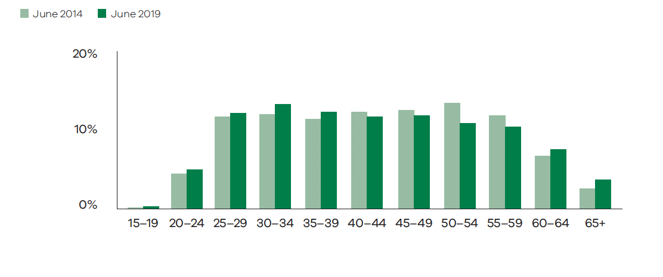 Work location

Work location – regional Victoria

Work location by industry group – regional Victoria
 | Barwon South West | Gippsland | Grampians | Hume | Loddon Mallee
Creative industries, finance, transport and other | 15.8% | 2.7% | 2.3% | 1.4% | 2.6%
Government schools | 6.9% | 6.3% | 4.7% | 5.9% | 6.9%
Police and emergency services | 6.1% | 4.9% | 5.5% | 5.0% | 5.2%
Public health care | 8.6% | 5.4% | 6.7% | 6.1% | 6.4%
TAFE and other education | 10.3% | 4.1% | 0.1% | 9.7% | 5.8%
Victorian Public Service | 6.2% | 3.7% | 4.4% | 3.4% | 3.4%
Water and land management | 10.6% | 12.9% | 5.3% | 15.8% | 8.7%
Total public sector | 8.0% | 5.4% | 5.2% | 5.7% | 5.8%
Note The table above does not show a small number of employees working outside of Victoria.

Work location – Melbourne metropolitan

Work location by industry group – Melbourne metropolitan
 | North and West Metro |  | Eastern Metro | Southern Metro
 | CBD | Suburban
Creative industries, finance, transport and other | - 47.6% | - 15.1% | - 5.7% | - 6.8%
Government schools | - 0.4% | - 30.9% | - 16.6% | - 21.5%
Police and emergency services | - 20.8% | - 19.9% | - 20.3% | - 12.4%
Public health care | - 9.3% | - 30.8% | - 15.2% | - 10.9%
TAFE and other education | - 11.6% | - 21.0% | - 13.6% | - 23.0%
Victorian Public Service | - 51.7% | - 16.8% | - 5.9% | - 4.6%
Water and land management | - 16.1% | - 9.3% | - 11.0% | - 10.3%
Total public sector | 16.6% | 25.9% | 13.9% | 13.1%

Remuneration

Median annual base salary of non-casual employees by industry group – June 2019
TAFE and other education | $78,081
Government schools | $82,192
Creative industries, finance, transport and other | $86,976
Public health care | $87,282
Water and land management | $88,223
Victorian Public Service | $89,671
Police and emergency services | $97,757
Overall public sector | $87,281

 | <$50,000 | $50,000–$69,999 | $70,000–$89,999 | $90,000–$109,999 | $110,000–$129,999 | $130,000–$149,999 | $150,000–$169,999 | $170,000+
TAFE and other education | 5% | 26% | 33% | 31% | 3% | 1% | 0% | 1%
Government schools | 8% | 22% | 28% | 33% | 5% | 1% | 2% | 1%
Creative industries, finance, transport and other | 3% | 23% | 28% | 18% | 11% | 9% | 4% | 5%
Public health care | 7% | 28% | 23% | 24% | 7% | 2% | 2% | 8%
Water and land management | 2% | 21% | 29% | 23% | 9% | 7% | 4% | 5%
Victorian Public Service | 1% | 25% | 26% | 23% | 12% | 5% | 5% | 4%
Police and emergency services | 1% | 16% | 24% | 38% | 15% | 2% | 2% | 1%
Overall public sector | 5% | 24% | 26% | 28% | 8% | 3% | 2% | 4%

Major occupations

Victorian Public Service

Victorian Public Service classifications – Victorian Public Service structure
Headcount | FTE | Public Service FTE
32,017 | 30,325 | 64.3%

Grade | Headcount | FTE | Percent of total Victorian Public Service FTE
VPS Grade 1 | 105 | 98 | 0.2%
VPS Grade 2 | 3723 | 3370 | 7.1%
VPS Grade 3 | 5660 | 5364 | 11.4%
VPS Grade 4 | 6761 | 6412 | 13.6%
VPS Grade 5 | 8493 | 8058 | 17.1%
VPS Grade 6 | 5573 | 5357 | 11.4%
Senior Technical Specialist | 443 | 425 | 0.9%
Executives | 1259 | 1241 | 2.6%

Victorian Public Service classifications – Occupational classification (excluding executives)
 | Headcount | FTE | Percent of total Victorian Public Service (FTE)
Allied Health | 928 | 789 | 1.7%
Child Protection Practitioner | 2281 | 2116 | 4.5%
Children, Youth and Families | 507 | 463 | 1.0%
Clerk of Courts | 580 | 542 | 1.1%
Community Corrections Practitioner | 1098 | 1043 | 2.2%
Custodial Officers | 3356 | 3241 | 6.9%
Disability Development and Support Officer | 2656 | 2102 | 4.5%
Fisheries Officer | 69 | 69 | 0.1%
Forensic Officer | 307 | 286 | 0.6%
Forestry Field Staff | 508 | 457 | 1.0%
Housing Services Officer | 550 | 501 | 1.1%
Legal Officer | 519 | 483 | 1.0%
Ministerial Chauffeurs | 31 | 31 | 0.1%
Nurses | 288 | 198 | 0.4%
Police Custody Officer | 393 | 390 | 0.8%
Principal Scientist | 188 | 185 | 0.4%
Science Officer | 792 | 742 | 1.6%
Senior Medical Advisor | 47 | 42 | 0.1%
Senior Regulatory Officer | 5 | 5 | 0.0%
Sheriff’s Officer | 155 | 154 | 0.3%
Youth Justice Worker | 534 | 514 | 1.1%
PTV Classifications | 527 | 508 | 1.1%
VicRoads Classifications | 1879 | 1824 | 3.9%
Other | 201 | 182 | 0.4%
Total occupational classifications | 18,399 | 16,867 | 35.7%

Public entities

Major occupations – Public entities
Occupations | FTE | Percent of public entities (FTE)
School teachers (excluding casual relief teachers) | 43,221 | 20.0%
Midwifery and nursing professionals | 32,888 | 15.2%
Clerical and administrative workers | 22,485 | 10.4%
Carers and aides | 22,588 | 10.4%
Police and Protective Service Officers | 16,428 | 7.6%
Medical practitioners | 10,892 | 5.0%
Managers | 9826 | 4.5%
Health and Welfare Support Workers | 9142 | 4.2%
Health therapy, diagnostic and promotion professionals | 7713 | 3.6%
Labourers | 6273 | 2.9%
Technicians and trade workers | 5656 | 2.6%
Design, engineering, science and transport professionals | 4318 | 2.0%

Education

Bachelor’s degree level or above
Overall public sector | Victorian Population (aged 20–64)
68% | 37%

Employment status

Employment status by industry group
 | Ongoing | Fixed term | Casual
Creative industries, finance, transport and other | 73% | 13% | 14%
Government schools | 69% | 15% | 15%
Police and emergency services | 96% | 2% | 3%
Public health care | 71% | 21% | 8%
TAFE and other education | 50% | 27% | 24%
Victorian Public Service | 79% | 18% | 3%
Water and land management | 81% | 15% | 4%
Overall public sector | 74% | 17% | 9%

Full time/part time employment by industry group
 | Full time | Part time
Creative industries, finance, transport and other | 74% | 26%
Government schools | 54% | 46%
Police and emergency services | 90% | 10%
Public health care | 33% | 67%
TAFE and other education | 54% | 46%
Victorian Public Service | 81% | 19%
Water and land management | 82% | 18%
Overall public sector | 55% | 45%

Flexible work
Flexible working arrangements are widely encouraged across the public sector. The form in which flexible working arrangements can be provided varies across occupational groups. Flexible arrangements give employees a level of control over when, where and how work is accomplished.
According to the 2019 People Matter Survey, women were significantly more likely than men to report using flexible work arrangements (68% compared to 52% of men). The most common types of arrangements used are indicated in the below table.
The survey responses indicate that working part time is the most popular flexible work arrangement option. Some respondents who work part time do not consider their part time work to be a flexible work arrangement however. 39% of survey respondents indicated that they worked part time. This compares to only 26% of all respondents reporting that they work part time as a flexible work arrangement.
Overall, 62% of respondents reported using some form of flexible work arrangements.

Using some form of flexible work arrangement
% of women respondents | % of men respondents | % of all respondents
68% | 52% | 62%

Most common types of arrangements for public sector employees with flexible work arrangements by gender, 2019
Type of flexible work arrangement used | As a % of women respondents | As a % of men respondents | As a % of all respondents
Part time | 34% | 9% | 26%
Flexible start and finish times | 23% | 23% | 22%
Shift swap | 19% | 12% | 16%
Using leave to work flexible hours | 12% | 10% | 11%
Working remotely | 10% | 12% | 10%
Study leave | 9% | 4% | 7%
Working more hours over fewer days | 5% | 5% | 5%
Purchased leave | 3% | 3% | 3%
Job sharing | 3% | 1% | 2%
Other | 2% | 2% | 2%

Source: People Matter Survey 2019

Personal leave usage varies between industry groups
Average time taken for personal leave – paid sick and carers leave – is a standard workforce management measure. It is used to report on time lost to unscheduled absences. In 2018–2019, the average time taken as personal leave across the whole public sector workforce was 10.0 days per full time equivalent employee.
During 2018–2019, just under half of employees used less than five days of personal leave each. These employees accounted for just 8% of all personal leave taken.

Average annual personal leave – public sector employees by industry

Days per ongoing and fixed term FTE employee, 2018–2019
TAFE and other education | 7.0
Creative industries, finance, transport and other | 8.4
Water and land management | 8.5
Victorian Public Service | 8.6
Government schools | 9.4
Police and emergency services | 11.3
Public health care | 11.4
Overall public sector | 10.0

Distribution of public sector workforce by personal leave taken (five year average of 2014–2015 to 2018–2019 period)
More than 20 day p.a. | 8%
11–20 days or less p.a. | 21%
6–10 days or less p.a. | 23%
5 days or less p.a. | 48%

Diversity

Diversity representation within the overall public sector (excluding government schools), as a proportion of survey participants, 2019
 | Overall public sector (excluding government schools) | Victoria or Australia wide figures
People with disability | 2.5% | 9% of the Victorian labour force
Aboriginal employees | 1.0% | 0.8% of the Victorian population
LGBTIQ | 4.4% | 3% of the Australian population
Culturally and linguistically

Born overseas | 17% | 33% of the Victorian labour force
Speak a language other than English at home | 18% | 26% of the Victorian population¹⁰
Source: People Matter Survey 2019 for all diversity figures and Workforce Data Collection 2019 for number of employees
Note There were 234,684 public sector employees (excluding government schools)

Gender

Public sector
Men | Women
32% | 68%

Victorian Public Service
Men | Women
53% | 47%

Proportion of women employees – June 2014 and June 2019
 | June 2014 | June 2019
Police and emergency services | 28% | 31%
Water and land management | 35% | 40%
Creative industries, finance, transport and other | 48% | 52%
TAFE and other education | 59% | 60%
Victorian Public Service | 60% | 60%
Government schools | 77% | 77%
Public health care | 79% | 78%
Victorian public sector | 67% | 68%

Note 151 employees, representing 0.05% of the overall public sector workforce, have identified a non-binary gender identity to their organisation. This figure is likely to be understated as 0.3% of respondents to the 2019 People Matter Survey reported identifying as non-binary gender.

Gender pay
The gender pay gap between women and men is often used as an indicator of gender inequality within the workplace. It is defined as the difference between women’s and men’s full time equivalent salary as a percentage of men’s salary.

Median salaries, June 2019

Public sector
Men | Women | Pay gap
$93,331 | $84,019 | 10.0%
The difference in remuneration between men and women is influenced by gender segmentation of occupations.

Victorian Public Service
Men | Women | Pay gap
$92,009 | $87,789 | 4.6%
The gap between the median salary of men and women reflects that women were more likely than men to be employed at lower classification levels.
Victorian Public Service employees are employed across approximately 100 different classification levels. When gender pay was compared across classification levels, the differences in mean salaries were generally less than 2% or $2000 per year. This is illustrated in the following table where gender pay gap figures are shown for each of the principal VPS Grade classifications.

Gender pay gap (based on average salary) across Victorian Public Service classifications, June 2019
 | Average 2019 salary |  | 2019 pay gap |  | 2018 pay gap
 | Women | Men | $ | %
VPS Grade 1 | $46,751 | $46,891 | $140 | 0.3% | 0.7%
VPS Grade 2 | $57,810 | $57,105 | –$705 | –1.2% | –1.5%
VPS Grade 3 | $73,924 | $73,812 | –$112 | –0.2% | –0.3%
VPS Grade 4 | $89,638 | $89,880 | $242 | 0.3% | 0.5%
VPS Grade 5 | $107,221 | $107,825 | $604 | 0.6% | 0.6%
VPS Grade 6 | $140,040 | $142,038 | $1998 | 1.4% | 1.5%
Senior Technical Specialist | $187,546 | $191,848 | $4302 | 2.2% | 3.5%

- Insights from employees

Key points
- According to the People Matter Survey, employee engagement has been broadly stable over the last five years
- For the last four years, around one in five employees reported experiencing high to severe levels of work-related stress73% of surveyed employees intend to continue working at their organisation for the next two years
- Survey results indicate a significant difference in the perceptions of executives and their staff regarding the performance of public sector executivesSpeaking up is a vital component of psychological safety; only 62% of employees reported feeling safe to do so.

2.1. How public sector employees feel about their workplace
The People Matter Survey is the Victorian Government’s largest sector-wide workforce survey. It provides a rich source of data about employee experiences and workplace climate.
This information helps identify existing strengths and areas for improvement, in turn helping to drive positive change in workplaces across the sector. Gathering high quality data is very important, particularly in times of change. The People Matter Survey continues to adapt to remain relevant and assist organisations to create high performing workforces that are healthy, inclusive and engaged.
A positive values-based climate is the foundation of any good workplace. It produces job, role, and team conditions that support a healthy and safe psychological environment. These conditions drive outcomes for engagement, satisfaction, wellbeing, innovation and intention to stay.
This chapter of the State of the Public Sector in Victoria 2018–2019 looks at employee perceptions on people outcomes, perceptions of senior leadership and psychological conditions.

2.2. People outcomes
Figure 2.1 outlines the People Matter Survey framework. The framework centres on obtaining employee perceptions of outcomes that are key to modern, high-performing workplaces. Research shows organisational, job/team and individual level drivers lead to outcomes including positive employee experience in engagement, satisfaction and wellbeing.
These are key areas of focus for public sector organisations.
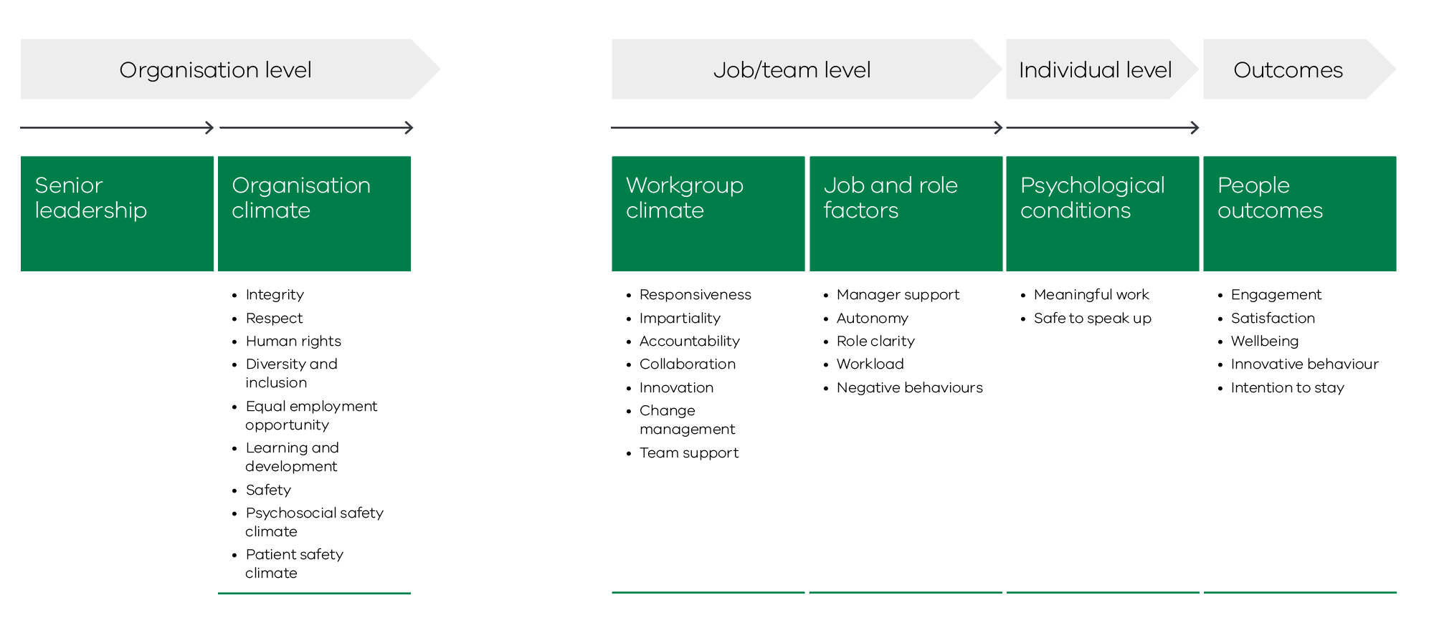

2.2.1. Engagement
Employee engagement seeks to measure the psychological satisfaction that employees derive from their work. A high employee engagement rating indicates a positive psychological state in which employees are enthusiastic and energetic about the work that they perform. Employees who are proactive and motivated help their organisations meet their strategic objectives.
Research shows that high engagement is associated with positive outcomes for organisations, including greater satisfaction, lower rates of absenteeism, turnover and lower levels of workplace stress. The most widely cited theoretical explanation of engagement is the Job Demands-Resources theory. This theory describes how job resources (e.g. autonomy, manager support, role clarity) provide a motivational pathway that directly influences work engagement.Five questions in the People Matter Survey are used to measure an employee’s engagement with their organisation:
- I am proud to tell others I work for my organisation
- I would recommend my organisation as a good place to work
- My organisation inspires me to do the best in my job
- My organisation motivates me to help achieve its objectives
- I feel a strong personal attachment to my organisation.
Employee engagement, as measured by the People Matter Survey, has remained broadly unchanged over the last five years (Figure 2.2).
Figure 2.2 Employee engagement index (points), 2015–2019
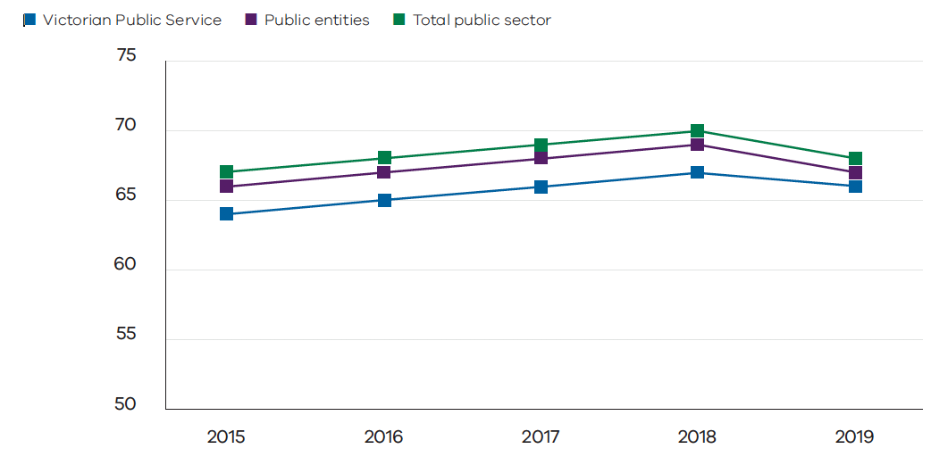Source: People Matter Survey 2015 to 2019
Table 2.1 Employee engagement index by industry group, 2019, in points
 | 2019
TAFE and other education | 62
Police and emergency services | 64
Victorian Public Service | 66
Creative industries, ﬁnance, transport and other | 67
Public health care | 69
Water and land management | 73
Overall public sector | 67

Source: People Matter Survey 2019

2.2.2. Satisfaction
Satisfaction relates to an employee’s level of contentment with their job, work-life balance and professional development.
Research shows job satisfaction is strongly associated with engagement. Higher satisfaction is associated with improved performance, lower absenteeism and turnover.
The People Matter Survey asked respondents to rate how satisfied they are with their current job, work-life balance and career development.
Figure 2.3 Percentage satisfied with current job, work-life balance and professional development, 2016–2019
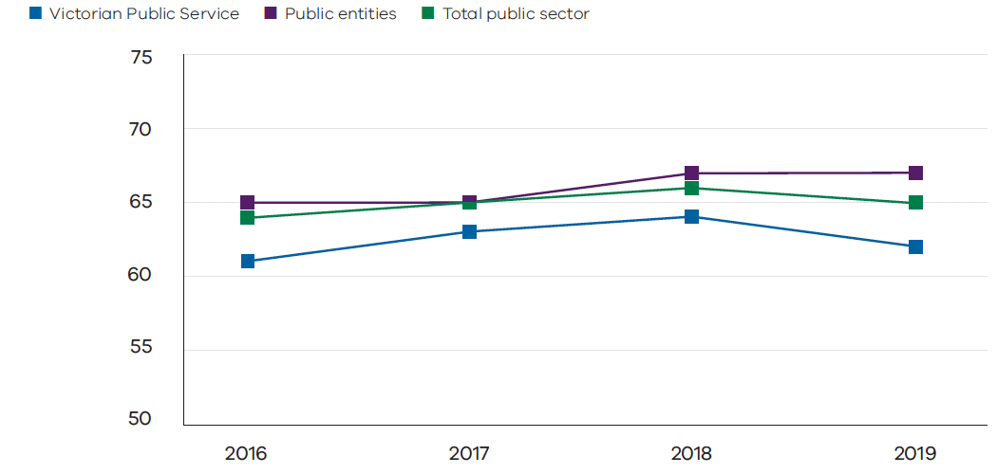Source: People Matter Survey 2016 to 2019
Table 2.2 Percentage satisfied with current job, work-life balance and professional development by industry group, 2019
 | 2019
TAFE and other education | 59%
Police and emergency services | 60%
Victorian Public Service | 62%
Creative industries, ﬁnance, transport and other | 62%
Public health care | 68%
Water and land management | 74%
Overall public sector | 65%
Source: People Matter Survey 2019

2.2.3. Wellbeing/stress
Wellbeing involves comfort, health and satisfaction across physical, mental, emotional and social domains. It has also been linked to organisational outcomes such as job retention and performance.
Research shows employees with high levels of wellbeing are less at risk from, and less likely to experience, physical injury in the workplace. They are also less at risk of mental or emotional strain due to excessive workload or unacceptable conduct.
Stress and burnout have also been shown to result in serious health and psychological problems. This may include anxiety, depression, poor sleep and neck pain.
Work-related stress is an important determinant of wellbeing. The People Matter Survey asked respondents to rate their current level of work-related stress. Further information on stress and its key drivers across the public sector workplaces is provided in more detail in Chapter 5 Workplace mental health and wellbeing.
Table 2.3 Percentage of employees rating their work-related stress as high to severe by industry group, 2019
 | 2019
Water and land management | 18%
Public health care | 20%
Police and emergency services | 23%
Victorian Public Service | 24%
Creative industries, ﬁnance, transport and other | 24%
TAFE and other education | 28%
Overall public sector | 22%

Source: People Matter Survey 2019
Figure 2.4 Percentage of employees rating their work-related stress as high to severe, 2016 to 2019
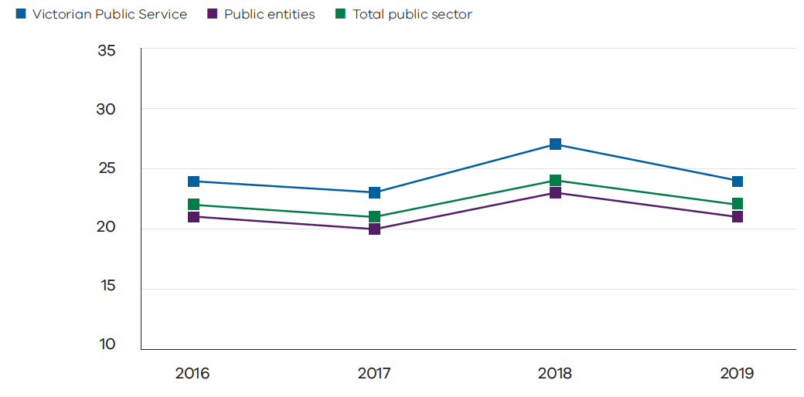Source: People Matter Survey 2019Innovative behaviour

2.2.4 Innovative behaviour
To adapt to the changing world of work, employees are encouraged to come up with innovative and adaptive ideas to improve their work, and organisations should provide the environment to nurture and support such behaviour.
Innovative behaviour is a new index introduced in the People Matter Survey in 2019.
Survey respondents are asked how often in the past three months they have made changes to improve their work or suggested ways to improve their organisation’s effectiveness and efficiency.
Table 2.4 Innovative behaviour index (points) by industry group, 2019
 | 2019
Police and emergency services | 52
Public health care | 57
Victorian Public Service | 60
Creative industries, ﬁnance, transport and other | 61
Water and land management | 61
TAFE and other education | 62
Overall public sector | 58
Source: People Matter Survey 2019

2.2.5. Intention to stay
The Victorian public sector aims to attract the best employees and keep them motivated, engaged and performing well. Engagement, satisfaction and wellbeing are predictive of whether an employee intends to stay with their employer. In workplaces where culture and climate are positive and employees are valued and engaged, the data suggest that employees intend to stay at their organisation. This also allows organisations to attract and keep the best people.
Respondents to the People Matter Survey are asked about their likely career paths over the next two years.
Table 2.5 Percentage of employees intending to stay with their current employer for the next two years by industry group, 2019
 | 2019
Creative industries, ﬁnance, transport and other | 65%
Victorian Public Service | 66%
TAFE and other education | 68%
Water and land management | 70%
Public health care | 76%
Police and emergency services | 85%
Overall public sector | 73%

Source: People Matter Survey 2019
Table 2.6 Percentage of employees intending to stay with their current employer for the next two years by age group, 2019
Below 35 years old | 35–54 years old | 55+ 35 years old
71% | 74% | 74%

2.3. Perceptions of senior leadership
Engagement starts from the top. Effective senior leadership is crucial to positive people outcomes. Senior leaders are responsible for setting an organisation’s strategic agenda and workplace culture. They can influence the extent to which employees share organisation values.
The People Matter Survey measures employee perceptions of senior leadership. It asks respondents to agree (or not agree) with the following statements:
Senior leaders…
- provide clear strategy and direction
- model my organisation’s values
- support staff to work in an environment of change
- actively support diversity and inclusion in the workplace
- demonstrate honesty and integrity.
Senior leaders within organisations rate senior leadership more positively than other staff (Figure 2.5). Leadership approaches and communication styles can be quite diverse. There is a general consensus that transformational leadership can result in improved and meaningful outcomes. In this model, leaders and followers make each other advance to a higher level of motivation and performance after articulating an inspiring vision. Evidence suggests that the most effective way a leader can communicate their vision is through face-to-face dialogue. This time-intensive approach however may prove to be more challenging for some public sector organisations with a large workforce or with operations located on multiple sites.
The relatively low positive response rate provided by non-managers to questions such as ‘senior leaders demonstrate honesty and integrity’ and ‘senior leaders support staff to work in an environment of change’, indicates there is considerable scope to further strengthen the quality and effectiveness of senior leadership in public sector organisations. This can be achieved through a variety of strategies including:
- a greater focus on training and professional development;
- more effective and rigorous performance evaluations of senior leaders (including by public sector boards and governing bodies); and
- strengthening senior executive recruitment and promotion processes to place greater emphasis on positive leadership attributes relative to technical skills or professional prowess.
Figure 2.5 Percentage agreement with leadership questions by manager status, 2019
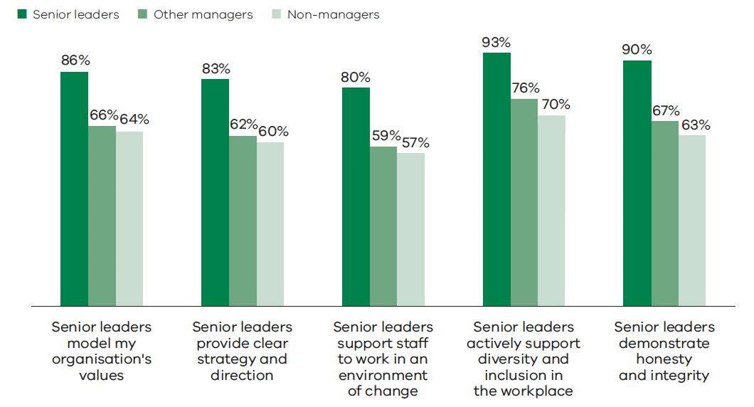 Source: People Matter Survey 2019
Table 2.7 Average agreement rate with the five leadership questions by industry group, 2019
 | 2019
TAFE and other education | 56%
Police and emergency services | 57%
Creative industries, ﬁnance, transport and other | 61%
Victorian Public Service | 64%
Public health care | 65%
Water and land management | 76%
Overall public sector | 63%

Source: People Matter Survey 2019

2.4. Psychological conditions
Engagement theory proposes that three psychological conditions (meaningfulness, psychological safety, and confidence in the availability of resources) are preconditions for employees feeling invested and engaged in their work.
Meaningful work and a culture of psychological safety also contribute to improved productivity, innovation and employee wellbeing.

2.4.1. Meaningful work
Job meaningfulness has been shown to have an important influence on employee engagement, wellbeing and performance. Employees who experience their work as meaningful can help organisations achieve optimum and sustainable individual, team and organisational outcomes.
The scorecard for ‘meaningful work’ includes responses to the following statements:
- My job allows me to utilise my skills, knowledge and abilities
- I enjoy the work in my current job
- I get a sense of accomplishment from my work.
Table 2.8 Percentage agreement rate with all meaningful work questions by industry group, 2019
 | 2019
Victorian Public Service | 76%
Police and emergency services | 77%
TAFE and other education | 78%
Creative industries, ﬁnance, transport and other | 79%
Public health care | 83%
Water and land management | 85%
Overall public sector | 80%
Source: People Matter Survey 2019

2.4.2. Safe to speak up
A safe work environment helps organisations to attract, keep, motivate and engage employees. It also reduces inappropriate behaviour.
The People Matter Survey measures whether employees feel safe to speak up using the following statements:
- I would be confident in approaching my manager to discuss concerns and grievances
- I am confident that if I requested a flexible work arrangement, it would be given due consideration
- I feel able to challenge inappropriate behaviour at work
- I am confident that I would be protected from reprisal for reporting improper conduct
- I am confident that if I raised a grievance in my organisation, it would be investigated in a thorough and objective manner.
Table 2.9 Percentage agreement rate with all safe to speak up questions by industry group, 2019
 | 2019
Police and emergency services | 57%
TAFE and other education | 60%
Creative industries, ﬁnance, transport and other | 62%
Victorian Public Service | 62%
Public health care | 62%
Water and land management | 75%
Overall public sector | 62%
Source: People Matter Survey 2019
- Building workforce capability

Key points
- The future Victorian Public Service workforce will need to be mobile and ﬂexible
- Mobility between public sector employers remains relatively lowThe public sector is increasingly diverse, although people with disability and culturally and linguistically diverse people remain under represented
- There is a clear need to further improve the employment experience for Aboriginal staff and people with disabilityAn overall gender pay gap persists but has narrowed slightly across the Victorian public sector as a whole in 2019.
The Victorian community rightly expects the public sector to evolve to meet its changing needs.
Increasingly, tackling the most difficult public policy challenges requires multiple services to be provided in an integrated way, with the customer at the centre. It also requires a public sector workforce that is mobile and ﬂexible, to shift to new types of work and different business models in response to social, economic and demographic change. Looking to the future, public sector organisations need to consider the capabilities and composition of their workforces to effectively adapt to meet the changing needs of the communities that they serve.This chapter discusses the major reform initiatives affecting the Victorian public sector and its workforces.
Figure 3.1 Drivers of workforce change
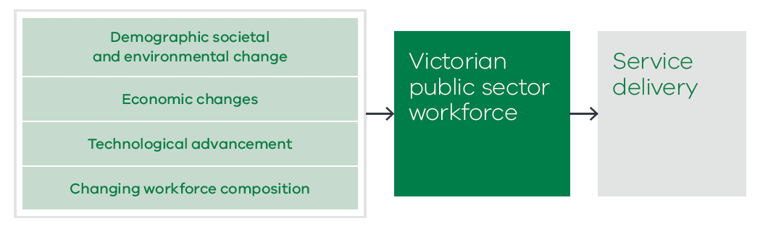

3.1. Public sector reform agenda
The 2016 Victorian Government statement, Public sector reform: delivering exceptional outcomes for Victorians, acknowledges that past approaches of addressing policy challenges through individual departments or portfolios are not effective in solving the most difficult problems facing governments and the communities that they serve. Instead, services and responses need to be joined across government and focused on solving a particular issue.
Integrated service delivery needs to be supported by changes to governance models, better quality use of evidence, consistent practices, information sharing and co-location of services. It also requires the public sector to work more closely with the community that it serves to co-design services that are based around people, and not the existing structures of Government and external service providers.
For example, the Orange Door support and safety hubs were established in response to the recommendations of the Royal Commission into Family Violence. The Orange Door is an example of a service delivery model that integrates public sector and community sector service providers. This model recognises that adults, children and young people who are experiencing or have experienced family violence will need to access specialist services as well as support for legal, health, housing and other issues. It also recognises that families need to be able to access services in a way and place that is appropriate to their needs.

3.1.1. Improving mobility
The Victorian Public Service is a single entity and a single employer. It comprises eight individual departments and 39 other public service employer offices, with staff employed under common terms and conditions. As a large and diverse employer, it offers many opportunities for staff to build and develop satisfying careers within the public service structure. As at 1 July 2019 the public service comprised 50,416 employees representing 1.4% of the Victorian labour force. Over the 2018–2019 year, more than 11,000 public service advertisements were posted on Careers.Vic – the public sector jobs board.
When employees move between public service agencies they do not break their employment continuity or forgo their entitlements. Despite this, mobility between public service employers has been relatively low over time. For the past three years, a low proportion (below 5%) of People Matter Survey respondents indicated an intention to leave their employer for another public service organisation within the next two years.

Mobility rates across the Victorian Public Service
Number of staff identified as transferring between Victorian Public Service employers in 2018–2019
1175
This number of staff represents:
- 12.0% of new commencements in Victorian Public Service agencies
- 17.1% of separations from Victorian Public Service agencies
- 2.5% of active Victorian Public Service employees
Transferring staff as a percentage of new commencements in Victorian Public Service agencies over time:
2014–2015 | 2015–2016 | 2016–2017 | 2017–2018
13.7% | 11.6% | 11.7% | 10.3%
Source: Workforce Data Collection 2019
Proportion of People Matter Survey respondents who indicate an intention to leave their employer for another Victorian Public Service organisation within two years:
2017 survey | 2018 survey | 2019 survey
4.5% | 4.2% | 3.8%
Source: People Matter Survey 2019

Public service employee responses to all People Matter Survey mobility questions indicate the most common reason for staff looking to leave their public service employer is to pursue career opportunities. Typically, around two-thirds (64%) of people who separate from their public service agency are aged under 45 years (39% aged under 35, and 25% aged 35–44 years – five year average to 2018–2019). These are age groups at which people are building and developing their careers.
The data suggests that, while opportunities exist for public service staff to move to other public service agencies, it is relatively uncommon for people to move to take promotions or transfers. New initiatives currently being implemented are aimed at reducing cultural and practical barriers to mobility, and reducing the costs and disruption of organisational changes.
In particular, initiatives being undertaken under the One VPS program, led by the Department of Premier and Cabinet, aim to make it easier for the public service to work together by fostering a public service workplace culture that encourages mobility, collaboration and innovation.A current focus of One VPS is working with departments to implement common systems and processes to manage public service staff. The work will deliver a seamless back office to facilitate transfers, increase opportunities through shared workforce data and simplify the implementation of organisational change across the service.
In addition, to support greater workforce mobility and career opportunities for employees across the Victorian Public Service, a Jobs and Skills Exchange (see below) has also been established in the Department of Premier and Cabinet.
A more flexible and mobile workforce should, over time, improve capability to respond to the changing service needs of the community. It should also help build skills through promoting career paths and professional specialisations. Mobility also assists in building professional networks, which contribute to meaningful career pathways.

Reform initiative: Jobs and skills exchange
The Jobs and Skills Exchange (JSE), established in July 2019, provides a single place for public servants to access career development opportunities. It supports the Government’s election commitment to create a more efficient, fair and high-quality public service. The JSE makes it easier for staff to access internal job opportunities and for hiring managers to locate skills and talent across the Victorian Public Service.
As large-scale projects and new services are delivered, the Government has committed to reducing spending on labour hire and professional services. It wants to boost existing skills and capability to encourage employees to move within the service and build meaningful career pathways.
The JSE is a new approach to build capability and match skills to changing workforce demand. It includes an online platform for staff, human resources teams and hiring managers. The platform brings together all job opportunities to Victorian Public Service employees and includes roles only advertised on department intranet pages.
It will explore best practice skills development and enhancements are planned over the next year, including employee member profiles, job matching functionality and career networking resources.

3.2. Developing the workforce
A capable, collaborative and diverse workforce is critical to achieving a public sector that delivers exceptional outcomes for Victorians.
Capability encompasses technical and general skills, as well as attributes such as agility and flexibility.
As community needs evolve, different skills and the ability to build new partnerships within and outside the public sector are required. A more diverse public sector is more open to new ideas and different perspectives, and better reflects the community that it serves.

3.2.1. Capability – building the Victorian Public Service workforce
Capabilities are the knowledge, skills and behaviours required by employees to undertake their roles effectively. To ensure it can continue to deliver high quality services and adapt to change, the public service must consider current and future workforce capability.
While individual departments and agencies have a broad understanding of their workforce capability, there is currently no comprehensive picture of capability across the whole public service. A common language for identifying capability can help to form the basis of strategic workforce planning, talent attraction and development.
An overarching workforce planning framework is being developed by the Victorian Public Sector Commission in partnership with departments. It will detail the capabilities required by employees at all levels to undertake their roles effectively and succeed within the public service. The proposed framework is being co-designed with departments to complement existing technical and professional frameworks.

3.2.2. A diverse and inclusive workforce
Victoria has a highly diverse community and it is important that this diversity is reflected in the public sector workforce. A public sector that reflects the community it serves, and draws on different experiences and perspectives, is likely to be better equipped to deliver effective outcomes for Victorians.
Table 3.1 reports diversity levels across the public sector, based on responses to the 2019 People Matter Survey compared to the broader community.
Table 3.1 Diversity representation across each industry sector, as a proportion of survey participants, 2019
 |  |  | Culturally and linguistically
 | No. of employees | People with disability | Aboriginal employees | Born overseas | Speak a language other than English at home | LGBTIQ
Public health care | 119,888 | 2.0% | 0.7% | 20% | 21% | 3.7%
Victorian Public Service | 50,416 | 3.7% | 1.2%28 | 15% | 17% | 6.1%
Police and emergency services | 29,107 | 1.7% | 0.8% | 10% | 11% | 4.2%
Creative industries, finance, transport and other | 15,472 | 2.5% | 0.6% | 14% | 16% | 5.7%
TAFE and other education | 10,426 | 3.6% | 0.8% | 15% | 19% | 3.2%
Water and land management | 9375 | 2.8% | 1.4% | 11% | 12% | 2.9%
Overall public sector (excluding government schools) | 234,684 | 2.5% | 1.0% | 17% | 18% | 4.4%
Victoria or Australia wide figures |  | 9% of the Victorian labour force | 0.8% of the Victorian population | 33% of the Victorian labour force | 26% of the Victorian population³⁰ | 3% of the Australian population

The 2019 People Matter Survey results suggest that people with disability and culturally and linguistically diverse people are underrepresented in the public sector workforce relative to the broader Victorian workforce or community.
In contrast, Aboriginal people and people who identify as lesbian, gay, bisexual, trans and gender diverse, intersex, queer or questioning (LGBTIQ) are close to, or better than, proportionately represented in the public sector.
Action plans are being implemented to support improved representation of people with disability and Aboriginal people in the public sector as detailed below.

Getting to work: disability employment action plan
Disability includes physical, mental health, intellectual, neurological or sensory impairments that, in interaction with attitudinal and environmental barriers, may hinder full participation in society on an equal basis with others.
In February 2018, the Government released Every opportunity: Victorian economic participation plan for people with disability 2018–2020 (Every opportunity). It sets employment targets for people with disability of 6% by June 2020 and 12% by 2025. Initially applied to the Victorian Public Service, the targets will be expanded to apply to the broader public sector in time.
Getting to work: Victorian public sector disability employment action plan 2018–2019 (Getting to work) was a key commitment in Every opportunity. Developed by the Victorian Public Sector Commission in close consultation with departments, and launched in October 2018, Getting to work is a public commitment to Victorians with disability.
The plan outlines 21 actions to increase engagement, representation and meaningful employment of people with disability. It will help people with disability to have successful careers and a fairer employment experience at all levels of the public sector. It will also support the public service to meet the disability employment targets.
Key achievements to date include development of guidelines for Sharing and Collecting Disability Information, and for Offering Inclusive Employee Assistance programs. A new ‘opt-in’ Disability Pathway into the Victorian Government Graduate Program commenced in 2019, resulting in 10% of all offers for the 2020 program being made to disability pathway candidates.
The proportion of public service employees responding to the People Matter Survey who identify with disability increased marginally to 3.7% in 2019 from 3.6% in 2018. Successful implementation of the Getting to work action plan will drive improved employment prospects and workplace experience of people with disability, promising an increase in representation over time.

Increasing diversity from the ground up
To drive better representation of people with disability, the Victorian Public Sector Commission created a disability pathway for the general public service graduate program.
Following the introduction of the disability pathway, the number of graduate program applicants with disability quadrupled from 2018 to 2019.
To achieve this result, the Victorian Public Sector Commission reduced barriers to participation for people with disability. These included the invisible barriers of low expectations and mistaken assumptions. This approach was applied to a mass recruitment program involving 4000 applicants.
A marketing campaign was undertaken to improve low application rates of graduates with disability. Prototype web content was tested with eligible students, including those with various disabilities. Using the students’ feedback, edits were made to messages, advertising and web copy and improvements made to functionality, word choices and imagery. A data collection statement covered disability information and built trust early.
Candidates were invited to express their interest in the program early, including choosing their preferred communication channel. Program administrators answered questions and responded to concerns that might have previously held candidates back.
More than 100 assessors were provided with disability confidence training. To give candidates the best possible chance at selection, dozens of individual adjustments were made. Many were simple and easily replicable, such as:
providing a separate interview room at assessment centres. This reduced background noise for a Deaf person or someone with autism
using larger fonts in printed materials for candidates with vision impairment
replacing videos with phone or in-person options where appropriate.
The new recruitment campaign doubled applications overall and quadrupled applications from people with disability. A total of 156 applicants opted into the disability pathway and 150 others shared disability information.
By taking decisive action to ensure fairer recruitment and selection, the program’s targets were exceeded, with eight per cent of accepted offers going to candidates with disability.

Bringing a unique perspective to digital innovation
The Department of Health and Human Services’ (DHHS) award-winning employment initiative harnessing individual strengths to meet business needs, was successfully replicated at the Department of Environment, Land, Water and Planning (DELWP) in January 2019.
The Rise at DHHS program created opportunities for people on the autism spectrum to digitise records. It was developed from a recommendation in the Victorian Government’s 2017 Inquiry into services for people with Autism Spectrum Disorder. The program won a TechDiversity award and participants reported excellent experiences.
When DELWP required a specialist team to ensure its $45 million project to modernise Victoria’s digital map met quality standards, they turned to the DHHS model. The department required similar skills to quality assure around 230,000 digitised map files, but the nature of the work made it difficult to fill the positions and retain employees. It was repetitive work that required a systematic approach, good judgement and exceptional attention to detail.
DELWP determined it would need to closely match employee skills with the needs of the business unit and that a neuro-diverse team such as that which had been successful at DHHS might be the answer.
Because people on the autism spectrum can find standard recruitment practices difficult, DELWP adapted some of its usual recruitment practices. Candidates were assessed on their ability to provide accurate quality assurance, not on their performance in job interviews.
DELWP formed a unique, neuro-diverse team that included members of the Rise at DHHS team.
Members of the original Rise at DHHS team who moved to the DELWP project are effective and well regarded.
The project’s director said: “We needed the best of the best to carry out this technical quality assurance work on one of Victoria’s most important datasets.”
One manager commented: “Bold new solutions and ideas come from harnessing the skills and life experiences from people right across our community. Our team is enriched by our neuro-diverse staff.”

Barring Djinang Aboriginal employment strategy
In 2017, the public sector adopted a five-year Aboriginal employment strategy, Barring Djinang. Its 15 initiatives include a focus on improving career opportunities and experiences of Aboriginal staff members.
The strategy seeks to achieve a two per cent Aboriginal employment target for the public service by June 2022. There were 607 employees who identified as Aboriginal in the 2019 workforce data collection. This represented 1.2% of all public service employees at 1 July 2019. This is a significant increase on the 294 Aboriginal employees reported at June 2014.
Career development and leadership programs were developed in 2018–2019 to add to existing internship and graduate pathway recruitment programs.
The Barring Djinang Internship Program commenced in 2018–2019. The program enables Aboriginal university students to gain experience in the Victorian public sector. There is a 12-week summer program and a four-week winter program. In total, 33 students took part in 2019.
The Aboriginal Pathway for the Victorian Government Graduate Program commenced in 2013. It provides a culturally supportive entry point including work placements across three different departments. Since 2013, 37 people have accessed this pathway into the graduate program.
The Baring Djinang Career Development Program commenced in 2017 and 84 employees have taken part. The program runs for eight months. It provides tailored career development support to eligible Aboriginal employees in the public sector.
The Barring Djinang Leadership Program began in June 2018. A total of 28 mid-career leaders from across the public sector and community organisations have taken part. It provides development activities based around Aboriginal leadership attributes. The program is open to Aboriginal staff at senior sub-executive levels. A two-day leadership residential provides learning and development, coaching and mentoring activities.
Workforce data shows that Aboriginal employees comprised 0.48% of the overall public sector workforce. This percentage has increased marginally each year since 2012, when 0.31% of the workforce identified as Aboriginal. The numbers of Aboriginal employees reported in workforce data relies on human resources and payroll data. This in turn relies on employees self-identifying as Aboriginal or non-Aboriginal.
The People Matter Survey, in contrast, allows employees to anonymously identify as Aboriginal. It shows a higher level of Aboriginal employment, at around 1.0% of the workforce in 2019. In Victoria, Aboriginal people comprised 0.8% of the population as at August 2016.

Developing the unique leadership style of Aboriginal staff
Aboriginal staff at Victorian government and community organisations are being equipped with expanded leadership skills to take on complex roles through the Barring Djinang Leadership Program.
Barring Djinang is the public sector’s five-year Aboriginal employment strategy. It is part of the Victorian Government’s commitment to Aboriginal self-determination.
The leadership program brings together high-performing Aboriginal and/or Torres Strait Islander staff from the Victorian Public Service, public sector agencies, Aboriginal Community Controlled Organisations and Traditional Owner Groups.
The six-month program is highly tailored and culturally informed. It is designed to draw on the strengths of Aboriginal leaders. It focuses on storytelling, resilience, emotional intelligence, and cultural and personal authenticity.
It encourages participants to uncover their unconscious motivators, work to their strengths and draw on identity as a resource.
Coaching in the program is designed around a set of Aboriginal leadership attributes. This emerging style is more relationally based than in traditional leadership concepts. There is a focus on stewardship, relationships and community, performance and a leader mindset.
Nine participants completed the pilot program in 2018–2019. One participant described the impact of the program for them:
“Thank you for the opportunity to work with a person of your calibre. I have grown as a person, both professionally and personally, throughout the entire journey.”
“Having been able to recognise triggers, having the ability to combat some of the internal fears through your coaching methods was remarkable. You have given me the strength and ability to maintain my composure and professionalism whilst being confronted by difficult situations. I am truly grateful.”
More Aboriginal voices are needed at the centre of decision-making. This program is designed to strengthen the leadership pipeline and ensures Aboriginal Victorians are increasingly represented at high levels of the public sector.

3.2.2.1. Inclusion
A diverse workforce involves building a positive culture for different groups of employees and providing access to employment opportunities.
The People Matter Survey measures employee perceptions of the degree of inclusion in their organisations. In more inclusive workplaces, a high proportion of employees would be expected to report agreement that demographic characteristics are not a barrier to success.
Where respondents report higher levels of agreement to these questions, and particularly those who identify with a diversity characteristic, the results suggest that workplaces are reasonably inclusive. Where agreement rates are lower, or where the diversity group respondents report a lower level of agreement, it is an indicator inclusivity may be an insufficient priority for the organisation.

Barriers to success and positive cultures questions in the 2019 People Matter Survey
The survey asks employees to rate their agreement to the following questions against a response scale of: Strongly agree, Agree, Neither agree nor disagree, Disagree and Strongly disagree.
- Gender identity is not a barrier to success in my organisation
- Disability is not a barrier to success in my organisation
- Age is not a barrier to success in my organisation
- Cultural background is not a barrier to success in my organisation
- Sexual orientation is not a barrier to success in my organisation.
In the discussion that follows, these questions are referred to as the barrier to success questions.
- There is a positive culture within my organisation in relation to:
- employees of different age groups
- employees of different sexes/genders
- employees who are LGBTIQ (lesbian, gay, bisexual, trans and gender diverse, intersex, queer or questioning)
- employees who are Aboriginal and/or Torres Strait Islander
- employees from varied cultural backgrounds
- employees with disability.
In the discussion that follows, these questions are referred to as the positive culture questions.

Gender
Across the public sector workforce, two-thirds of employees are women. This gender employment pattern has remained broadly consistent over the last ten years. The industry group with the largest percentage of women is Public health care (78% in 2019) while Police and emergency services has the lowest (31% in 2019). However, the proportion of women in Police and emergency services has increased from 26% in 2009.
People Matter Survey results for 2019 indicate that, overall, there are relatively high rates of agreement among both men and women that gender identity is not a barrier to success and there is a positive culture in relation to gender in their organisations. Agreement rates for men are a little lower than for women. A comparison of People Matter Survey results since 2016 indicates that these responses have been broadly stable over the last four years at the whole sector level.
In contrast, the agreement rate for the 0.3% of employees who identify as non-binary is much lower (Table 3.2). Further effort is required across public sector organisations to ensure that this agreement rate improves, so that workplaces become more inclusive of different genders.
In 2019, the whole of sector results were reflected across most industry groups. However, in Police and emergency services men and women both report lower agreement rates of only 57% for men and 62% for women to the ‘gender identity is not a barrier to success’ question (see Appendix A4 Table 1).
Table 3.2 Percentage agreement with positive culture and barriers to success questions by gender identity, 2019
 | Men | Self-described | Women | All
There is a positive culture within my organisation in relation to employees of different sexes/genders | 81% | 63% | 85% | 82%
Gender identity is not a barrier to success in my organisation | 72% | 49% | 78% | 75%

Source: People Matter Survey 2019

LGBTIQ identity
The 2019 People Matter Survey indicates that there is a relatively high level of agreement that LGBTIQ identity is not a barrier to success and there is a positive culture in relation to LGBTIQ identity in all industry groups (Table 3.3). Nevertheless, more than one in five of all employees were unable to agree that LGBTIQ identity is not a barrier to success. There remains scope for public sector organisations to further strengthen their efforts to provide inclusive workplaces. 2019 was the first year respondents were asked if they identify as LGBTIQ.
Results by industry group (see Appendix A4 Table 2) indicated that:
- TAFE and other education and Police and emergency services recorded lower agreement rates for a positive culture in relation to employees who identify as LGBTIQ. In TAFE and other education, 68% of LGBTIQ and non-LGBTIQ groups agreed. The Victorian Public Service reported the highest agreement rates to this question (80% for both LGBTIQ and non-LGBTIQ groups)
- Police and emergency services recorded a lower agreement rate to to the ‘sexual orientation is not a barrier to success’ question; 68% of LGBTIQ and 72% of non-LGBTIQ staff agreed that sexual orientation was not a barrier to success.
Table 3.3 Percentage agreement with positive culture and barriers to success questions by LGBTIQ identity, 2019
 | Lesbian, gay, bisexual, trans and gender diverse, intersex, queer or questioning | Not lesbian, gay, bisexual, trans and gender diverse, intersex, queer or questioning | All
There is a positive culture within my organisation in relation to employees who identify as LGBTIQ (lesbian, gay, bisexual, trans and gender diverse, intersex, queer or questioning) | 77% | 77% | 76%
Sexual orientation is not a barrier to success in my organisation | 78% | 80% | 79%
Source: People Matter Survey 2019

Age
The public sector workforce is relatively evenly distributed across the age range over 25 years. In 2019, approximately 20% of the workforce fell into each age cohort between age 25 and 64, decreasing from 26% at age 25 to 34, to 18% at age 55 to 64. Only five per cent were aged under 25 and four per cent over 65. Since 2009, the percentage of employees aged 25 to 44 has increased from 47% to 50% while the percentage aged 45 to 64 has fallen from 46% to 41%.
The relatively low proportion of the public sector workforce aged under 25 years reflects the professional nature of much of the work in the public sector, requiring employees with formal post-secondary qualifications and/or prior workforce experience. Nevertheless, there are a number of different entry-level employment programs operating across the public sector, including traineeships, cadetships and vocational education and training graduate entry programs, that support younger cohorts to gain public sector experience.
In the 2019 People Matter Survey respondents generally reported a reasonably high level of agreement that there is a positive culture with respect to employees of different ages and that age is not a barrier to success. However, respondents in the 45 to 54 and 55 to 65 age groups are less likely to report agreement than younger employees (Table 3.4). This indicates that perceptions of acceptance and success decrease for older employees. This pattern of responses is broadly consistent with responses from People Matter Surveys since 2016.
In the 2019 results the whole of sector pattern is reflected across all industry groups for both positive culture for different age groups and age as a barrier to success. Police and emergency services recorded particularly low agreement rates for employees aged 55 to 64 (55% for positive culture with respect to employees of different age and 42% for age is not a barrier to success) (Appendix A4 Table 3).
Table 3.4 Percentage agreement with positive culture and barriers to success questions by age cohort, 2019
 | 15–24 | 25–34 | 35–44 | 45–54 | 55–64 | 65+ | All
There is a positive culture within my organisation in relation to employees of different age groups | 86% | 83% | 80% | 77% | 74% | 79% | 79%
Age is not a barrier to success in my organisation | 80% | 74% | 72% | 69% | 67% | 76% | 71%

Source: People Matter Survey 2019

Aboriginal employees
In the 2019 People Matter Survey, one per cent of all respondents (885 people) identified as being of Aboriginal and/or Torres Strait Islander descent.
The survey asks respondents to rate their level of agreement to the question; “There is a positive culture within my organisation in relation to employees who are Aboriginal and/or Torres Strait Islander.” Across the public sector workforce, Aboriginal and non-Aboriginal employees have similar agreement rates to this question (at 72% and 73% respectively). While these agreement rates are relatively high, more than one quarter of all public sector employees did not agree that their organisation has a positive culture in relation to employees who are Aboriginal and/or Torres Strait Islander. This indicates scope for departments and agencies across the public sector to further intensify their efforts to eliminate perceptions that they do not actively promote a positive organisational culture for Aboriginal and/or Torres Strait Islander people.
Since 2016 agreement rate responses to the positive culture in relation to employees who are Aboriginal and/or Torres Strait Islander question have been trending up:
- from 69% in 2016 to 72% in 2019, for Aboriginal and/or Torres Strait Islander respondents; and
- from 63% in 2016 to 73% in 2019 for non-Aboriginal and/or Torres Strait Islander respondents.
Perceptions of positive culture in relation to employees who are Aboriginal and/or Torres Strait Islander vary between industries (Appendix A4 Table 4). Agreement rates are comparatively low for Creative industries, finance, transport and other (54% for Aboriginal employees and 62% for non-Aboriginal employees). They are high for Water and land management (89% for Aboriginal employees and 80% for non-Aboriginal employees). Aboriginal employees in the public service also recorded a lower agreement rate (69% compared to 74% for non-Aboriginal employees.)
Aboriginal employees were less likely to agree to the question that cultural background is not a barrier to success (Table 3.5). This may reflect that non-Aboriginal employees may interpret cultural background broadly, whereas Aboriginal employees may be more likely to interpret this question in relation to their own cultural background.
Table 3.5 Percentage agreement with positive culture and barriers to success questions by Aboriginal identity, 2019
 | Aboriginal | Non-Aboriginal | All
There is a positive culture within my organisation in relation to employees who are Aboriginal and/or Torres Strait Islander | 72% | 73% | 72%
Cultural background is not a barrier to success in my organisation | 73% | 79% | 78%
Source: People Matter Survey 2019
People Matter Survey results indicate that Aboriginal respondents reported broadly similar rates of engagement to non-Aboriginal respondents in 2019, with an engagement index of 68.2 compared with 67.7 for non-Aboriginal respondents. Aboriginal and non-Aboriginal respondents also reported similar agreement rates in relation to learning and development opportunities. Aboriginal respondents were slightly happier, enthusiastic and innovative at work (see Table 3.6).
Table 3.6 Positive job affects and innovative behaviours, by Aboriginal status, 2019
 | Aboriginal | Non-Aboriginal
Your work made you feel happy (frequency) | 58% | 57%
Your work made you feel enthusiastic (frequency) | 50% | 48%
Made changes to improve the way work tasks are done (frequency) | 43% | 42%
Suggested ways to increase efficiency & effectiveness (frequency) | 43% | 40%

Source: People Matter Survey 2019
There were several workplace indicators where Aboriginal respondents reported significantly poorer experiences than non-Aboriginal respondents in 2019. In particular, Aboriginal respondents were more likely to experience negative behaviours at work, such as bullying, discrimination and sexual harassment (see Table 3.7).
The Department of Premier and Cabinet’s Victorian Aboriginal Affairs Framework 2018–2023 is the Victorian Government’s overarching framework for working with Aboriginal Victorians. It contains specific action areas to ensure the cultural safety and relevance of government departments, and to support the Aboriginal workforce. Departments have taken active steps to improve the workplace experience of Aboriginal employees by developing Aboriginal inclusion and employment plans. The Departments of Environment, Water, Land and Planning and Health and Human Services have also launched Aboriginal Cultural Safety Frameworks.
Table 3.7 Incidence of negative behaviours, by Aboriginal status, 2019
 | Aboriginal | Non-Aboriginal
Experienced bullying | 24% | 14%
Experienced discrimination | 16% | 6%
Experienced sexual harassment | 14% | 8%

Source: People Matter Survey 2019

Employees with disability
In 2019, 2.5% of all respondents to the 2019 People Matter Survey (2264 public sector employees) identified as being a person with disability. The proportion of respondents with disability was higher, at 3.7%, in the public service.
The 2019 People Matter Survey responses indicate that respondents with a disability recorded significantly lower agreement rates than other respondents to both the positive culture to employees with a disability and disability is not a barrier to success questions (Table 3.8). There has been little change in the agreement rates reported in the People Matter Survey responses since 2016 for both respondents who identify with a disability, and those who do not identify.
The low agreement rate of respondents identifying with a disability is repeated for each industry (Appendix A4 Table 5). Police and emergency services recorded the lowest agreement rates: only 29% of employees with disability and 50% of other employees agreed that there is a positive culture in relation to employees with disability. Just 23% of employees with disability and 44% of other employees said that disability is not a barrier to success.
Victoria Police’s Accessibility Inclusion Strategy and Action Plan 2018–2021 was developed to improve employment outcomes for employees with disability at Victoria Police through building respectful and inclusive workplaces. The actions from this strategy closely align to the whole of government Getting to work – disability employment action plan.
Table 3.8 Percentage agreement with positive culture and barriers to success question by disability identity, 2019
 | Identifying as an employee with disability | Not identifying as an employee with disability | All
There is a positive culture within my organisation in relation to employees with disability | 57% | 67% | 66%
Disability is not a barrier to success in my organisation | 55% | 66% | 65%

Source: People Matter Survey 2019
Respondents to the 2019 survey who identified with disability were generally less positive about their workplace experience than respondents who did not identify with disability across most work environment indicators.
Table 3.9 shows selected indicators where differences in responses were particularly large. Almost one-third, or 30%, of respondents who identified with disability indicated that they had experienced bullying at work. This compared with 14% of respondents who did not identify.
Table 3.9 Workplace indicators, by disability status, 2019
 | Identifying as an employee with disability | Not identifying as an employee with disability
Satisfied with your job overall | 60% | 72%
Satisfied with career development in current organisation | 46% | 60%
Experienced high to severe work-related stress | 34% | 21%
Experienced bullying | 30% | 14%
Experienced discrimination | 21% | 6%

Source: People Matter Survey 2019
When asked if they were planning to continue to work in their current team for the next two years, 47% of respondents who identified with disability said yes. This compared to 59% of employees who did not identify as an employee with disability (see Table 3.10).
Table 3.10 Career plan for next two years, by disability status, 2019
 | Identifying as an employee with disability | Not identifying as an employee with disability
Continue to work in my current team within my organisation | 47% | 59%
Work in a different team within my organisation | 12% | 12%
Stay at my organisation – Other | 6% | 4%
Leave my organisation for another public service organisation | 2% | 2%
Leave my organisation for another Victorian public sector organisation | 7% | 5%
Leave my organisation for a private sector organisation | 4% | 2%
Leave my organisation to take up full time or part time study | 1% | 0%
Leave my organisation – Other | 5% | 2%
Retire | 2% | 2%
Take a career break | 1% | 1%
Don't know | 12% | 11%

Source: People Matter Survey 2019
Respondents who identified with disability also reported lower positive opinions than those who did not identify, on workplace aspects and behaviours measuring the support and collaboration provided by both their workgroup and managers (see Table 3.11).
Table 3.11 Opinions on workgroup and manager behaviours, by disability status, 2019
 | Identifying as an employee with disability | Not identifying as an employee with disability
People in my workgroup actively support diversity and inclusion in workplace | 76% | 84%
People in my workgroup appropriately manage conflicts of interest | 61% | 70%
My manager models my organisation’s values | 71% | 80%
My manager is committed to workplace safety | 76% | 85%
My work performance is assessed against clear criteria | 50% | 62%

Source: People Matter Survey 2019
Under the Victorian Equal Opportunity Act 2010, organisations are required to make reasonable adjustments for employees with disability to enable them to perform the genuine and reasonable requirements of their work. Many employees with disability will not need any workplace adjustments, whilst others may need a minor adjustment such as changes to work hours, or specific equipment, additional training or mentoring. Implementing workplace adjustments ensures fair and equal participation of employees with disability in the public sector workforce.
In the 2019 survey, one-third of respondents who identified with disability reported that they requested workplace adjustments to allow them to work safely and effectively. Table 3.12 shows that when those adjustments are made through a satisfactory process, respondents who identified with disability tend to report significantly more positive results in relation to job satisfaction and levels of stress. However, when adjustments were not made, or were made through unsatisfactory processes, respondents reported significantly higher rates of stress and of feeling miserable more frequently.
Table 3.12 Comparison of key indicators by disability status and workplace adjustment outcomes, 2019
 | Satisfied with job overall | Experienced high to severe work-related stress | Work made respondent feel miserable more frequently
Not identifying as an employee with disability | 72% | 21% | 13%
Identifying as an employee with disability | 60% | 34% | 23%
Identifying as an employee with disability and requested workplace adjustments – adjustments made and process satisfactory | 70% | 27% | 17%
Identifying as an employee with disability and requested workplace adjustments – adjustments made but process unsatisfactory | 38% | 50% | 32%
Identifying as an employee with disability and requested workplace adjustments – adjustments not made | 35% | 62% | 44%
Source: People Matter Survey 2019

Culturally and linguistically diverse
People Matter Survey results for 2019 indicate culturally and linguistically diverse groups (people who speak a language other than English at home and people born overseas) generally agree that there is a positive culture in their organisation in relation to employees from varied cultural backgrounds, and that cultural background is not a barrier to success in their organisation.
Overall, employees who identified as English speakers, born in Australia or born in a country where English is a primary language, reported marginally lower agreement rates to these questions (Table 3.13 and Table 3.14).
The survey results by industry group indicate that, in each group, the difference in agreement rates by cultural identity were marginal in 2019 (Appendix A4 Table 6 and Table 7).People Matter Survey results since 2016 show that there has been an upward trend in agreement rates from respondents who identified as Speaking a language other than English at home, to the cultural background is not a barrier to success question; increasing from 75% in 2016 to 80% in 2019.
There is a similar upward trend in agreement rates for respondents who identified as Born in a country where English is not a primary language to the positive culture to employees from varied cultural backgrounds question (from 84% in 2016 to 88% in 2019) and the cultural background is not a barrier to success question (from 76% in 2016 to 83% in 2019).
Table 3.13 Percentage agreement with positive culture and barriers to success questions by language spoken at home, 2019
 | Speak a language other than English at home | Speak English at home | All
There is a positive culture within my organisation in relation to employees from varied cultural backgrounds | 84% | 83% | 83%
Cultural background is not a barrier to success in my organisation | 80% | 79% | 78%

Source: People Matter Survey 2019
Table 3.14 Percentage agreement with positive culture and barriers to success questions by country of birth, 2019
 | Born in Australia | Born overseas in a country where English is a primary language | Born overseas in other country | All
There is a positive culture within my organisation in relation to employees from varied cultural backgrounds | 83% | 83% | 88% | 83%
Cultural background is not a barrier to success in my organisation | 79% | 79% | 83% | 78%
Source: People Matter Survey 2019

3.3. Gender pay
The overall pay gap between women and men is often used as an indicator of the extent of gender equality within the workplace. It is measured in this report as the difference between women’s and men’s full time equivalent median salary as a percentage of men’s median salary.Median salaries – public sector workforce
Men | Women | Pay gap
$93,331 | $84,019 | 10.0%
Source: Workforce Data Collection 2019
The difference in median salaries reflects the distribution of males and females across the pay scale and occupational roles. Women were more concentrated in the bottom pay quartile (29% compared to 17% of men). Men were more concentrated in the top pay quartile (39% compared to 18% of women).
The overall gender pay gap in the Victorian public sector decreased to 10% in 2019 from 11% at June 2018. The narrowing of the gap was primarily influenced by:
- significant salary increases paid to public hospital nursing staff during the 2018–2019 year, in accordance with their negotiated enterprise agreement
- an increase in the percentage of men at the lower end of the salary scale primarily due to an increase in the number of entry level sworn police who were men, and men employed at the lower levels of the education support and classroom teacher classification structures.
As illustrated in Figure 3.2, the difference in remuneration distribution by gender is influenced by gender segmentation of occupations. Pay quartile one represents employees in occupations with salaries up to $67,312, mainly comprising junior clerical, administrative and caring roles that are predominately filled by women. Pay quartile four represents employees in occupations with salaries of $102,778 and above, comprising professional and managerial roles where men employees are concentrated.
Figure 3.2 Distribution of men and women across the pay quartiles, overall public sector, June 2019
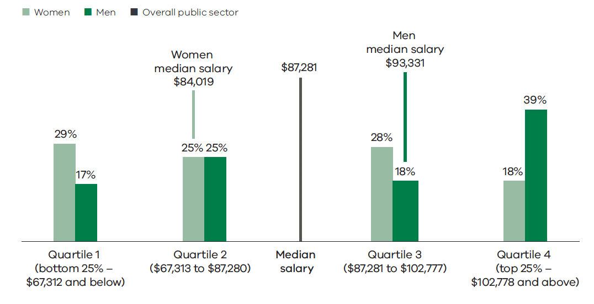Source: Workforce Data Collection 2019Median salaries – Victorian Public Service workforce
Men | Women | Pay gap
$92,009 | $87,789 | 4.6%
Source: Workforce Data Collection 2019
The overall gender pay gap in the public service widened to 4.6% at June 2019, up from 3.3% in June 2018. This was primarily due to the impact of the inclusion of staff from VicRoads and Public Transport Victoria (PTV). The incoming VicRoads and PTV staff tend to be paid higher up the salary scale and the majority are men.
As for the overall public sector, the gap between the median salary of men and women in the public service reflects the different distribution of men and women across classification levels. Women were more likely than men to be employed at classification levels in the lower half of the salary scale (Figure 3.3).
Figure 3.3 Distribution of men and women across the pay quartiles, Victorian Public Service, June 2019
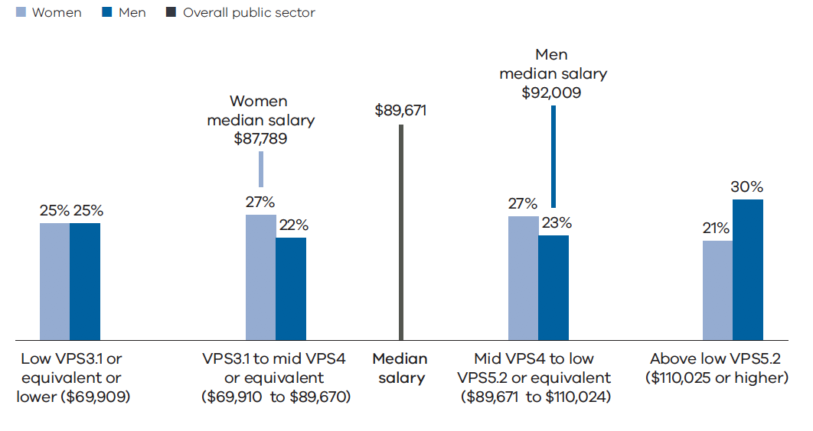Source: Workforce Data Collection 2019
Table 3.15 shows how the proportion of non-executive women employees in the public service declines at each classification level from VPS Grade 2 to VPS Grade 6. Men were significantly under represented at VPS Grade 2, comprising just 26% of employees. Roles at VPS Grade 2 predominantly involve administrative support and process administration. Women have historically filled these roles both in the public service and across the general labour market.
Table 3.15 Distribution of women across Victorian Public Service classifications, June 2019
 | % Women | % Men | Number of staff
VPS Grade 1 | 66% | 34% | 105
VPS Grade 2 | 74% | 26% | 3723
VPS Grade 3 | 67% | 33% | 5660
VPS Grade 4 | 65% | 35% | 6761
VPS Grade 5 | 60% | 40% | 8493
VPS Grade 6 | 52% | 48% | 5573
Senior Technical Specialist | 38% | 62% | 443
Executive | 50% | 50% | 1259

Source: Workforce Data Collection 2019
Public service employees are employed across approximately 100 different classification levels. When gender pay was compared across classification levels, the differences in mean salaries were generally less than 2% or $2000 per year. This is illustrated in Table 3.6 where gender pay gap figures are shown for each of the principal VPS Grade classifications.
Table 3.6 Gender pay gap (based on average salary) across Victorian Public Service classifications, June 2019
 | Average 2019 salary |  | 2019 pay gap |  | 2018 pay gap
 | Women | Men | $ | %
VPS Grade 1 | $46,751 | $46,891 | $140 | 0.3% | 0.7%
VPS Grade 2 | $57,810 | $57,105 | –$705 | –1.2% | –1.5%
VPS Grade 3 | $73,924 | $73,812 | –$112 | –0.2% | –0.3%
VPS Grade 4 | $89,638 | $89,880 | $242 | 0.3% | 0.5%
VPS Grade 5 | $107,221 | $107,825 | $604 | 0.6% | 0.6%
VPS Grade 6 | $140,040 | $142,038 | $1998 | 1.4% | 1.5%
Senior Technical Specialist | $187,546 | $191,848 | $4302 | 2.2% | 3.5%

Source: Workforce Data Collection 2019
- Strengthening senior leadership

Key messages
- Reforms are being implemented in the Victorian Public Service to foster a senior executive service that is capable, mobile, efficient and talented
- A new senior executive service classification structure will support consistent classification of executive positions and clarify performance expectations
- The senior executive service is charged with providing a unified collective leadership group for the public service
- Executive remuneration bands are to be determined by the new Victorian Independent Remuneration TribunalExecutive leadership development initiatives focus on building leadership capability and capacity
- The representation of women in leadership roles is improving, women now comprise more than 50% of the members of major public sector boards and public service executives
- The higher rates of appointment of women executives to entry level executive roles has resulted in a small increase in the overall 2019 pay gap between men and women executives in the public service.
The public sector workforce is led by members of public sector boards and the executive employees of Victorian Public Service and public entity organisations.
Executive employees are essential to the delivery of effective public services and the stewardship of the Victorian public sector. They are accountable for substantial budgets and assets and manage considerable risks. Executives are responsible for delivering a range of outcomes for the Victorian community.
Public sector boards are responsible for the strategic direction, governance and risk management of Victorian public sector entities.
In addition, it is important that Victoria attracts and retains high performing executives and that public sector boards operate effectively.
This chapter discusses the major reform initiatives affecting executive employment across the Victorian public sector and its workforces.

4.1. Reform of executive employment

4.1.1.1 The case for reform
The senior executive reform program currently being implemented is intended to shape an executive workforce for the public sector that is capable, mobile, efficient and talented. It includes the establishment of a Senior Executive Service for the Victorian Public Service based around the consistent classification of senior executive roles across departments and agencies; robust performance management arrangements; and a more comprehensive approach to senior executive leadership development through the Victorian Leadership Academy.
To meet the challenges facing Victoria, the public sector needs high-performing, agile, diverse and collaborative leaders. They must deliver sustainable, high-quality outcomes now and into the future. Leaders need to be equipped to operate in an increasingly complex and changing environment and deliver the Government’s priorities for Victoria.
Senior leaders are collectively responsible for the administration of billions of dollars of state assets, management of substantial budgets and oversight of large workforces. They oversee the delivery of critical policies and services and manage considerable risk. Their performance has a significant effect on the success of organisations. Senior leaders influence the appointment of subsequent leaders. They also influence the culture of organisations through personal values and leadership decisions.
The Victorian community has high expectations of the public sector. Senior leaders must be innovative and accountable. They need to demonstrate integrity and responsibility and must collaborate with other leaders and stakeholders.
In 2015, the Victorian Public Sector Commission commenced a series of comprehensive reviews of employment and remuneration arrangements applying to senior leaders.
The reviews, which were completed in 2018, found limitations with respect to public service executive employment that included:
- the Executive Officer classification and remuneration framework was uncompetitive with other jurisdictions. Arrangements lacked transparency, resulting in inconsistencies in remuneration across departments and agencies
- Victoria’s executive employment offer did not sufficiently incentivise internal candidates to move into Executive Officer roles
- there was limited oversight of the executive workforce as a whole
- performance management needed strengthening to create clear accountabilities for executives.
To address these issues, a number of reforms are being implemented, including:
- improving employment terms to make Victoria’s executive offer more competitive
- creating a new framework for classifying public service executives based on work value
- creating a new performance management framework for senior executives
- more systematic oversight and governance of the senior executive workforce, including a single point of oversight for significant remuneration decisions by the recently established Victorian Independent Remuneration Tribunal and analysis of public sector senior executive employment trends.

4.1.2. Reforms now in place

4.1.2.1 Removing limits on the size and composition of the public service executive workforce
Limits on the number of people who could be employed as executives were imposed on public service organisations between 2000 and 2016. During this period successive governments expanded the activities and services provided by the public service. As a result, public service employee numbers increased from approximately 26,000 at June 2000 to 39,807 at June 2016. Over the same time, executive numbers only increased from 560 to 691. Executives fell from comprising 2.2% of the public service workforce to 1.7%.
Since the limits were removed, public service executive numbers have increased. This reflects the demand for leaders to deliver programs, services and major projects. In addition, machinery of government changes in 2018–2019 saw 90 VicRoads and Public Transport Development Corporation (Public Transport Victoria) executives now being counted in overall public service numbers. These senior executives transferred from the broader public sector into the Department of Transport and the Major Transport Infrastructure Authority.
As at July 2019 the number of public service executives had increased to 1259.
Table 4.1 Executive employment by year 2016 to 2019
 | 2016 | 2017 | 2018 | 2019
Number of executives | 691 | 853 | 1025 | 1259
Percentage of Victorian Public Service workforce (headcount) | 1.7% | 2.0% | 2.2% | 2.5%

Source: Executive and Workforce Data Collections 2016–2019
Note The reported growth from 2018 to 2019 includes the transfer of 90 executives from the public sector agencies VicRoads and Public Transport Victoria, to the public service agencies Major Transport Infrastructure Authority and Department of Transport.

4.1.2.2 Addressing the gender imbalance in executive roles
Increasing women’s participation in the workforce and in leadership roles has positive impacts on organisational culture and promotes social and economic equality. A diverse and inclusive workforce creates benefits including efficiency, productivity, innovation and creativity. It improves employee engagement. Diversity spurs effort and motivation, leading to improved decision-making. International evidence shows a broad range of positive performance impacts from greater female representation on governing boards and in leadership positions.
Additional benefits include:
- Enhanced ability to attract talent. Workplaces that are equally appealing to women and men have access to a larger talent pool
- Enhanced ability to retain staff. Policies that support gender equality are an important tool to retain talented employees
- Enhanced reputation. High performing employees are attracted to organisations that promote gender equality.
To achieve gender equality in executive roles, in 2016 the Government established a target of 50% of executive appointments in the Victorian Public Service to be women. The target was set under Safe and Strong - A Victorian Gender Equality Strategy.

Performance against the target that 50% of Victorian Public Service executive appointments are to be women
For the period July 2018 to June 2019 women comprised 50% of executive appointments in the Victorian Public Service.
Executive appointments include:
- people appointed to an executive role for the first time
- existing executives who were appointed to an executive role with a new public service agency
- existing executives who were appointed to a higher classification with their existing public service agency.

Over the 2018–2019 year there was a further small increase in the proportion of executives who are women in both public service and public entity employers. In the public sector as a whole, women now comprise 46.6% of executives. This is up from 44.7% at June 2018. Within the public service, women now comprise the majority of public service executives – 50.04% at July 2019. This is up from 49.6% in 2018. In public entities the proportion of executives who are women is 42.6%. This has increased from 41% in 2018.
Figure 4.1 Percentage of executives who are women, June 2014 – June 2019
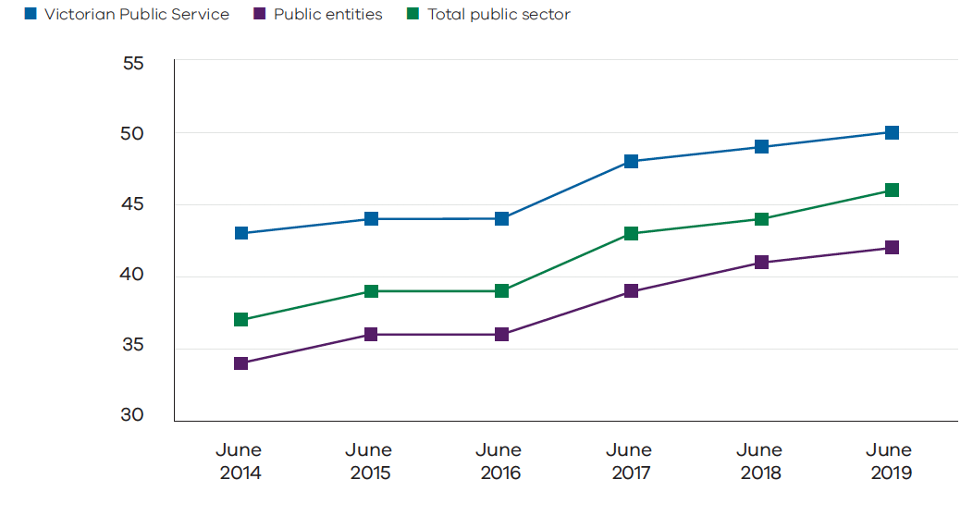Source: Executive Data Collection and Public Entity Executive Remuneration Survey 2014 to 2019Executive gender pay gap
Gender pay gaps, expressed as a simple difference in median remuneration, exist at the executive level in the public sector. As at June 2019, the pay gap for all public sector executives was 5.5% ($12,904). The pay gap was higher for public service executives (7.1%) than for executives in public entities (2.6%).
For public entity executives the pay gap has been trending down over time, falling from 4.5% as at June 2013 and 2.8% as at June 2018.
Figure 4.2 Median executive remuneration, June 2019
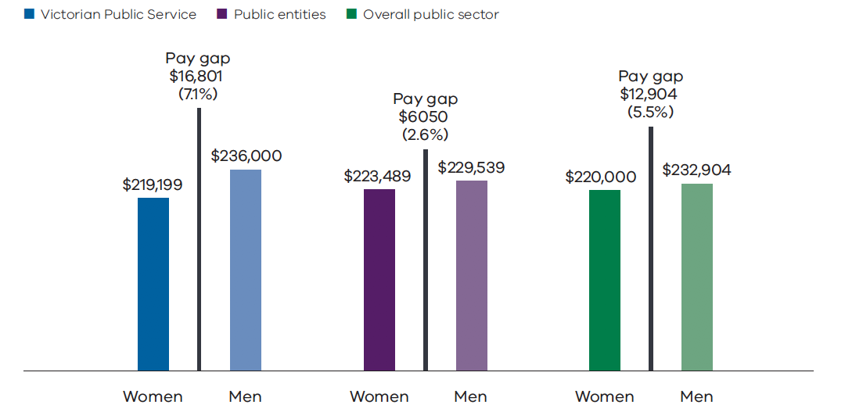
Source: Executive Data Collection and Public Entity Executive Remuneration Survey 2019
The gender pay gap for all public sector executives increased marginally when compared to 2018 (from 4.9% to 5.5%). This is due to the pay gap for public service executives increasing from 6.9% to 7.1%.
This is influenced by the impact of growth in public service executives during the 2018–2019 year, in particular growth in the number of executives at the EO 3 level. The EO 3 level is the lowest level on the executive scale. During 2018–2019 there were 156 women newly appointed as executives in the public service. Of these, 115 (74%) were at EO 3 level.
The proportion of women at the lower end of the remuneration scale increased more than the proportion of men at the lower end. This meant that the median remuneration for women increased by less than the median remuneration of men.
In other words, successful efforts to boost the representation of women in the public service in 2018–2019 contributed to a small increase in the executive gender wage gap, measured in terms of differences in overall median remuneration. All other things being equal, it might be expected that this effect will dissipate over time as newly promoted women executives accumulate experience at the executive level, and hence progress up the executive pay scales.
For public entity executives, the gender pay gap fell from 2.8% in 2018 to 2.6% in 2019. This reduction was principally due to compositional changes with the transfer of 90 executives from the public entities VicRoads and Public Transport Victoria into the public service. The composition of public entity executive population also changed. The threshold for who is to be counted as an executive increased from $162,691 to $182,070, and is explained in Section 4.1.6 below. This meant that 81 women and 95 men were no longer included in executive reporting.
Figure 4.3 shows the distribution of women and men across executive remuneration levels:
- Women and men executives in public entities are similarly distributed across much of the remuneration range, although men are more likely to fill the highest paid positions (remuneration above $340,000)
- Public service women executives are more heavily concentrated at lower classification levels, and therefore the lower end of the remuneration scale. Men are more heavily represented in the remuneration range $270,000 to $330,000 and in the highest paid positions.
Figure 4.3 Distribution of women and men executives by remuneration – public entities and Victorian Public Service

Distribution of executive salary – public entities, June 2019

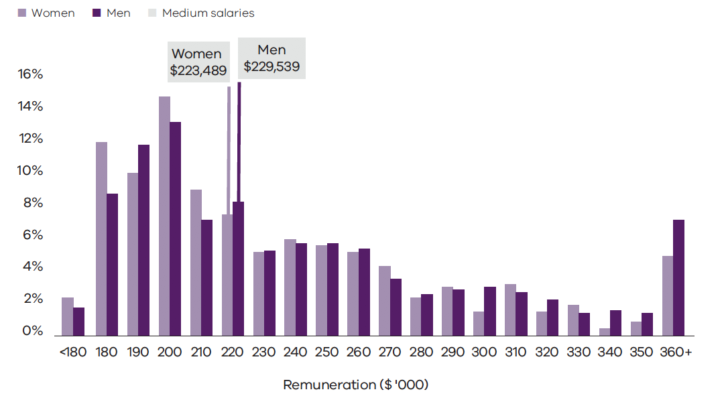Distribution of executive salary – Victorian Public Service, June 2019
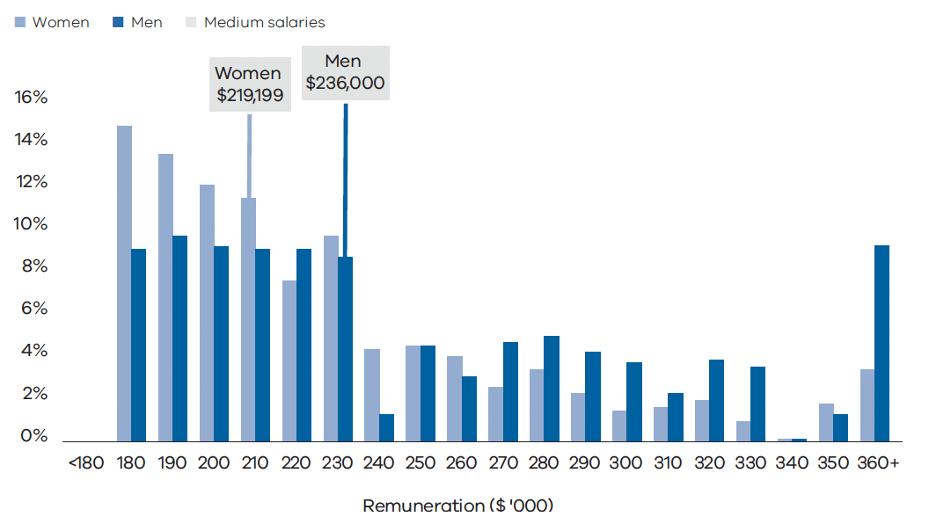Source: Executive Data Collection and Public Entity Executive Remuneration Survey 2019
Differences in the distribution of women and men public service executives across the remuneration range is reflected in the pay gaps at each executive officer level.
Table 4.3 shows that the pay gap as measured by average (mean) remuneration has increased at both EO 1 and EO 2 levels as the number of positions at these levels has increased. The shift in the pay gap at EO 1 is influenced by more women being newly appointed to this level and remunerated at the lower rates applying to newly promoted executives.
Table 4.2 Number of women and men Victorian Public Service executives by executive officer level – June 2018 and June 2019
 | June 2018 |  |  | June 2019
Executive officer level | Women | Men | Total | Women | Men | Total
Secretaries | 2 (29%) | 5 | 7 | 3 (38%) | 5 | 8
EO 1 | 17 (34%) | 33 | 50 | 28 (41%) | 40 | 68
EO 2 | 185 (44%) | 235 | 420 | 215 (44%) | 276 | 491
EO 3 | 304 (55%) | 244 | 548 | 384 (55%) | 308 | 692

Table 4.3 Gender pay gap for Victorian Public Service executives by executive officer level – June 2018 and June 2019
 | Average June 2019 remuneration |  | June 2019 pay gap |  | June 2018 pay gap
Executive officer level | Women executives | Men executives | $ | % | %
EO 1 | $369,384 | $416,131 | $46,747 | 11.2% | 4.4%
EO 2 | $268,196 | $294,081 | $25,885 | 8.8% | 6.2%
EO 3 | $204,176 | $207,016 | $2840 | 1.4% | 1.4%

Perceptions of gender equality amongst executive employees
Women and men both recorded positive responses to People Matter Survey questions relating to gender equality in employment, opportunities for career development and respect (Table 4.4). Agreement rates were around 90% for public service and public entity executives. Almost all women and men in public entities agreed that gender identity was not a barrier to success in their organisations. While the rate of agreement among women and men in the public service was still very high (at 88% for both groups), it was noticeably lower than agreement rates in public entities, which were approaching 100%. This suggests that there is still some scope for the public service to intensify its efforts to address perceptions that gender identity can be a barrier to success.
Table 4.4 Executive percentage agreement with equal opportunity, career development and respect questions by gender, 2019
 | Victorian Public Service |  | Public entities
 | Men | Women | Men | Women
Equal employment opportunity

Gender identity is not a barrier to success in my organisation | 88% | 88% | 96% | 98%
There is a positive culture within my organisation in relation to employees of different sexes/genders | 92% | 96% | 94% | 97%
Career development

My manager encourages and supports my participation in learning and development opportunities | 89% | 89% | 91% | 86%
There are adequate opportunities for me to develop skills and experience in my organisation | 84% | 88% | 90% | 87%
How satisfied are you with your career development within your current organisation? | 79% | 82% | 85% | 88%
Respect

I have the authority to do my job effectively | 90% | 89% | 93% | 94%
My manager involves me in decisions about my work | 93% | 91% | 91% | 90%
My manager listens to what I have to say | 94% | 96% | 97% | 95%
My manager keeps me informed about what's going on | 91% | 91% | 92% | 88%
My manager treats employees with dignity and respect | 94% | 95% | 94% | 92%
I receive adequate recognition for my contributions and accomplishments | 83% | 82% | 83% | 83%

Source: People Matter Survey 2019

4.1.3. Establishment of the Victorian Independent Remuneration Tribunal
The Victorian Independent Remuneration Tribunal was established in March 2019 under the Victorian Independent Remuneration Tribunal and Improving Parliamentary Standards Act 2019. It will determine remuneration bands for executives across the public sector. It must act independently and impartially. The tribunal brings Victoria into line with several other jurisdictions in Australia.
The establishment of the tribunal has provided an avenue to address a key recommendation of the Victorian Public Sector Commission’s executive employment and remuneration review. In particular, the review recommended that there should be systematic and strategic oversight and governance of the executive workforce. This included a single point of oversight for remuneration decisions and the analysis of sector employment trends.
The tribunal will issue substantive executive remuneration determinations every four years. The first will relate to public service bodies and, when made, will take effect from September 2019. A determination on executive remuneration in public entities will take effect from March 2020. The determinations must include a comprehensive review of the roles of executives and existing remuneration.
The tribunal must also consider:
- any Victorian Government wage statement or policy
- alignment with the Executive Classification Framework for public service executives
- Victoria’s financial position and strategy
- current and projected economic conditions and trends.

4.1.4. Implementing a new Executive Classification Framework
A new Executive Classification Framework for the Victorian Public Service was approved by the Victorian Secretaries Board in September 2018. The new classification framework promotes consistency, fairness and objectivity in assessing classification of executive roles.
The framework provides clarity on the expectations of executives at different levels. It sets a consistent methodology for classifying all public service executive positions into one of three bands.
It incorporates a change in terminology for executive bands from Executive Officer to Senior Executive Service (SES) and applies a standard position titles model. The EO 3 level has become SES 1 (Director), EO 2 has become SES 2 (Executive Director), EO 1 has become SES 3 (Deputy Secretary).
The new framework uses a rigorous work value assessment methodology. Executive positions are assessed using standards that recognise differences in complexity and responsibility across three executive bands. These are:
- knowledge
- relationships
- judgement and risk
- independence
- strategic change
- breadth
- impact
- resource management.
To support implementation of this framework, the Victorian Public Sector Commission:
- has published the framework and associated resources on its website
- is providing executive classification assessment services for Victorian Public Service agencies through a fee for service model
- is uplifting public service human resource capability to complete assessments in the long term.
The framework is expected to be fully implemented in the public service by December 2020.

4.1.5. Performance Management Framework
A new Performance Management Framework for executives in the Victorian Public Service was endorsed by the Victorian Secretaries Board in September 2018. The framework outlines foundational principles to drive high performance and support career development, where outcomes and expectations align with organisational and government priorities, public sector values and leadership capabilities.
To support the implementation of this framework, the Victorian Public Sector Commission has published the framework and resources on its website.
Executives are more likely to be high performing in workplaces that show strong organisational principles and focus on achieving objectives.

4.1.6. Implementation of executive employment reforms in public entities
The Victorian Public Sector Commission’s executive employment and remuneration reviews identified several issues related to executive employment in public entities.
Reforms implemented to date include:
- The publication of a Public Entity Executive Employment Handbook. In October 2018, the Victorian Public Sector Commission accepted a recommendation from the Victorian Ombudsman to develop an executive employment handbook for public sector executives, drawing on the approach adopted in the existing Victorian Public Service Executive Employment Handbook. In early 2019, the VPS undertook a program of consultation and developed a new public entity executive employment handbook that was published in July 2019. The handbook promotes executive employment arrangements across the public sector that are consistent and transparent, to ensure appropriate use of public funds and the minimisation of integrity risks. It also assists public entities to manage employment contracts, remuneration, and employment matters relating to executives.
- A simplified definition of a public entity executive has also been adopted: The Chief Executive Officer of a public entity; or an employee of any public entity who receives a Total Remuneration Package equal to or greater than the base of the Victorian Public Service executive remuneration range and has significant management responsibility (the primary role of the employee is to provide leadership and strategic direction for other staff members).
The revised definition has lifted the remuneration threshold for an employee to be considered an executive from $162,691 to $182,070. This has meant that the number of people reported as public entity executives fell by 176 between 2018 to 2019 (comprising 95 men and 81 women). This has not had a material impact on the percentage of public entity executives who are women, or on the gender pay gap for public entity executives.

4.2. Victorian Leadership Academy
The Victorian Leadership Academy (the academy) was established in 2016 to address leadership challenges faced by public service executives. It replaced the former Victorian Leadership Development Centre.
The academy focuses on fostering the development of capabilities that enable leaders to think, lead and work differently in delivering services that meet the needs of Victorians.
The programs and activities of the academy are building capacity in executive leaders to provide contemporary and effective leadership. Among other things, they also seek to strengthen the capabilities of senior executives to use data and technology, shape policies, and make decisions that help solve the problems faced by Victorians.
The academy supports the work of the Victorian Secretaries Board. Programs and activities help to connect leaders as a united public service, working together as one Victorian Public Service.
The academy’s objectives are to:
- convene the Senior Executive Service as a collective leadership group
- support a mindset of collective accountability to further develop a modern and agile public service
- equip executives with the skills, knowledge and confidence to drive change across boundaries
- connect leadership development to the new work of the public service.
To meet these objectives, the academy has developed a suite of executive programs. All programs have been shaped by executives through their participation in extensive ‘discovery’ processes that identify the capabilities they are seeking to build.
The Director program focuses on fostering talent and building capability, continuous improvement and collaboration. Each capability is essential to develop a future-focused, flexible and professional public service. Over twelve months, executives undertake development activities that include online insight tools, coaching, facilitated peer group support and workshops.
Executive Director development focuses on advanced leadership and intensive core capability building. Executive Directors repeat the on-line insight tools of the Director program, participate in one on one coaching and attend facilitated peer group exchanges and workshops. In a further stage of the program they address stewardship, performance and people pillars.
For example, Executive Directors have considered their specific development needs to inform the programs to be delivered by the academy. A series of core public sector ‘general management’ capabilities have been identified as critical to their performance along with an expanded set of leadership and change capabilities.
Deputy Secretary development focuses on the establishment of the Senior Executive Service as a collective leadership body with a focus on whole of Victorian government challenges and initiatives.
Figure 4.4 E0 3/SES 1 Director Program
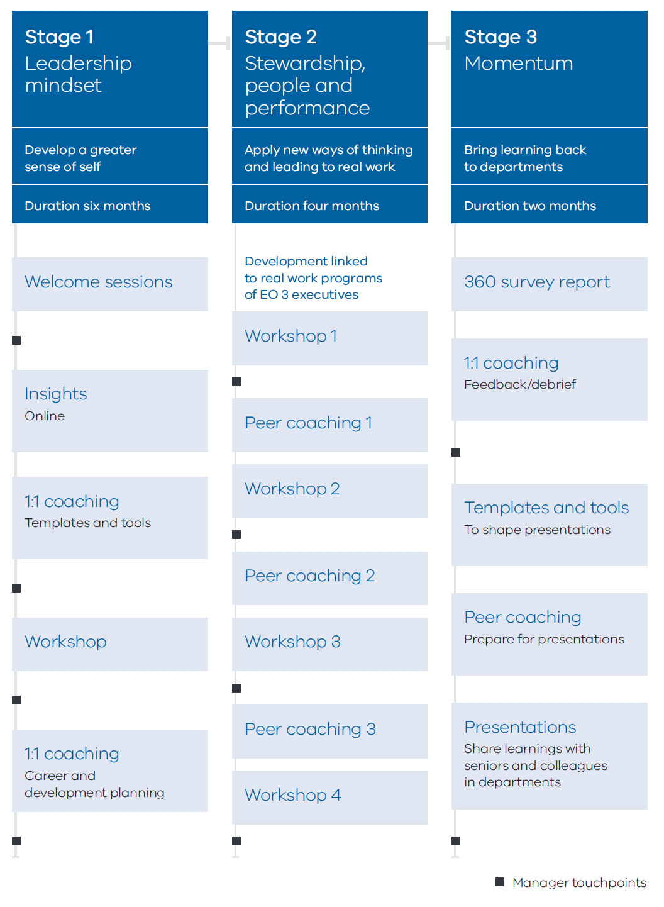

Program delivery in 2018–2019
Following the establishment of a new academy program for executives at the Director level in September 2018, the academy is now delivering leadership programs and activities for all three executive levels.
The Director program had an intake of 176 executives. Over 100 Executive Directors completed coaching and mentoring development in support of their direct reports who were also attending the program. The Executive Director program commenced mid-2019 and had an intake of 130 executives. There are also around 80 executives participating in the Deputy Secretary program.“The program gave me peace. It made me realise I was content where I was at in my role and that I didn’t feel the need to be seeking a promotion which is what I had previously been thinking.”
“The VLA program is well-paced with a good mix of theory and practice delivered by a good quality faculty (incl. facilitators and coaches) supported by strong cohort interaction. The program challenged me to think differently and apply that difference back in the workplace.”
“The sustained development approach by VLA is efficient and effective, attending the program over 12 months. I found great value in the assessments and coaching, the lessons and case studies, and the real work application.”
“The VLA has helped me to mature as a leader with enhanced capability and agility. I am confident of my ability to optimise team performance through the advanced techniques and methods that I learned and applied.”
 | % agreement | % neutral or disagreement
Overall participant satisfaction with the EO 3/SES 1 Director Leadership Development Program | 83% | 17%

Note
The analysis consists of the average response rated by participants in the EO 3/SES 1 Leadership Development Program.
The analysis is based on voluntary responses from 167 participating EO 3/SES 1 executives as at December 2019 and demonstrates the percentage of EO 3/SES 1 that have either agreed or strongly agreed to the statement ‘was a valuable part of your leadership journey’ in workshop feedback sheets.

4.3. Public sector boards
Public sector boards play an essential role in overseeing the delivery of a range of important functions including service delivery, asset management and stewardship, regulation, specialist advice and local-level governance. They are responsible for the strategic direction, governance and risk management of Victorian public sector entities.
At June 2019, the Victorian Government had 3503 public sector boards with 31,803 members. The vast majority of members (81%) contribute their time on an unpaid voluntary basis.
Public sector boards include boards of governance of public entities and advisory bodies established to provide expert advice to the Government or to deliberate on technical standards or issues on behalf of Government. They comprise members appointed by the Government in accordance with the entity’s establishing legislation or constitution.
The Appointment and Remuneration Guidelines for public sector boards issued by the Department of Premier and Cabinet state that, “Appointments to Victorian Government entities should as far as practicable, reflect the diversity of the Victorian Community.”
Research suggests that diverse and inclusive workplaces and boards are more productive and better at problem solving. They are more creative and resilient in the face of economic downturns. Diversifying the backgrounds, skillsets and experiences of board members also has financial benefits.

4.3.1. Women on boards
Traditionally, women have been under-represented on public sector boards in Victoria. In March 2015, the Government implemented a target that 50% of all new appointments to major boards should be women. From 2015 to June 2019, the percentage of major board members who identify as women increased from 39% to 54%.

Women’s representation on major boards
Table 4.5 shows the percentage of members of major boards who identify as women by portfolio grouping over time. It shows improvements in women’s representation in most portfolios, however women remain under-represented in the Agriculture, Resources, Racing and Assistant Treasurer portfolios. At the same time women are over represented in several portfolios, such as Disability, Ageing and Carers, Workplace Safety, Youth Justice and Special Minister of State.
Table 4.5 Percentage of major board members who are women by portfolio
Portfolio | 2015 | 2016 | 2017 | 2018 | 2019
Department of Education and Training

Education (excluding school councils) | 54% | 55% | 57% | 57% | 57%
Training and Skills | 53% | 55% | 63% | 62% | 61%
Department of Environment, Land, Water and Planning

Energy, Environment and Climate Change | 29% | 41% | 47% | 52% | 56%
Local Government | 50% | 50% | 50% | 50% | 50%
Planning | 31% | 36% | 42% | 46% | 46%
Water | 36% | 50% | 51% | 55% | 55%
Department of Health and Human Services

Ambulance Services | 0% | 44% | 44% | 44% | 44%
Cemeteries | 49% | 47% | 45% | 48% | 54%
Child Protection | 48% | 67% | 70% | 65% | 57%
Disability, Ageing, and Carers | 43% | 43% | 61% | 67% | 67%
Families and Children | 65% | 74% | 83% | 71%
Health | 44% | 50% | 52% | 54% | 56%
Mental Health | 56% | 57% | 58% | 56% | 57%
Department of Jobs, Precincts and Regions

Agriculture | 35% | 45% | 44% | 42% | 45%
Creative Industries | 38% | 51% | 56% | 55% | 53%
Jobs, Innovation and Trade | 42% | 47% | 49% | 50% | 50%
Priority Precincts | 33% | 40% | 43% | 50% | 57%
Racing | 19% | 38% | 44% | 44% | 33%
Regional Development⁴² |  |  | 53% | 53% | 53%
Resources | 26% | 42% | 41% | 44% | 40%
Small Business | 23% | 52% | 54% | 50% | 56%
Suburban Development⁴² |  |  | 56% | 51% | 55%
Tourism, Sport and Major Events | 35% | 41% | 49% | 48% | 48%
Department of Justice and Community Safety

Attorney General | 36% | 52% | 54% | 55% | 55%
Consumer Affairs, Gaming and Liquor Regulation | 41% | 46% | 54% | 49% | 49%
Corrections | 40% | 38% | 42% | 52% | 56%
Police and Emergency Services | 35% | 47% | 56% | 59% | 61%
Workplace Safety | 63% | 63% | 67% | 70% | 67%
Youth Justice | 57% | 67% | 50% | 63% | 71%
Department of Premier and Cabinet

Aboriginal Affairs | 38% | 44% | 50% | 50% | 63%
Industrial Relations | 33% | 29% | 28% | 48% | 47%
Multicultural Affairs | 47% | 48% | 47% | 47% | 47%
Premier | 33% | 33% | 44% | 45% | 43%
Special Minister of State | 50% | 69% | 71% | 71% | 80%
Veterans | 30% | 32% | 41% | 44% | 53%
Women | 100% | 100% | 100% | 100% | 100%
Department of Transport

Fishing and Boating | 10% | 14% | 50% | 48% | 52%
Ports⁴² | 0% | 46% | 86%
Ports and Freight | 25% | 36% | 45% | 53% | 50%
Public Transport | 25% | 39% | 47% | 63% | 63%
Road Safety and TAC | 20% | 17% | 50% | 63% | 57%
Roads42 | 5% | 12% | 47% | 50%
Department of Treasury and Finance

Assistant Treasurer | 34% | 48% | 46% | 46% | 44%
Treasurer | 26% | 44% | 48% | 63% | 64%
Total | 39% | 48% | 52% | 53% | 54%

Women’s representation on all boards
When small cemetery trusts, small rural hospitals, small Crown land committees of management and most advisory boards are included in the gender representation figures, only 38% of board members were women at June 2019, up only slightly from 36% at June 2018.
Women’s representation is lowest in small Crown land committees of management and cemetery trust boards (35% and 28% respectively). Since 2015, the percentage of women on cemetery trusts has increased from 23% to 28%, but for Crown land committees of management the percentage of women members has remained at 35%.
The small growth in women’s representation across all boards is heavily influenced by cemetery trusts and Crown land committees of management. The low level of women’s representation and lack of change over time for these boards should be considered in the context that in both cases there are a large number of boards (1555) and board members (10,251). The vast majority of these boards administer small assets and do not employ staff. They are predominately based in rural areas. Members are nominated from within the local communities or are long-term appointees.

4.3.2. Diversity groups
In 2018, the Appointment and Remuneration Guidelines for public sector boards, required boards to explore opportunities to appoint Aboriginal people, people with disability, people from culturally and linguistically diverse backgrounds (CALD), and LGBTIQ people. The Office for Disability began the People with disability on Victorian public sector boards initiative in 2019. It aims to shift attitudes and remove barriers so people with disability are appointed to boards.
At June 2019 diversity group representation on major boards was:
Aboriginal | 1.3%
Disability | 0.9%
CALD | 19%

4.4. Profile of executives

Number of executives employed at June 2019

2371 total executives comprising:
Victorian Public Service  (2.5% of workforce) | Public entities (0.4% of workforce)
1259 | 1112

Victorian Public Service and public entity executives by gender, June 2019
 |  | Number | %
Victorian Public Service | Women | 629 | 50.0%
 | Men | 630 | 50.0%
Public entities | Women | 638 | 57.4%
 | Men | 474 | 42.6%
Overall public sector | Women | 1267 | 53.4%
 | Men | 1104 | 46.6%

Part time employment among Victorian Public Service and public entity executives, June 2019
Victorian Public Service | 7.8%
Public entities | 3.1%
Overall public sector | 5.6%

Victorian Public Service and public entity executives by age, June 2019
 | 25–34 | 35–44 | 45–54 | 55–64 | 65+
Victorian Public Service | 2.8% | 35.0% | 42.2% | 19.1% | 0.9%
Public entities | 1.5% | 22.3% | 40.7% | 31.7% | 3.8%
Overall public sector | 2.2% | 29.1% | 41.5% | 25.0% | 2.2%

Source: Executive Data Collection and Public Entity Executive Remuneration Survey 2019

Percentage of executives identifying with diversity group, 2019
 | Aboriginal and/or Torres Strait Islander | With disability | Culturally and linguistically diverse | LGBTIQ
Victorian Public Service | 1.3% | 3% | 19% | 8%
Public entities | 0.7% | 2% | 29% | 3%
Overall public sector | 1.0% | 3% | 23% | 6%

Source: People Matter Survey 2019
Victorian Public Service and public entity executives remuneration distribution, June 2019
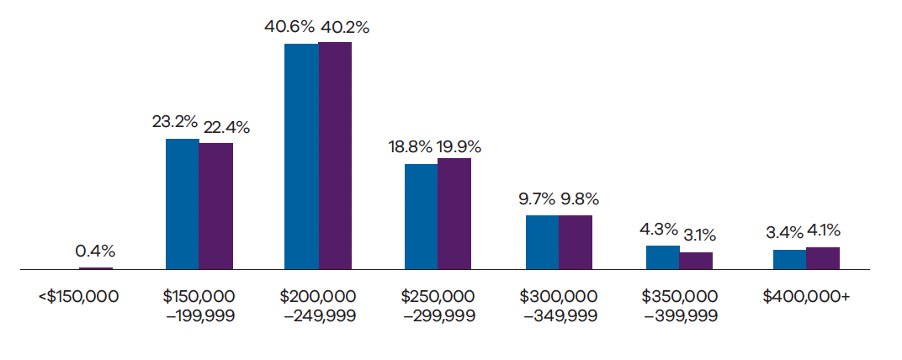
Source: Executive Data Collection and Public Entity Executive Remuneration Survey 2019

Executive recruitment and turnover, 2018–2019

Victorian Public Service
Existing executives moving to another Victorian Public Service organisation (excluding machinery of government changes) | New executives | Departing executives
71 | 314 | 146

Public entities
New executives | Departing | executives
233 | 195
Source: Executive Data Collection and Public Entity Executive Remuneration Survey 2019

4.5. Profile of board members

Gender, June 2019
 | Men | Women
Major boards | 46% | 54%
All boards | 62% | 38%

Source: GAPED Database

Age distribution – all boards, June 2019
<35 | 35–44 | 45–54 | 55–64 | 65+
3% | 10% | 17% | 28% | 42%

Source: GAPED Database

Percentage of board members by diversity group location and volunteer status, June 2019
Aboriginal and/ or Torres Strait Islander | 1.3%
Culturally and linguistically diverse | 19%
Rural | 77%
Volunteer | 81%

Source: People Matter Survey 2019
.
- Workplace mental health and wellbeing

Key points
- Levels of high to severe stress have remained almost unchanged over the last four years
- Stress is typically driven by workload and time pressureHigh levels of stress can make employees feel miserable at work
- Stress and its consequences affect some employee groups more than othersHigher levels of job control, manager support and more meaningful work can help manage stress and its negative consequences.
Poor mental health has replaced musculoskeletal problems as the main cause of work absence and long term work incapacity in almost all developed countries.
Poor mental health can have significant impacts for individuals, their families and friends, and has considerable economic and social costs.
In Victorian workplaces, the rate of mental health related compensation claims is increasing. In 2018, 13% of standard claims were for mental injury. This is expected to increase by 34% by 2030. As at August 2019, the average mental injury claim costs $125,000. In comparison, the average physical injury claim costs was $72,000.
Victorian workers suffering from mental injuries also take longer to return to work. Two years after their mental injury, 38% have not returned to work.
Acknowledging the influence that workplace culture and experiences have on mental health, the People Matter Survey has begun to construct a picture of the wellbeing of the Victorian public sector workforce. Since 2016 the People Matter Survey has asked respondents to rate their current level of work-related stress. Building upon this, the 2019 survey introduced questions on how often work triggers positive and negative emotions (happy, enthusiastic, worried and miserable).
This chapter explores the levels of employee wellbeing and work-related stress reported by Victorian public sector employees.

5.1. Improving communication on mental health and wellbeing
To manage work-related stress, employers need to communicate and educate consistently and frequently on mental health and wellbeing and look for ways to open up the discussion and normalise such conversations. That means creating an environment where staff at all levels are open about their mental health and wellbeing issues, know what support is available to them, feel they belong, and that they are making a valued contribution.
The 2019 People Matter Survey results suggest that there is still considerable scope for many senior leaders to improve communication on mental health and wellbeing. Table 5.1 shows that, across the Victorian public sector as a whole, just 51% of respondents considered there was good communication about psychological safety issues in their workplaces. Moreover, only 43% of respondents believe that senior leaders consider the psychological health of employees to be as important as productivity.
Table 5.1 Percentage agreement with questions on communication and priority given to psychological safety by industry group, 2019
 | In my workplace, there is good communication about psychological safety issues that affect me | Senior leaders consider the psychological health of employees to be as important as productivity
Water and land management | 61% | 54%
Police and emergency services | 59% | 43%
Public health care | 52% | 45%
Victorian Public Service | 49% | 41%
Creative industries, finance, transport and other | 45% | 40%
TAFE and other education | 42% | 36%
Overall public sector | 51% | 43%

Source: People Matter Survey 2019
Leaders play a critical role in supporting their employees’ wellbeing. They can shape organisational culture. Table 5.2 shows notable differences between the perceptions of senior managers (managers of managers) and other staff on how effectively senior leaders support stress prevention or consider the psychological health of employees. Across the public sector, non-senior managers’ responses were least positive about senior leaders’ commitment to stress prevention and ensuring the psychological health of employees.
Table 5.2 Percentage agreement with questions on how senior leaders support psychological safety by manager status, 2019
 | Non-manager | Manager (exc. manager of manager) | Manager of manager
Senior leaders consider the psychological health of employees to be as important as productivity | 43% | 42% | 56%
Senior leaders show support for stress prevention through involvement and commitment | 41% | 40% | 55%

Source: People Matter Survey 2019

5.1.1. One in five public sector employees experience high to severe work-related stress
Research shows stress affects health and wellbeing. High levels of stress have a negative impact on the ability to perform tasks. The relationship between stress and performance is mediated by task complexity, individual differences, and the characteristics of the work environment.The 2019 People Matter Survey asked respondents to rate their ‘current level’ of work-related stress. More than one in five respondents indicated that they experienced high (14%), very high (6%) or severe (2%) levels of stress. This level has remained broadly unchanged over the last four years (Figure 5.1).
Figure 5.1 Incidence of high to severe work-related stress, 2016 to 2019
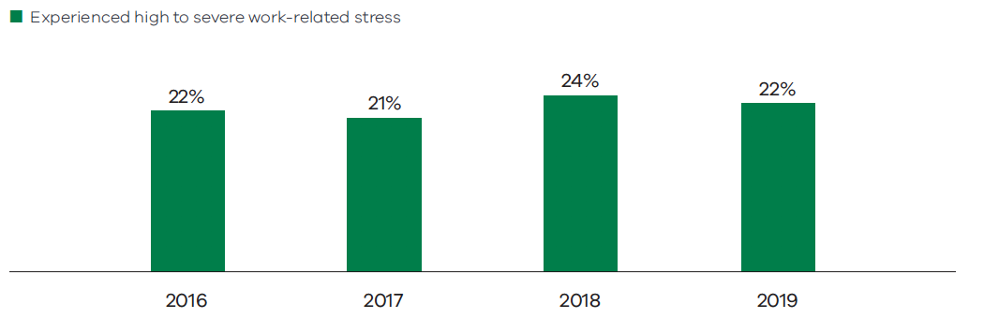 Source: People Matter Survey 2019
Figure 5.2 shows that the incidence of high to severe stress is reported as more common in some public sector industry categories. High to severe stress is common in TAFE and other education organisations, and among people with management responsibilities or higher salary levels.Figure 5.2 also shows results for groups where high to severe stress is higher than the average for the public sector (22%). Almost three in ten police sergeants and senior sergeants reported experiencing high to severe stress. Just over one in four medical employees also reported experiencing higher stress levels. TAFE teachers reported the highest incidence – more than one-third experience high to severe stress levels.
Figure 5.2 Incidence of high to severe work-related stress by employee groups, 2019
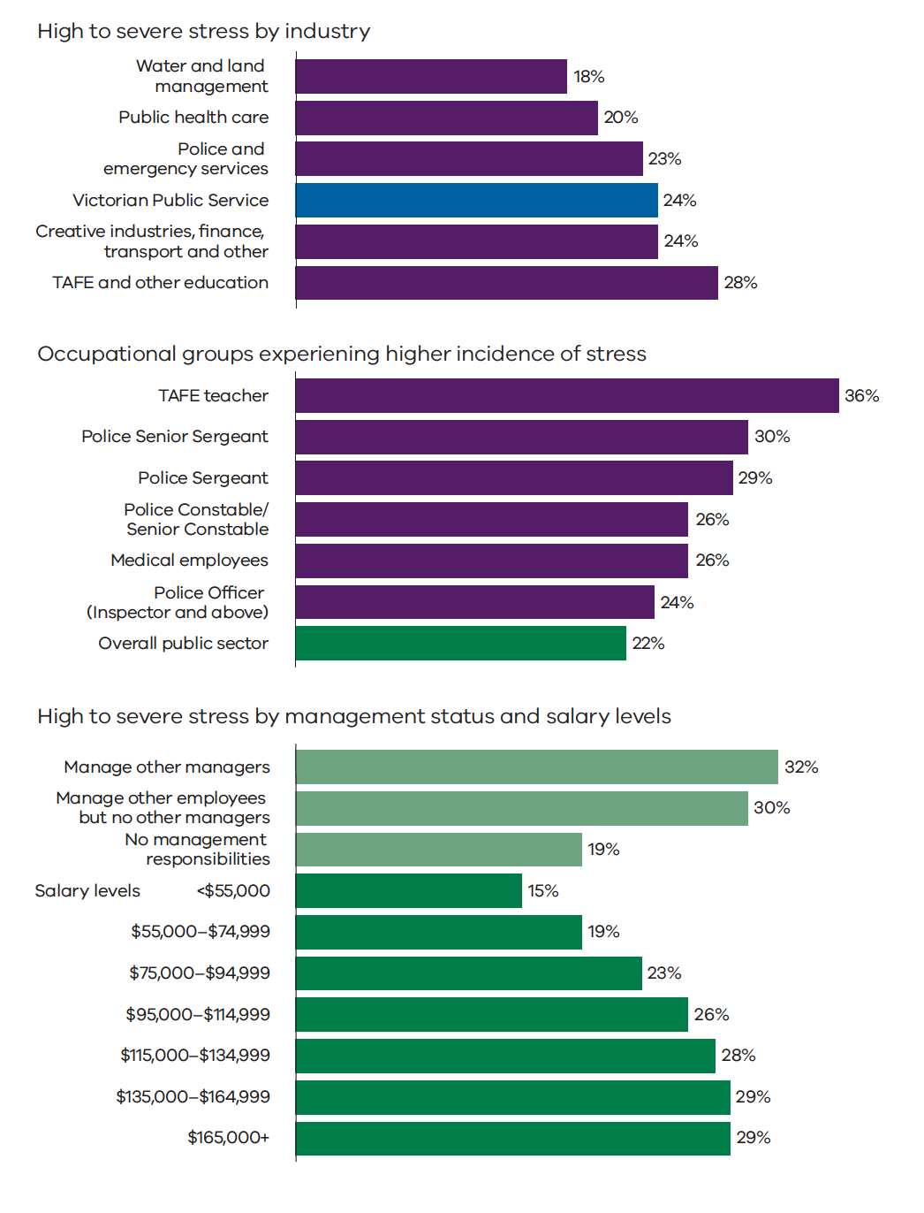
Source: People Matter Survey 2019
High to severe stress correlates with employee opinions on their organisation’s procedures to support stressed staff. It also correlates with perceptions of the involvement of senior leaders and different organisation levels in stress prevention.
In 2019, only 61% of respondents considered that their organisation had effective procedures to support employees experiencing stress (Table 5.3). Even lower proportions of respondents considered that their senior leaders showed support for stress prevention (42%) or that all levels of the organisation helped to prevent stress (39%).

Road to wellness
The State of the Public Sector in Victoria 2017–2018 report provided an overview of Victoria Police’s Mental Health and Wellbeing Strategy and Action Plan 2017–2020. Victoria Police have continued to progress this strategy and it is of note that their 2019 People Matter Survey showed a 12 percentage point increase in agreement to the question “In my workplace, there is good communication about psychological safety issues that affect me”, increasing from 42% agreement in 2017 to 54% agreement in 2019.

The proportion of respondents who agree or strongly agree that their organisation effectively manages stress is low in the TAFE and other education industry, where the incidence of stress is high. In the Water and land management industry, where overall stress incidence is lower, high proportions of respondents agree or strongly agree that their organisation effectively manages stress.
Table 5.3 Percentage agreement with questions on stress support and prevention by industry group, 2019
 | My organisation has effective procedures in place to support employees who may experience stress | Senior leaders show support for stress prevention through involvement and commitment | All levels of my organisation are involved in the prevention of stress
Water and land management | 74% | 52% | 49%
Public health care | 64% | 44% | 41%
Police and emergency services | 57% | 42% | 41%
Victorian Public Service | 57% | 40% | 36%
Creative industries, finance, transport and other | 57% | 38% | 34%
TAFE and other education | 55% | 35% | 32%
Overall public sector | 61% | 42% | 39%

Source: People Matter Survey 2019

5.1.2. Workload is the key driver of stress
In the 2019 People Matter Survey, respondents who reported experiencing work-related stress were also asked to identify its causes. Table 5.4 shows that ‘nature of work and work demands’ was reported by survey respondents experiencing high to severe work-related stress, as the main cause of stress. When asked what aspects of the nature of work caused this stress, respondents indicated that amount of work and time pressure were key drivers.
Table 5.4Causes of stress identified by survey respondents experiencing high to severe stress, 2019
Causes of stress | Proportion of respondents
Relationship/s with supervisor/s | 15%
Incivility, bullying or harassment | 16%
Unclear job expectations | 21%
Organisation or workplace change (e.g. restructure, change of work conditions etc.) | 24%
Level of support from supervisor | 29%
Nature of work and work demands | 71%

Causes of nature of work and work demands related stress | Proportion of respondents reporting nature of work and work demands related stress
Dealing with clients/patients | 10%
Work that doesn't utilise your skills and experience | 11%
Emotional demands of work | 19%
Work demands that conflict with other work demands | 30%
Time pressure | 65%
Amount of work | 71%

Source: People Matter Survey 2019
Further examination (Table 5.5) of People Matter Survey results suggests that workload, manager support, role clarity and negative behaviours are key drivers of stress. Employees in the TAFE and other education industry category reported experiencing higher incidence of stress than colleagues in the Water and land management industry. They also reported experiencing a higher incidence of bullying than counterparts in the Water and land management industry. More details on the reported incidence of bullying across the Victorian public sector are presented in Chapter 6.
Table 5.5 Stress levels and its key drivers by industry group, 2019
 | Experience high to severe stress % | Workload is appropriate for the job (% Agree) | Manager provides enough support during times of high workload (% Agree) | Experience bullying % | Have role clarity (% Agree)
Creative industries, finance, transport and other | 24% | 57% | 66% | 14% | 86%
Police and emergency services | 23% | 57% | 60% | 15% | 83%
Public health care | 20% | 57% | 64% | 15% | 91%
TAFE and other education | 28% | 50% | 61% | 14% | 82%
Water and land management | 18% | 67% | 74% | 8% | 90%
Victorian Public Service | 24% | 56% | 67% | 14% | 83%
Overall public sector | 22% | 57% | 64% | 15% | 87%

Source: People Matter Survey 2019
Table 5.6 below shows the proportion of survey respondents who reported that they experienced high to severe levels of work-related stress and a range of indicators identified as key drivers of stress. The table compares two groups of organisations in the Victorian public sector: those organisations with the lowest rates of reported high to severe stress, and those with the highest rates of high to severe stress.
Table 5.6 shows that organisations that report low rates of high to severe stress tend to be the same organisations that report a higher proportion of respondents who agree or strongly agree that their workload is appropriate, that their manager provides enough support, that they have clarity of their role, and that they experience lower levels of bullying. In contrast, organisations that report higher rates of high to severe stress tend to be the same organisations that report lower agreement rates that their workload is appropriate, that their manager provides enough support, that they have clarity of their role, and that they experience higher levels of bullying.
Table 5.6 Comparison of the key drivers of work-related stress according to the level of high to severe stress reported by staff within organisations, 2019
 | Average organisation result
 | 20% of organisations reporting the lowest levels of high to severe stress | 20% of organisations reporting the highest levels of high to severe stress
Experience high to severe stress % | 9% | 31%
Workload is appropriate for the job (% Agree) | 68% | 51%
Manager provides enough support during times of high workload (% Agree) | 72% | 60%
Experience bullying % | 11% | 17%
Have role clarity (% Agree) | 93% | 83%

Source: People Matter Survey 2019
Figure 5.3 presents the link between stress and its key drivers. Organisations where a higher proportion of staff considered their workload was appropriate, or where managers provided appropriate support, generally reported experiencing a lower incidence of stress.Figure 5.3Association between incidence of high to severe stress and its key drivers, 2019

Workload and incidence of high to severe stress

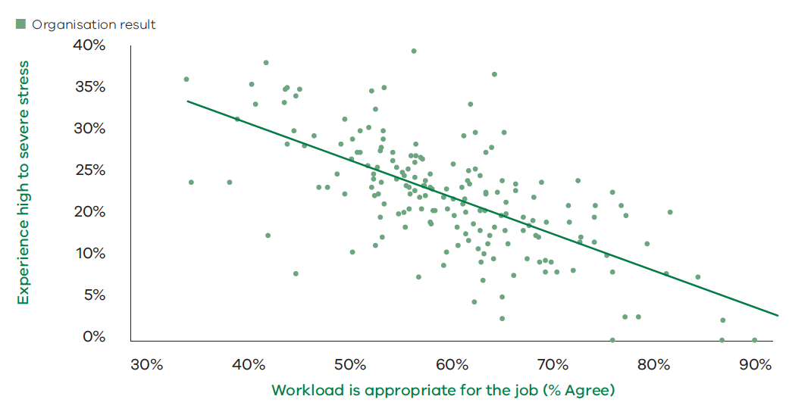Manager support and incidence of high to severe stress
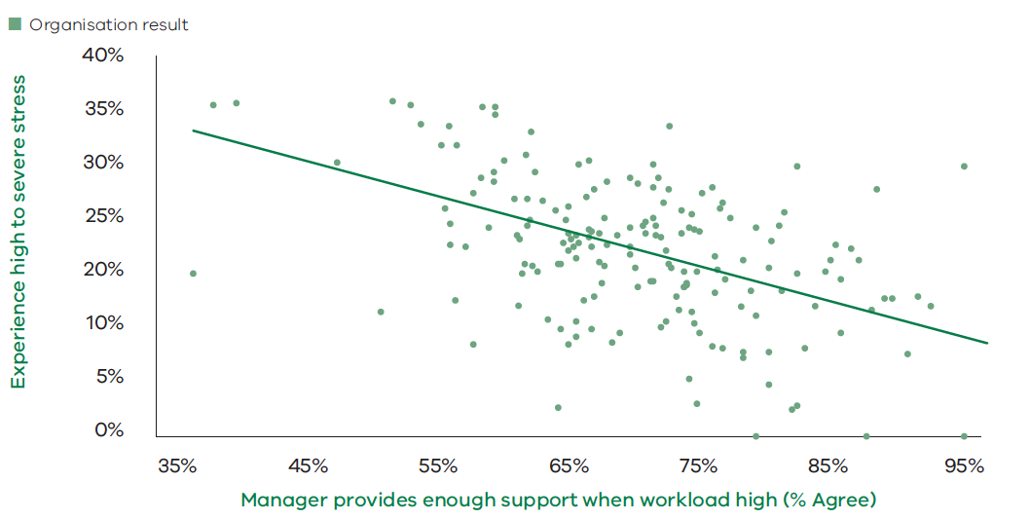Source: People Matter Survey 2019

5.1.3. Highly to severely stressed staff are more likely to report feeling miserable
Survey respondents experiencing high to severe stress are more likely to report that their work makes them feel miserable. Figure 5.4 shows that only 10% of respondents in 2019 experiencing moderate stress levels reported feeling miserable. This incidence of respondents reporting that they felt miserable at work increased to 55% of respondents experiencing very high stress and, further still, to 81% of those reporting severe stress.
Figure 5.4 Proportion of survey respondents feeling often to always miserable, by work-related stress level, 2019
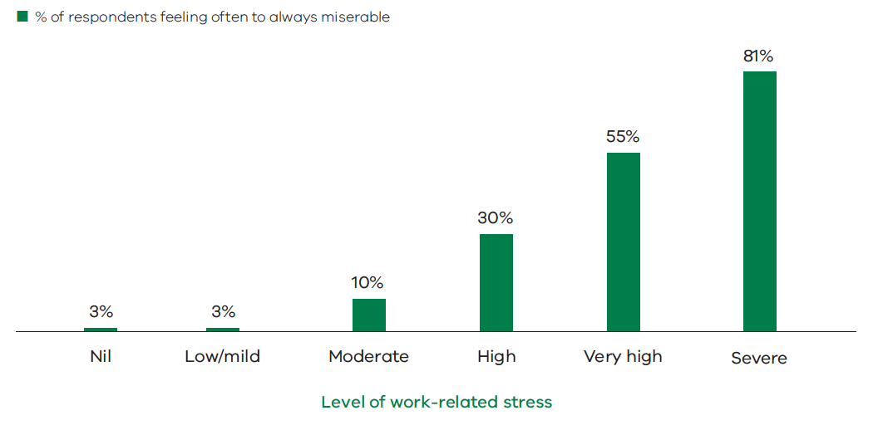Source: People Matter Survey 2019
Some employment factors appear to reduce exposure to feeling miserable. Respondents with management responsibilities and/or higher salary levels generally report higher incidence of stress than non-managerial staff (Figure 5.2 above). However, of these, fewer respondents reported feeling miserable than employees with no management responsibilities and/or lower salary levels. Table 5.7 shows that 45% of respondents with management responsibilities and very high stress reported feeling miserable often, very often or always. In comparison, 60% of respondents with no management responsibilities reported feeling miserable. A total of 46% of respondents with salaries of $115,000 and very high stress reported feeling miserable, yet 61% of their counterparts with salaries under $75,000 reported feeling miserable.
In contrast to employees reporting very high levels of stress, Table 5.7 shows that when stress reaches ‘severe’ levels, the proportion of respondents who report feeling miserable is similar regardless of management responsibilities or salary levels. Amongst respondents who reported experiencing severe stress in 2019, 81% of those earning less than $75,000 and 78% of those earning more than $115,000 reported feeling miserable more frequently.
Table 5.7 Proportion of survey respondents who feel often to always miserable, by stress level, management status and salary, 2019
Management responsibility | High stress | Very high stress | Severe stress
Manager | 22% | 45% | 78%
Non-manager | 33% | 60% | 83%

Salary level | High stress | Very high stress | Severe stress
<$75,000 | 35% | 61% | 81%
$75,000–$115,000 | 30% | 55% | 82%
$115,000+ | 21% | 46% | 78%

Source: People Matter Survey 2019

5.2. Mechanisms preventing stressed employees from feeling miserable
Public sector employers can do more to strengthen employee wellbeing by improving employee job control and manager support and by ensuring that all employees have meaningful work.
The People Matter Survey demonstrates that employees with high to severe levels of work-related stress are less likely to agree that they have adequate job control, manager support and meaningful work than employees with nil to moderate stress (Figure 5.5). Similarly, employees who often or always feel miserable are much less likely to agree that they have adequate job control, manager support and meaningful work than employees who never or rarely feel miserable (Figure 5.6).
Figure 5.5 Percentage agreement with positive statements on job control, manager support and meaningful work by level of work-related stress
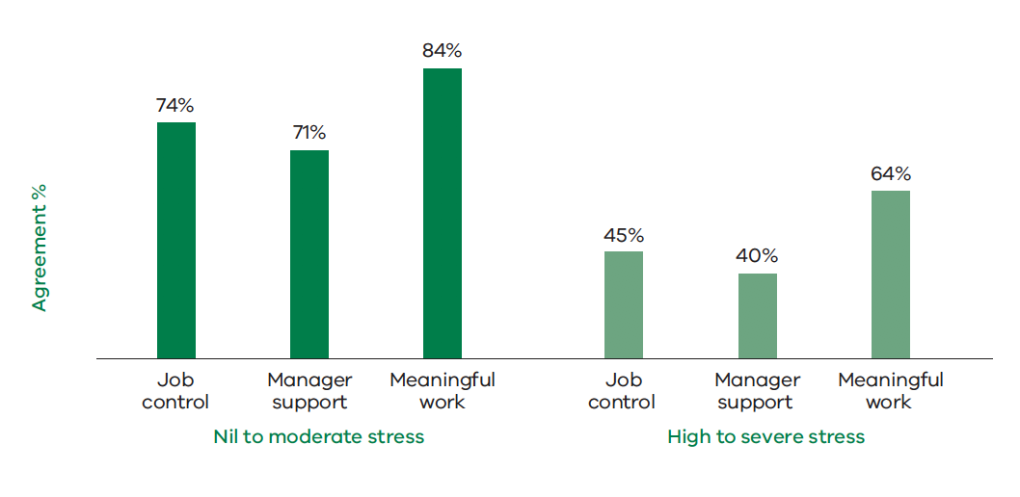
Source: People Matter Survey 2019
Job control is the average percentage agreement with three questions: I have the authority to do my job effectively; I have a choice in deciding how I do my work; I have enough time to do my job effectively.
Manager support is the percentage agreement with the question: My manager provides me with enough support during times of high workload.
Meaningful work is the average percentage agreement with three questions: I enjoy the work in my current job; My job allows me to utilise my skills, knowledge and abilities; I get a sense of accomplishment from my work.
Figure 5.6 Percentage agreement with positive statements on job control, manager support and meaningful work by frequency of feeling miserable
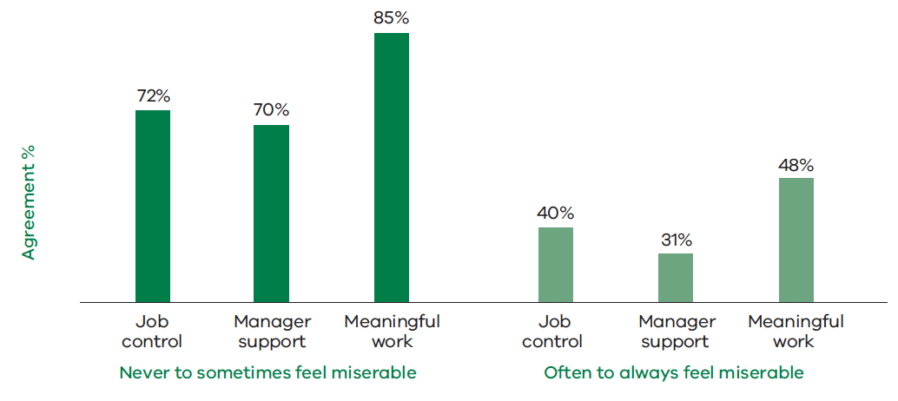
Source: People Matter Survey 2019
Job control, manager support and meaningful work support the psychological health of employees. The importance of these psychological supports is evident when we consider the experience of workers who experience high to severe stress. Workers with high to severe levels of stress are much less likely to be frequently miserable if they have high levels of job control, manager support and meaningful work (Figure 5.7).
Figure 5.7 The proportion of high to severely stressed employees who report they feel often to always miserable by level of psychological support
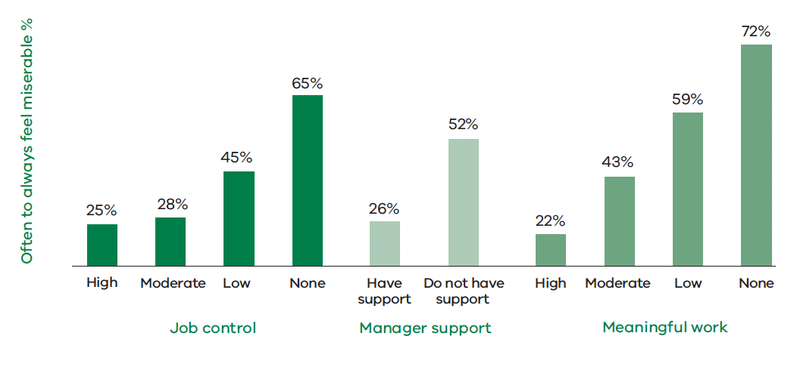
Source: People Matter Survey 2019
As demonstrated in Section 5.1, managers generally report lower levels of work-related stress and are less likely to feel miserable than their employees. This pattern is also associated with higher levels of job control, manager support and meaningful work. Figure 5.8, shows that for high to severely stressed employees as seniority increases the level of psychological supports also increase.
Figure 5.8 Percentage agreement of high to severely stressed employees with positive statements on job control, support and meaningful work by manager status
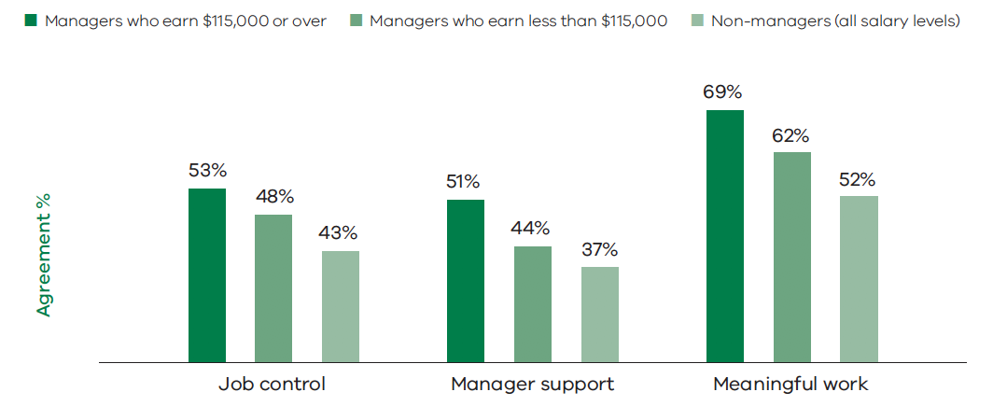Source: People Matter Survey 2019

WorkWell for better workplace mental health
WorkWell is a $50 million, five-year partnership between the Department of Health and Human Services and WorkSafe.
It provides resources and funding to make mental health and wellbeing a priority in Victorian workplaces. The program includes a five-year evaluation to assess its effectiveness to improve mental health and wellbeing and prevent mental ill health and injury in workplaces.
After its first full year of operation, the WorkWell program has three streams:
WorkWell Toolkit. This voluntary online tool uses a step-by-step approach to promote mental health and prevent mental injury. All Victorian workplaces can access tailored toolkits based on their business size and needs. Practical resources include case studies, policy examples, videos, tip sheets and templates. The toolkit covers role clarity, work design, change management, engagement and respect. Other topics include physical safety, fatigue, alcohol and other drugs and occupational violence and aggression.
WorkWell Mental Health Improvement Fund. This provides large-scale investment to create industry-wide and sustainable change. Mental Health Improvement Fund projects are being rolled out in three rounds. The projects will help build the evidence base on mentally healthy Victorian workplaces.
Five organisations were funded in round one:
- Arts Centre Melbourne, for the Arts Wellbeing Collective project
- Centre of Perinatal Excellence and Transitioning Well, for the Perinatal Workplace Wellbeing project
- Gippsland Women’s Health and Wellington Primary Care Partnership, for the Working Well in Wellington project
- Victorian Chamber of Commerce and Industry, for the Mental Health Essentials project
- SuperFriend, for the Wellbeing on Call project.
In round two, six organisations were funded:
- Australian Super, for the Ageing Workforce Ready project
- Community and Public Sector Union, for a project focusing on vicarious trauma
- Cross Yarra Partnership, for the Sense of Place project
- Peninsula Health (leading a consortium of Victorian health services), for the Thriving in Health: A consortium approach to staff wellbeing project
- Prevention United, for the Workplace Wellbeing Assist project
- Smiling Mind, for a project working with Victorian primary school principals
- Round three organisations will be announced in late 2019.
WorkWell Learning Networks. These networks bring workplaces and experts together to share ideas and knowledge. They provide advice to help create safe and mentally healthy working environments.

5.2.1. Stress management and prevention
The Victorian Government’s Mental Health and Wellbeing Charter was launched in 2016. It commits Victorian Government organisations to creating mentally sound and safe workplaces. The charter provides training and guidelines to employers to maintain a healthy workplace.
WorkSafe Victoria and the Department of Health and Human Services launched the WorkSafe WorkWell program in 2017. It promotes mental health and wellbeing. The WorkWell toolkit includes a questionnaire, a step by step approach and relevant resources.

5.2.2. Best practice approaches to stress management and prevention
The Victorian Public Sector Commission engaged the South Australian University to provide an analysis of psychosocial data collected over two-time periods (2017 and 2018) in the People Matter Survey for the Health sector. A number of recommendations were made to implement a best practice approach to stress management and prevention. These recommendations can be applied across the public sector. They are:
- conduct regular assessment of physical and psychological risks to assist managers and supervisors to prevent risks
- establish communication systems for employees to report physical and psychological risks or hazards and for leaders to provide information on policies and resources
- take fast action to prevent and end negative behaviours
- communicate genuine regard for psychosocial safety by all levels of leadership
- assess employees’ workloads and time pressures and provide management support
- design roles to ensure employees exercise adequate levels of job control
- support staff to achieve proper work-life balance.

5.2.3.Royal Commission into Victoria’s Mental Health System
On 22 February 2019, a Royal Commission into Victoria’s Mental Health System was established to investigate how Victoria’s mental health system can prevent mental illness, and deliver treatment, care and support so that all those in the Victorian community can experience their best mental health, now and into the future.
The Royal Commission’s interim report was published in November 2019 and makes some priority recommendations, including to substantially increase investment in mental health and the creation of a Victorian Collaborative Centre for Mental Health to spread the practice of evidence-informed treatment, care and support across the state. The final report will be released by 31 October 2020 and it is expected to set out an ambitious blueprint for transforming Victorian’s mental health system. The Royal Commission’s work in this area will inform future workplace initiatives to improve mental health and wellbeing.
.
- A values-based culture

Key messages
- A values-based culture fosters safe and respectful workplaces
- Employee perceptions around the application of the public sector values have remained broadly stable since 2016, albeit with small rises in some indicators
- In 2019, the lowest rates of agreement were for questions broadly relating to integrity, impartiality and leadershipThere was further progress in 2019 to reduce rates of bullying, sexual harassment and discrimination
- There is considerable scope to further intensify efforts across the Victorian public sector to eliminate negative work behaviours, particularly sexual harassment and bullyingEmployee responses suggest that more work is needed to increase confidence in merit-based recruitment
- Incidence of aggressive or violent behaviour at work is reported for the first time and is relatively high in the front-line services: Police and emergency services, Public health care.The seven public sector values and six employment principles set out in the Public Administration Act 2004 are at the centre of the public sector’s responsibility to serve the community.

Victorian Public Sector Values
- Responsiveness
- Integrity
- Impartiality
- Accountability
- Respect
- Leadership
- Human Rights.

Victorian Employment Principles
- Fair and Reasonable Treatment
- Merit in Employment
- Equal Employment Opportunity
- Human Rights
- Reasonable Avenue of Redress
- Career Public Service.
The public sector values form the basis for the professional and ethical conduct of public officials.
The People Matter Survey provides insights into how effectively the values are applied in public sector workplaces through the perception of those that work in them.
The People Matter Survey results show a strong association between the application of the values and higher reported job satisfaction and employee engagement. A positive values-based culture is also associated with lower reported negative behaviours such as bullying, sexual harassment and discrimination.

6.1. Public sector values over time
Table 6.1 reports agreement rates measuring the extent to which public sector employees perceive how each of the public sector values have been maintained in their organisation. The table presents results for each of the four years from 2016 to 2019 based on responses to the People Matter Survey. The overall agreement score is the average agreement rate of all seven public sector values.
There were some changes in the specific questions used to measure agreement rates in the 2019 survey (discussed in further detail in the following pages). While these changes were generally minor, in some cases it is apparent they may have materially influenced the measured agreement rates for at least two of the values (accountability and integrity). Consequently, a degree of caution should be exercised in making time series comparisons from earlier years to 2019.
Table 6.1 shows that overall agreement rates for the public sector values remained broadly stable from 2016 to 2018, albeit with small to moderate increases for most of the values.
The public sector value with the highest agreement rate among employees is the value of responsiveness (the extent to which employees perceive their workplace seeks to achieve timely and high-quality outcomes). In 2019 the overall agreement rate for this value was 89%. Overall agreement rates for all other values in 2019 were below 80%, indicating that there is significant scope for public sector organisations to continue intensifying their efforts to create workplace cultures that are strongly aligned with the public sector values.
Table 6.1 Percentage agreement with questions that embody the public sector values, 2016 to 2019
Public sector values | 2016 | 2017 | 2018 | 2019
Accountability (2016–2018) | 67% | 68% | 69%
Accountability (2019) |  |  |  | 79%
Integrity (2016–2018) | 71% | 72% | 74%
Integrity (2019) |  |  |  | 66%
Impartiality (2016–2018) | 72% | 72% | 74%
Impartiality (2019) |  |  |  | 73%
Leadership (2016–2018) | 66% | 66% | 67%
Leadership (2019) |  |  |  | 72%
Responsiveness (2016–2018) | 85% | 86% | 86%
Responsiveness (2019) |  |  |  | 89%
Human rights (2016–2018) | 72% | 74% | 82%
Human rights (2019) |  |  |  | 79%
Respect (2016–2018) | 71% | 72% | 74%
Respect (2019) |  |  |  | 78%
Overall agreement score (2016–2018) | 72% | 73% | 75%
Overall agreement score (2019) |  |  |  | 76%
Source: People Matter Survey 2019
The following sections explore each of the public sector values in more detail, and discuss insights from the responses provided by public sector employees.

6.1.1. Accountability: accepting responsibility for decisions and actions
Being accountable for decisions and actions is particularly important in public sector organisations that apply resources and make decisions on behalf of the communities that they serve.
Among other things, accountability requires:
- working to objectives
- acting in a transparent manner
- achieving the best use of resources
- being open to appropriate scrutiny.
Table 6.2 sets out the specific questions that are used to measure accountability in the People Matter Survey. As shown in the table, there were several changes in the questions surveyed in 2019, including the addition of three entirely new questions.
The overall agreement rate for the accountability value increased by 10 percentage points from 2018 to 2019; however, it seems likely that most, if not all, of this increase was due to the new and changed questions.
In 2019, there was a very high level of agreement by employees that they understood how their job contributed to the purpose of their organisation, with an agreement rate of 91%. In contrast, the agreement rate with the proposition that senior leaders provide clear strategy and direction was just 61%.
Table 6.2 Percentage agreement with Accountability measures to 2019
Survey year | Question wording | 2016 | 2017 | 2018 | 2019
2016–2018 | My workgroup always tries to improve its performance | 80% | 80% | 81%
 | People in my workgroup use their time and resources efficiently | 68% | 68% | 70%
 | Senior managers provide clear strategy and direction | 54% | 55% | 57%
 | Accountability value overall score | 67% | 68% | 69%
2019 | I understand how my job contributes to my organisation’s purpose |  |  |  | 91%
 | My workgroup strives to make the best use of its resources |  |  |  | 85%
 | I clearly understand what I am expected to do in this job |  |  |  | 84%
 | My workgroup has clear lines of responsibility |  |  |  | 77%
 | Senior leaders provide clear strategy and direction |  |  |  | 61%
 | Accountability value overall score |  |  |  | 79%

Source: People Matter Survey 2019

6.1.2. Integrity: earning and sustaining public trust
Public sector officials are entrusted with considerable powers, resources, and information to fulfil their duties and deliver outcomes for the community. Trust in the public sector’s integrity is critical to its ability to operate effectively, implement policy and deliver services for the benefit of all Victorians. Building and maintaining this trust requires dedicated effort from all parts of the workforce.
It is particularly important that public sector employees demonstrate integrity by:
- avoiding conflicts of interest
- using powers responsibly
- behaving honestly and transparently
- reporting improper conduct.
The People Matter Survey measures aspects of integrity such as employees’ perceptions of their organisation, their leaders and colleagues behaving honestly and with integrity, their confidence in organisational processes for reporting improper conduct, and their general sense of their organisation’s efforts to earn the trust of the Victorian public.
With an overall score of 66%, the integrity value recorded the lowest agreement rate of the seven public sector values. Table 6.3 reports each of the questions used to measure agreement rates relating to integrity within public sector organisations from 2016–2019.
In 2019 two entirely new questions were added to the People Matter Survey:
“senior leaders demonstrate honesty and integrity”; and
“I feel I am able to challenge inappropriate behaviour at work”
In addition to these new questions, the wording of two further questions was refined to be expressed in more active language.
The changes in the survey questions appear to be the principal cause of the sharp drop in the overall agreement rate for integrity from 74% in 2018 to 66% in 2019. Notwithstanding this, the improved and more detailed questions in 2019 provide deeper insights into the extent to which employees agree that integrity is embedded in the workplace culture of their organisations. The overall picture indicates that there is considerable scope to raise integrity indicators within public sector workplaces.
In particular, the agreement rates for all but two of the integrity related questions in 2019 were below 70%. This includes an agreement rate of 64% for the proposition that senior leaders demonstrate honesty and integrity, and 65% for the proposition that their organisations do not tolerate improper conduct. Overall, only 55% of public sector employees agreed or strongly agreed that they would be confident that they would be protected from reprisal for reporting improper conduct.
The development of an appropriate environment for employees to feel able and confident to report improper conduct is crucial to ensure that public sector organisations maintain the public’s trust. It falls to senior leaders to be more active in demonstrating their, and their organisation’s commitment to acting with integrity and putting measures in place to appropriately deal with improper conduct.
Table 6.3 Percentage agreement with Integrity measures, 2016 to 2019
Survey year | Question wording | 2016 | 2017 | 2018 | 2019
2016–2018 | People in my workgroup are honest, open and transparent in their dealings | 74% | 74% | 77% | 73%
 | I am confident that I would be protected from reprisal for reporting improper conduct | 50% | 52% | 55% | 55%
 | My manager sees avoiding conflicts of interest as being important | 72% | 72% | 73%
 | In my organisation, earning and sustaining a high level of public trust is seen as important | 88% | 89% | 88%
 | In my organisation, engaging in improper conduct is not tolerated | 73% | 74% | 76%
 | Integrity value overall score | 71% | 72% | 74%
2019 | People in my workgroup are honest, open and transparent in their dealings | 74% | 74% | 77% | 73%
 | I am confident that I would be protected from reprisal for reporting improper conduct | 50% | 52% | 55% | 55%
 | People in my workgroup appropriately manage conflicts of interest |  |  |  | 69%
 | Senior leaders demonstrate honesty and integrity |  |  |  | 64%
 | I feel able to challenge inappropriate behaviour at work |  |  |  | 63%
 | My organisation is committed to earning a high level of public trust |  |  |  | 77%
 | My organisation does not tolerate improper conduct |  |  |  | 65%
 | Integrity value overall score |  |  |  | 66%

Source: People Matter Survey 2019

6.1.3. Impartiality: acting objectively
Public sector employees serve the elected government of the day and are under an obligation to act in an impartial manner, ensuring their decisions are objective, fair and open to scrutiny. Behaving consistently with this value promotes community confidence in the delivery of programs and in public institutions.
Demonstrating impartiality requires that public sector employees and their organisations:
- make decisions without bias or self-interest, and based on merit, facts and fair criteria
- implement policies and programs equitably.
Public sector employees broadly had a high rate of agreement with the propositions that their workgroups made decisions informed by relevant facts and acted fairly and without bias, with overall agreement rates of 83% and 80% respectively.
The overall agreement rate in relation to political impartiality was, however, somewhat lower. Overall, 74% of public sector employees agreed or strongly agreed that people in their workgroup were politically impartial in their work.
Table 6.4 Percentage agreement with Impartiality measures, 2019
 | 2019
My workgroup focuses on making decisions informed by all relevant facts | 83%
My workgroup places a priority on acting fairly and without bias | 80%
People in my workgroup are politically impartial in their work | 74%
My organisation makes fair recruitment decisions based on merit | 53%
Impartiality value overall score | 73%

Source: People Matter Survey 2019
The 2019 survey suggests that more work is needed to increase employee confidence in merit-based recruitment practices.

6.1.4. Leadership: actively implementing, promoting and supporting the values
Leadership plays a fundamental role in the development of values-based cultures. For the public to have confidence in the public sector, employees must always demonstrate the highest standards of behaviour.
Leadership in actively implementing, promoting and supporting the values requires:
- understanding of what the values mean in practice
- modelling the values in everyday behaviour
- inspiring colleagues to create a positive work culture.
The People Matter Survey measures employees’ perceptions of the extent to which the values are modelled by leaders and managers within their organisations.
The 2019 survey results suggest that most public sector employees perceived that their immediate managers modelled the values of their organisation, with an overall agreement rate of 79%. The agreement rate in relation to senior leaders was noticeably lower at 64%. Please refer to Section 2.3 for a further discussion on the perceptions of senior leadership.
Table 6.5 Percentage agreement with Leadership measures, 2019
 | 2019
My manager models my organisation’s values | 79%
Senior leaders model my organisation's values | 64%
Leadership value overall score | 72%

Source: People Matter Survey 2019

6.1.5. Respect: treating others fairly and objectively
People want to be treated with respect in the workplace and in the community. Public sector organisations must ensure that their employees treat their colleagues and all members of the Victorian community with respect. This means treating them fairly and objectively, using feedback to improve, and ensuring that workplaces are free from bullying, harassment and discrimination.
The People Matter Survey measures several elements of respectful working environments including employee perceptions of the treatment of colleagues within workgroups, the extent to which negative behaviours are tolerated and whether managers listen to employees.
In 2019, Victorian public sector employees reported relatively high rates of agreement that their managers listen and treat them with dignity and respect. Further, respondents indicated relatively high agreement rates that their workgroups consulted respectfully with stakeholders and clients, and that people within their workgroup were treated with respect.
In contrast, respondents were noticeably less inclined to actively agree that their organisation takes steps to eliminate bullying, harassment and discrimination, with an overall agreement rate of 68% in 2019. This agreement rate indicates that there remains considerable scope for public sector organisations to take further action to eliminate sexual harassment, discrimination and bullying.
Table 6.6 Percentage agreement with Respect measures, 2019
 | 2019
My manager listens to what I have to say | 82%
My manager treats employees with dignity and respect | 82%
People in my workgroup treat each other with respect | 81%
My organisation encourages respectful workplace behaviours | 79%
My workgroup respectfully consults with stakeholders and clients to improve outcomes | 79%
My manager keeps me informed about what's going on | 72%
My organisation takes steps to eliminate bullying, harassment and discrimination | 68%
Respect value overall score | 78%

Source: People Matter Survey 2019

6.1.6. Responsiveness: providing the best standards of service and advice
Victorian public sector organisations have an obligation to be responsive to the community they serve. This manifests in public sector organisations seeking to adapt to meet the changing demands and circumstances of their clients and stakeholders.
Responsiveness is an important public sector value. Given the diversity of the public sector, it can encompass:
- the quality of service and care to patients in the Public health care industry
- effective teaching and training tailored to industry and student needs for particular skills in the TAFE sector
- the provision of timely and high-quality advice to the government of the day for those in policy and advice roles in the public service.
Measures relating to the responsiveness value tend to achieve some of the highest levels of agreement in the survey. Table 6.7 shows an overall agreement score of 89% for the responsiveness value.
Table 6.7 Percentage agreement with Responsiveness measures, 2019
 | 2019
My workgroup strives to provide high quality advice and services | 91%
My workgroup strives to deliver services in a timely manner | 91%
My manager ensures clients receive a high standard of service | 85%
Responsiveness value overall score | 89%

Source: People Matter Survey 2019

6.1.7. Human rights: respecting and upholding human rights
Individuals and communities expect that governments and people in authority will respect and uphold their basic human rights. The Victorian Charter of Human Rights and Responsibilities provides a framework for those working in public sector organisations to consider human rights in their conduct and actions.
Human rights must be respected, promoted and supported when:
- making decisions
- providing advice
- implementing decisions.
Employee perceptions of the degree to which the human rights value is maintained are reflected in generally high levels of agreement. Table 6.8 shows an overall agreement rate of 79% for the human rights value in 2019.
Table 6.8 Percentage agreement with Human rights measures, 2019
 | 2019
My workgroup values human rights | 85%
My organisation encourages employees to act in ways that are consistent with human rights | 80%
My organisation respects the human rights of employees | 77%
I understand how the Charter of Human Rights and Responsibilities applies to my work | 75%
Human rights value overall score | 79%
Source: People Matter Survey 2019

6.2. A values-based culture
There is a strong and well-established association between the degree to which employees perceive the public sector values are maintained and positive workplace cultures. Organisations that report high rates of employee agreement that the public sector values are maintained tend to be the same organisations that report lower levels of negative workplace behaviours and stress. In contrast, organisations with low public sector values scores tend to report higher levels of stress, bullying and harassment.
Table 6.9 below reports overall organisational scores for a range of indicators in the People Matter Survey that measure workplace culture, such as levels of bullying and harassment and overall job satisfaction. The table compares two groups of organisations in the Victorian public sector: those organisations with the highest 20% rates of agreement that the public sector values are maintained, and those with the bottom 20% rates of agreement.
As reported in Table 6.9, the 2019 People Matter Survey results confirm that those organisations recording strong rates of agreement in relation to the public sector values score significantly more positive results on all key measures of workplace culture.
Table 6.9 Workplace indicators for organisations with the highest and lowest levels of agreement that the public sector values are maintained, 2019
Workplace indicators | Top 20 % | Bottom 20%
Public sector values overall score (% Agree) | 87% | 68%
Experienced bullying % | 8% | 19%
Experienced sexual harassment % | 3% | 9%
Experienced discrimination % | 2% | 8%
Experienced high to severe work-related stress % | 14% | 28%
Work made you feel miserable (Often to always %) | 6% | 19%
Work made you feel worried (Often to always %) | 20% | 36%
Work made you feel happy (Often to always %) | 69% | 49%
Work made you feel enthusiastic (Often to always %) | 62% | 41%
Satisfaction with career development (% Satisfied) | 69% | 52%
Satisfaction with work-life balance (% Satisfied) | 79% | 64%
Overall job satisfaction (% Satisfied) | 81% | 63%
Engagement Index | 78 | 61

Source: People Matter Survey 2019
A similar correlation is evident in Figure 6.1, which shows that reported bullying rates decline, and engagement rates increase, as public sector values agreement rates increase within organisations.Figure 6.1Association between public sector values performance and key organisational outcomes, 2019

Experienced bullying at work by public sector values score

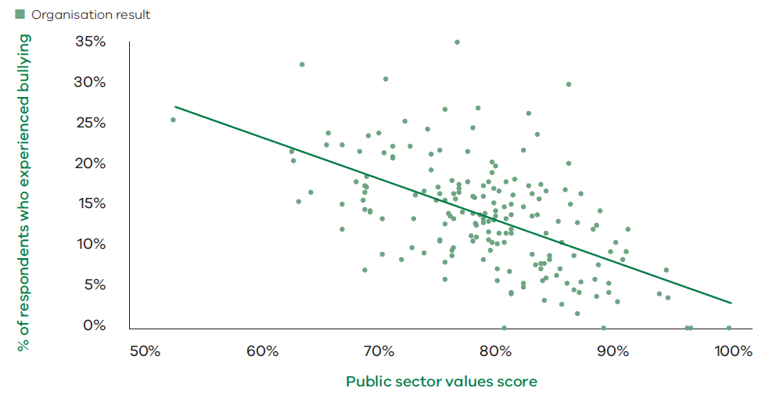Engagement index by public sector values score

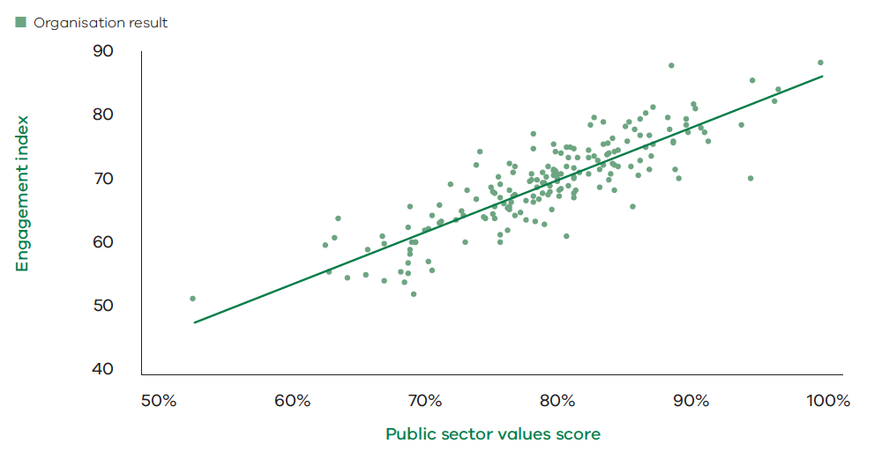6.2.1. Addressing negative behaviours
A values-based and respectful culture is also associated with a safe work environment. Table 6.10 shows that 80% of respondents agree or strongly agree that their organisation provides a safe environment.
Table 6.10 Percentage of employees who agree that “my organisation provides a safe work environment” by industry group 2019
 | 2019
Police and emergency services | 72%
TAFE and other education | 80%
Victorian Public Service | 80%
Public health care | 81%
Creative industries, finance, transport and other | 83%
Water and land management | 95%
Overall public sector | 80%

Source: People Matter Survey 2019
The People Matter Survey measures the incidence of four negative behaviours: bullying, sexual harassment, discrimination and aggression or violence. The proportion of employees reporting negative behaviours has gradually decreased from 2016 to 2019, as shown in Table 6.11. Over the same period, the overall agreement score for the public sector values has increased.
Table 6.11 Incidence of negative behaviours, 2016 to 2019
Negative behaviours | 2016 | 2017 | 2018 | 2019
Experienced bullying | 20.1% | 18.7% | 16.6% | 14.7%
Experienced sexual harassment | 11.7% | 10.3% | 10.1% | 8.5%
Experienced discrimination | 8.7% | 8.2% | 7.4% | 6.7%
Public sector values overall score 2016–2018 (% Agree) | 72% | 73% | 75%
Public sector values overall score 2019 (% Agree) |  |  |  | 76%

Source: People Matter Survey 2019
As Table 6.12 shows, the decline in the incidence of bullying, sexual harassment and discrimination has been widespread across the sector. There is, however, further room for improvement. Seven per cent of respondents indicated that they had experienced discrimination. A little over one-third of those seven per cent of respondents believed they were discriminated against for their employment activity, which includes making reasonable requests for information about employment entitlements or for communicating concerns about these entitlements. One in four of those seven per cent of respondents said they were discriminated against for their age. Overall, the results suggest that discrimination is substantially under-reported through formal channels; only eight per cent of those who reported experiencing discrimination submitted a formal complaint about it.
Table 6.12 Incidence of negative behaviours by industry group, 2017 to 2019
Experienced discrimination | 2017 | 2018 | 2019
Water and land management | 5.9% | 7.0% | 3.8%
TAFE and other education | 7.0% | 6.1% | 5.9%
Public health care | 6.9% | 6.2% | 5.9%
Creative industries, ﬁnance, transport and other | 6.0% | 6.2% | 6.4%
Victorian Public Service | 9.0% | 7.9% | 7.2%
Police and emergency services | 14.0% | 14.5% | 11.4%
Overall public sector | 8.2% | 7.4% | 6.7%

Experienced bullying | 2017 | 2018 | 2019
Water and land management⁵⁶ | 10.3% | 12.2% | 7.6%
Creative industries, ﬁnance, transport and other | 14.3% | 12.0% | 13.6%
TAFE and other education | 16.7% | 15.3% | 14.1%
Victorian Public Service | 18.3% | 16.2% | 14.3%
Police and emergency services | 19.0% | 19.0% | 15.0%
Public health care | 19.8% | 17.3% | 15.2%
Overall public sector | 18.7% | 16.6% | 14.7%

Experienced sexual harassment | 2017 | 2018 | 2019
Water and land management⁵⁶ | 5.9% | 8.1% | 4.7%
TAFE and other education | 6.5% | 7.7% | 6.0%
Creative industries, ﬁnance, transport and other | 11.6% | 8.7% | 7.7%
Victorian Public Service | 10.0% | 9.4% | 7.6%
Public health care | 10.3% | 10.4% | 9.1%
Police and emergency services | 11.7% | 11.7% | 9.9%
Overall public sector | 10.3% | 10.1% | 8.5%

Source: People Matter Survey 2019
The majority of respondents who reported experiencing bullying and sexual harassment said this behaviour was carried out by colleagues. Consistent with the under-reporting through formal channels observed for other negative behaviours, just one in ten respondents who experienced bullying and less than one in twenty respondents who experienced sexual harassment reported that they submitted a formal complaint. The main reason respondents did not submit a formal complaint was that they thought it would not make a difference. There is clearly room for public sector organisations to further improve policies and processes for the submission and handling of complaints and grievances.
Responses relating to aggressive or violent behaviour at work were collected for the first time in 2019. Almost one in five respondents reported that they had experienced such behaviour. Table 6.13 shows that aggressive or violent behaviour is more frequently experienced by employees in police, emergency services and health care organisations. In these organisations one in four respondents indicated having experienced aggressive or violent behaviour at work.
Table 6.13 Incidence of aggression or violent behaviour by industry group, 2019
Experienced aggression or violent behaviour | 2019
Water and land management | 5%
Creative industries, ﬁnance, transport and other | 9%
TAFE and other education | 10%
Victorian Public Service | 11%
Police and emergency services | 24%
Public health care | 25%
Overall public sector | 19%

Source: People Matter Survey 2019
Eight in ten reported that clients, customers, patients, stakeholders or members of the public were responsible for the acts of aggressive or violent behaviour that they experienced. Whereas, two in ten reported experiencing aggression or violence perpetrated by colleagues or managers.
Negative behaviours were experienced more by some employee groups. Table 6.14 shows that employees with a disability and Aboriginal employees are more likely to experience these negative behaviours. Women, particularly those younger than 35 years, are more likely to report experiencing sexual harassment or aggression or violence at work.
Table 6.14 Incidence of negative behaviours by employee groups, 2019
Employee group | Experienced discrimination | Experienced sexual harassment | Experienced bullying | Experienced aggression or violence
Employees with disability | 21% | 15% | 30% | 24%
Aboriginal or Torres Strait Islander | 16% | 14% | 24% | 22%
Women (all ages) | 6% | 9% | 15% | 20%
Women 15–34 years | 6% | 15% | 14% | 25%
Women 35 years + | 6% | 7% | 15% | 18%
Men (all ages) | 7% | 6% | 11% | 16%
Men 15–34 years | 6% | 8% | 9% | 19%
Men 35 years + | 7% | 5% | 12% | 15%
All respondents | 7% | 8% | 15% | 19%

Source: People Matter Survey 2019
The Victorian Public Sector Commission has developed a respectful workplaces framework and action plan to assist public service organisations work towards achieving zero incidence of sexual harassment in the workplace.

Preventing workplace sexual harassment
On 22 March 2018, the Victorian Secretaries Board (VSB) released a statement on sexual harassment, sending a clear message to the Victorian public sector: We will listen to and work with people affected by sexual harassment.
Building on this statement, the Sexual Harassment in the Victorian Public Service Working Group was established under the auspices of the Integrity and Corporate Reform Sub-committee of the VSB. Chaired by the Victorian Public Sector Commission Deputy Commissioner, this group is promoting best practice prevention and response strategies to sexual harassment in the workplace and delivery of consistent outcomes.
In 2018–2019 the working group developed a Model Policy for Preventing and Responding to Sexual Harassment and a Guide for the Prevention of Sexual Harassment in the Workplace to assist departments with preventing sexual harassment and responding to allegations. The working group also developed a Respectful Workplaces Framework and Prevention of Sexual Harassment Model Action Plan that were approved by the VSB and made available on the Victorian Public Sector Commission website.

Appendices
- Victoria’s public sector
  - Victorian Public Service
The public service is defined in Part 3 of the Public Administration Act 2004. It consists of the staff employed in Departments, Administrative Offices and other designated Authorities and Offices. Departments and Administrative Offices are created by the government of the day through administrative orders which can be amended at any time. The number and scope of Departments, Administrative Offices and Authorities are therefore subject to restructuring and realignment as government strategies, priorities and objectives adjust to meet changing community needs.
In Victoria, each Department advises and supports multiple Ministers. Departments undertake a wide range of functions and activities and are the primary providers of policy and administrative support to Ministers.
Administrative Offices and other public service employers are typically established to undertake specific tasks. Administrative Offices are established under a Department. Authorities are established through a variety of means and are generally accountable to their Minister through a Department.
  - Public entities
Public entities are statutory authorities, state owned corporations and advisory bodies that exercise a public function (defined in section 5 of the Public Administration Act 2004). Established outside of the public service, for a specific purpose with defined functions, they operate with varying degrees of autonomy and are ultimately accountable to a Minister for their performance.
  - Special bodies
Special bodies are listed in section 6 of the Public Administration Act 2004 and most are Victorian Public Service employers. Those that are not (such as the Departments of the Parliament of Victoria) function like public entities and are treated as public entities in this report.
  - Departments
These include:
- policy and administrative support to Parliament and Ministers
- service delivery functions such as:
- child protection, welfare services for families, services for people with disabilities and their families, and public housing
- providing advice to the community on public health and consumer issues
- maintenance and management of state forests and fisheries
- bushfire prevention and suppression on public land
- managing delivery of education through the government schools system
- provision of research and other support to agriculture industries
- operating the corrections system (including prisons)
- public registries such as land titles and births, deaths and marriages.
- funding and coordinating the delivery of services (often delivered by public entities), such as:
- public health care services (for example, hospitals and health services)
- public transport, roads and ports
- TAFE and adult education providers
- water and sewage supply and environmental management
- cultural assets such as the Royal Botanic Gardens and the Melbourne Arts Centre.Department Heads are responsible to the relevant Minister for the general conduct and the effective and efficient management of the activities and functions of their Department and any associated Administrative Offices. They also have a responsibility to work with the public entities within their Ministers’ portfolios and to advise their Ministers on matters relating to these entities. These entities must provide any information that will assist them to meet these obligations.
  - Administrative Offices and other public service employers
Administrative Offices and other public service employers are typically established to undertake specific tasks, such as:
- providing administrative and technical support to police officers (Victoria Police)
- undertaking public audits as required by the Victorian Parliament (Victorian Auditor-General’s Office)
- managing and conducting elections (Office of the Victorian Electoral Commissioner)
- advocating for protection of the environment, regulating environmental standards, and prosecuting breaches of environmental laws (Environment Protection Authority).
See Appendix 2 for a list of Departments, Administrative Offices, and other public service employers.
  - Public entity agencies
Public entities include employing and non-employing entities.
Employing entities include:
- cemetery trusts
- creative industries agencies
- emergency services organisations
- facilities management entities
- finance and insurance agencies
- hospitals and health care services
- regulators
- school councils
- sports and recreation entities
- TAFE institutes
- transport entities
- water corporations, alpine resorts and other public land management agencies.
Public entities with no employees generally have functions specified in legislation, with boards of management generally comprised of volunteers. They include most of Victoria’s cemetery trusts, committees that manage Victoria’s Crown land reserves and some advisory bodies.
For ease of reporting, special bodies that are not public service employers are treated as public entities in this report. Public entity subsidiaries are generally excluded from figures and listings in this report.
  - Department portfolio
A department portfolio is made up of the entities (both public service and public entities) that are responsible to a specific public service department and associated Minister. See Appendix 3 for the composition of department portfolios as at June 2018.
  - Industry groups
To provide a consistent picture of employment, the Victorian public sector has been categorised into seven industry groups. Victorian Public Service employers form one group and public entities are split across the six remaining groups. These are listed and described below:
    - Public health care
Public health care includes government owned hospitals and health services and a small number of research, professional registration, health promotion and ancillary service bodies. It includes:
- large metropolitan health services that run a number of hospitals e.g. Melbourne Health
- specialist health services e.g. Royal Women’s Hospital
- regional health services e.g. Latrobe Regional Hospital
- small rural health services e.g. Casterton Memorial Hospital.
Note this industry group does not include private or denominational health services, such as St Vincent’s or Mercy Health, as they are not public entities (as defined by the Public Administration Act 2004).
    - Government schools
Government schools includes primary, secondary, primary-secondary (P-12), special schools and other schools that provide education on a short-term basis to children enrolled in other schools e.g. Austin Hospital School and Bogong Outdoor Education Centre.
Teachers and support staff are employed by the Department of Education and Training in the Government Teaching Service. The Teaching Service is a single public entity employing 75,000 people. Each School Council is also a separate public entity, and they are distinct from the Teaching Service. They have limited powers to employ casual relief teachers and other casual supplementary employees.
    - Victorian Public Service
The staff employed in Departments, Administrative Offices, the Victorian Public Sector Commission, and other bodies and offices designated as public service employers by specific legislative reference.
    - Police and emergency services
Police and emergency services includes the six organisations that deliver policing, fire, ambulance and emergency response services across Victoria:
- Victoria Police is comprised of sworn police officers, recruits in training, protective services officers (PSOs) and reservists as well as public service employees. Sworn police officers deliver law enforcement services that are aimed at the prevention, detection, investigation and prosecution of crime and disorderly behaviour. PSOs provide security services to senior public officials, designated public buildings and train stations. Police and PSOs are responsible to the Chief Commissioner of Police. Public service employees of Victoria Police work in professional, technical and support roles and are not included in figures for this sector (they are included in the Victorian Public Service group).
- Ambulance Victoria provides emergency and non-emergency pre-hospital patient treatment, ambulance transport services and various public education services.The Metropolitan Fire and Emergency Services Board provides fire prevention, fire suppression and emergency response services to Melbourne’s CBD, most suburban areas and Port Phillip Bay.
- The Country Fire Authority provides fire services to rural Victoria and areas of outer metropolitan Melbourne.
- The Victoria State Emergency Service responds to floods, storms and earthquakes, and assists other emergency services and municipal councils in planning and auditing their emergency management plans.
- The Emergency Services Telecommunications Authority provides and manages the operational communications that dispatch the services listed above.
Note fire prevention and suppression and land management employees of the Department of Environment, Land, Water and Planning and Parks Victoria are not included in this group. Department employees are reported within the Victorian Public Service and Parks Victoria employees are reported under Water and land management.
    - TAFE and other education
This group is comprised of 12 TAFE institutes and four other non-school entities (the Centre for Adult Education, Adult Multicultural Education Service, Vocational Education and Training Development Centre, and the regulator of the teaching profession, the Victorian Institute of Teaching).
TAFE institutes provide vocational training and education services, including programs and courses, to school leavers, adults, apprentices, trainees, employees and industry. TAFE institutes also work in partnership with industry to provide a range of training and related services, and some offer higher education courses.
    - Water and land management
Water and land management is comprised of organisations that are responsible for water resources and the administration of public land. It includes:
- the metropolitan water retailers that provide and service water supply to domestic and commercial users in metropolitan Melbourne e.g. City West Water, Yarra Valley Water, and South East Water
- Melbourne Water and the regional water corporations that manage the State’s water storage, sewage, and distribution systems, and retail water in rural and regional Victoria
- catchment management authorities that plan, promote and co-ordinate water and land management within their regions to support sustainable use, conservation and rehabilitation
- other land management and planning organisations e.g. Parks Victoria.
    - Creative industries, finance, transport and other
The Creative industries, finance, transport and other sector is a diverse collection of employers. It includes:
- creative industries agencies e.g. Victorian Arts Centre Trust
- cemetery trusts e.g. Greater Metropolitan Cemeteries Trust
- facilities management entities e.g. Melbourne Convention and Exhibition Trust
- finance and insurance entities e.g. Transport Accident Commission
- regulators e.g. Victorian Building Authority
- sports and recreation entities e.g. Emerald Tourist Railway Board
- transport entities e.g. VicRoads
- other entities e.g. the Departments of the Parliament.
A full listing of the organisations within each group can be found in Appendix 2 (page 160).
  - Machinery of government changes
The composition of the public sector is determined by the Government and reflects the Government’s policy priorities and choices as to the structure for delivering government administration and services.
Multiple machinery of government changes occurred over the 2018–2019 year.
Five new public service employers were established:
- Family Violence Prevention Agency, known as Respect Victoria (staff transferring from Department of Health and Human Services)
- Major Road Projects Authority (staff transferring from VicRoads and becoming public service employees). MRPA was subsequently incorporated into the Major Transport Infrastructure Authority
- Labour Hire Licencing Authority
- Service Victoria (staff transferring from Department of Premier and Cabinet).
Significant changes were made to public service department and office/authority structures:
- The Department of Economic Development, Jobs, Transport and Resources was split into two, forming the Department of Jobs, Precincts and Regions and the Department of Transport
- The Department of Justice and Regulation was renamed the Department of Justice and Community Safety
- The Administrative Offices: Level Crossing Removal, Major Road Projects, North East Link, West Gate Tunnel and Rail Projects Victoria were amalgamated to form the Major Transport Infrastructure Authority.
Functions and staff were transferred between agencies as follows:
Functions | Transferred to | Transferred from
Precincts and cities | Department of Jobs, Precincts and Regions | Department of Premier and Cabinet
National Disability Insurance Scheme Implementation | Department of Health and Human Services | Department of Premier and Cabinet
Transport Accident Commission Policy | Department of Transport | Department of Treasury and Finance
Worksafe Policy | Department of Justice and Community Safety | Department of Treasury and Finance
Suburban development | Department of Jobs, Precincts and Regions | Department of Environment, Land, Water and Planning
Industrial Relations | Department of Premier and Cabinet | Department of Economic Development, Jobs, Transport and Resources
Economic Development and Invest Victoria | Department of Treasury and Finance | Department of Economic Development, Jobs, Transport and Resources
Maternal health, parenting services and supported playgroups | Department of Health and Human Services | Department of Education and Training
Disability direct care | Non-Government NDIS service providers | Department of Health and Human Services
Office for Women | Department of Premier and Cabinet | Department of Health and Human Services
Office for Youth | Department of Premier and Cabinet | Department of Health and Human Services
Sport and Recreation and Women in Sport | Department of Jobs, Precincts and Regions | Department of Health and Human Services
Racing | Department of Jobs, Precincts and Regions | Department of Justice and Regulation

For public entities:
- The Centre for Adult Education was incorporated into Box Hill Institute
- The Greater Sunraysia Pest Free Area Development Committee ceased to employ staffThe Public Transport Development Authority (Public Transport Victoria) was incorporated into the Department of Transport and ceased to exist as a separate entity (effective from 1 July 2019)
- VicRoads policy, planning, operational and contract management functions were incorporated into the Department of Transport (effective from 1 July 2019).
- Employing organisations by industry group
The following tables provide the employment numbers as at the last full pay period in June 2019, for employing organisations in the Victorian public sector in headcount and full time equivalent (FTE) terms.
  - Victorian Public Service

Departments
Employing organisation | Headcount | FTE
Department of Education and Training | 4184 | 3820.7
Department of Environment, Land, Water and Planning | 4380 | 4111.4
Department of Health and Human Services | 11,121 | 9966.8
Department of Jobs, Precincts and Regions | 2681 | 2540.0
Department of Justice and Community Safety | 10,128 | 9658.5
Department of Transport | 3140 | 3042.4
Department of Premier and Cabinet | 1125 | 1068.0
Department of Treasury and Finance | 1265 | 1207.1

Agencies and offices
Employing organisation | Headcount | FTE
Designated as Administrative Offices under the PAA

Family Safety Victoria | 310 | 290.8
Latrobe Valley Authority | 35 | 32.9
Local Government Inspectorate | 10 | 10.0
Major Transport Infrastructure Authority | 1617 | 1587.9
Office of Projects Victoria | 17 | 15.7
Office of the Chief Parliamentary Counsel | 43 | 38.4
Office of the Governor | 41 | 36.5
Office of the Victorian Government Architect | 13 | 11.7
Public Record Office Victoria | 70 | 62.3
Safer Care Victoria | 131 | 120.3
Service Victoria | 41 | 40.4
Victorian Agency for Health Information | 75 | 72.2
Victorian Government Solicitor’s Office | 221 | 203.2
Designated as a public service employer by specific legislative reference

CenITex | 537 | 528.5
Commercial Passenger Vehicle Commission | 120 | 115.5
Commission for Children and Young People | 73 | 70.6
Court Services Victoria | 2195 | 2065.6
Emergency Services Superannuation Board | 162 | 152.3
Environment Protection Authority⁶² | 636 | 598.1
Essential Services Commission | 119 | 113.9
Family Violence Prevention Agency (Respect Victoria) | 16 | 16.0
Game Management Authority | 16 | 16.0
Independent Broad-based Anti-corruption Commission | 206 | 199.3
Infrastructure Victoria | 38 | 34.4
Labour Hire Licensing Authority | 24 | 23.4
Office of Public Prosecutions | 380 | 356.5
Office of the Legal Services Commissioner | 82 | 77.3
Office of the Ombudsman Victoria | 112 | 103.2
Office of the Road Safety Camera Commissioner | 2 | 2.0
Office of the Victorian Electoral Commissioner | 145 | 137.0
Office of the Victorian Information Commissioner | 55 | 52.0
Victoria Police (public service) | 4091 | 3866.9
Victorian Auditor-General’s Office | 161 | 155.1
Victorian Commission for Gambling and Liquor Regulation⁶² | 218 | 209.4
Victorian Equal Opportunity and Human Rights Commission | 55 | 51.3
Victorian Fisheries Authority⁶² | 168 | 160.4
Victorian Inspectorate | 14 | 14.0
Victorian Public Sector Commission | 90 | 85.1
Victorian Responsible Gambling Foundation⁶² | 53 | 51.4

  - Public entities

Government schools
Employing organisation | Headcount | FTE
Department of Education and Training (Teaching Service and school support) | 75,010 | 64,315.0
School Council Staff | 6994 | 3232.3
Casual Relief Teachers | 6532 | 3162.0

TAFEs and other education
TAFEs
Employing organisation | Headcount | FTE
Bendigo Kangan Institute | 1225 | 1002.8
Box Hill Institute | 1450 | 830.5
Chisholm Institute | 1105 | 888.1
Gippsland Institute of TAFE | 393 | 303.8
Gordon Institute of TAFE | 685 | 489.7
Goulburn Ovens Institute of TAFE | 474 | 385.4
Holmesglen Institute | 1445 | 981.4
Melbourne Polytechnic | 1392 | 965.7
South West Institute of TAFE | 357 | 241.7
Sunraysia Institute of TAFE | 297 | 233.1
William Angliss Institute of TAFE | 397 | 320.8
Wodonga Institute of TAFE | 497 | 391.4

Other education
Employing organisation | Headcount | FTE
AMES Australia | 605 | 498.6
VET Development Centre | 10 | 9.5
Victorian Institute of Teaching | 94 | 85.2

Public health sector
Health services
Employing organisation | Headcount | FTE
Albury Wodonga Health | 2276 | 1682.5
Alexandra District Health | 97 | 56.2
Alfred Health | 8355 | 6489.9
Alpine Health | 338 | 236.1
Austin Health | 7746 | 5832.2
Bairnsdale Regional Health Service | 785 | 518.1
Ballarat Health Services | 3960 | 2897.2
Barwon Health | 6201 | 4314.5
Bass Coast Health | 656 | 447.2
Beaufort and Skipton Health Service | 162 | 101.2
Beechworth Health Service | 175 | 119.5
Benalla Health | 279 | 178.8
Bendigo Health Care Group | 3710 | 2726.7
Boort District Hospital | 80 | 50.7
Casterton Memorial Hospital | 96 | 74.9
Castlemaine Health | 618 | 401.8
Central Gippsland Health Service | 927 | 638.6
Cobram District Hospital | 178 | 154.8
Cohuna District Hospital | 97 | 68.4
Colac Area Health | 472 | 311.0
Corryong Health | 131 | 92.0
Dental Health Services Victoria | 652 | 432.3
Djerriwarrh Health Services | 632 | 444.4
East Grampians Health Service | 427 | 283.7
East Wimmera Health Service | 335 | 212.7
Eastern Health | 8411 | 6211.2
Echuca Regional Health | 707 | 502.5
Edenhope and District Memorial Hospital | 116 | 76.6
Gippsland Southern Health Service | 443 | 259.2
Goulburn Valley Health Services | 2170 | 1492.4
Heathcote Health | 146 | 76.3
Hepburn Health Service | 348 | 225.2
Hesse Rural Health Service | 130 | 81.0
Heywood Rural Health | 124 | 65.8
Inglewood and Districts Health Service | 106 | 63.0
Kerang District Health | 152 | 92.4
Kilmore and District Hospital | 282 | 148.6
Kooweerup Regional Health Service | 195 | 111.3
Kyabram and District Health Services | 269 | 169.3
Kyneton District Health Service | 143 | 78.9
Latrobe Regional Hospital | 1946 | 1479.4
Lorne Community Hospital | 103 | 57.9
Maldon Hospital | 69 | 34.1
Mallee Track Health and Community Service | 194 | 118.2
Mansfield District Hospital | 206 | 122.5
Maryborough District Health Service | 423 | 297.5
Melbourne Health | 9455 | 7313.5
Monash Health | 15,723 | 11782.0
Moyne Health Services | 198 | 120.2
Nathalia District Hospital | 73 | 46.4
Northeast Health Wangaratta | 1184 | 882.6
Northern Health | 4573 | 3421.2
Numurkah District Health Service | 225 | 145.6
Omeo District Health | 73 | 34.6
Orbost Regional Health | 176 | 103.4
Otway Health & Community Services | 77 | 33.5
Peninsula Health | 5437 | 4029.4
Peter MacCallum Cancer Centre | 2913 | 2360.1
Portland District Health | 424 | 274.2
Robinvale District Health Services | 148 | 112.8
Rochester and Elmore District Health Service | 185 | 119.9
Royal Children’s Hospital | 5134 | 3698.2
Royal Victorian Eye and Ear Hospital | 898 | 541.9
Royal Women’s Hospital | 2099 | 1451.3
Rural Northwest Health | 264 | 178.1
Seymour Health | 223 | 144.5
South Gippsland Hospital | 96 | 53.3
South West Healthcare | 1541 | 1123.7
Stawell Regional Health | 246 | 172.2
Swan Hill District Health | 570 | 458.3
Tallangatta Health Service | 154 | 98.1
Terang and Mortlake Health Service | 134 | 71.6
The Queen Elizabeth Centre | 133 | 94.1
Timboon and District Healthcare Service | 83 | 47.8
Tweddle Child and Family Health Service | 87 | 51.2
Victorian Institute of Forensic Mental Health | 740 | 650.3
West Gippsland Healthcare Group | 1145 | 785.4
West Wimmera Health Service | 535 | 380.7
Western District Health Service | 732 | 527.9
Western Health | 6445 | 5082.9
Wimmera Health Care Group | 953 | 678.6
Yarram and District Health Service | 173 | 108.2
Yarrawonga Health | 236 | 170.3
Yea and District Memorial Hospital | 58 | 40.0

Other health organisations
Employing organisation | Headcount | FTE
BreastScreen Victoria | 99 | 76.1
Health Purchasing Victoria | 90 | 88.4
Victorian Assisted Reproductive Treatment Authority | 14 | 9.6
Victorian Health Promotion Foundation | 74 | 65.8

Police and emergency services
Employing organisation | Headcount | FTE
Ambulance Victoria | 5722 | 4950.3
Country Fire Authority | 2614 | 2483.1
Emergency Services Telecommunications Authority | 962 | 894.2
Metropolitan Fire and Emergency Services Board | 2387 | 2370.5
Victoria Police (Officers) | 17,201 | 16,881.1
Victoria State Emergency Service | 221 | 205.5

Water and land management
Alpine resorts
Employing organisation | Headcount | FTE
Falls Creek Alpine Resort Management Board | 81 | 58.5
Mount Buller and Mount Stirling Alpine Resort Management Board | 74 | 54.7
Mount Hotham Alpine Resort Management Board | 75 | 58.9
Southern Alpine Resort Management Board | 184 | 162.3

Catchment management authorities
Employing organisation | Headcount | FTE
Corangamite Catchment Management Authority | 36 | 33.3
East Gippsland Catchment Management Authority | 29 | 25.0
Glenelg Hopkins Catchment Management Authority | 52 | 44.5
Goulburn Broken Catchment Management Authority | 52 | 48.2
Mallee Catchment Management Authority | 55 | 51.4
North Central Catchment Management Authority | 59 | 53.0
North East Catchment Management Authority | 29 | 25.5
Port Phillip and Westernport Catchment Management Authority | 15 | 12.5
West Gippsland Catchment Management Authority | 52 | 41.3
Wimmera Catchment Management Authority | 27 | 23.1

Land management and planning agencies
Employing organisation | Headcount | FTE
Barwon Coast Committee of Management | 56 | 45.4
Barwon South West Waste and Resource Recovery Group | 7 | 5.8
Bellarine Bayside Foreshore Committee of Management Inc | 32 | 24.5
Capel Sound Foreshore Committee of Management Inc | 4 | 4.0
Development Victoria | 200 | 192.8
Gippsland Ports Committee of Management | 61 | 58.0
Gippsland Waste and Resource Recovery Group | 9 | 6.5
Goulburn Valley Waste and Resource Recovery Group | 6 | 4.9
Grampians Central West Waste and Resource Recovery Group | 9 | 7.2
Great Ocean Road Coast Committee Inc | 81 | 61.8
Loddon Mallee Waste and Resource Recovery Group | 8 | 6.6
Metropolitan Waste and Resource Recovery Group | 34 | 32.2
North East Waste and Resource Recovery Group | 5 | 3.2
Parks Victoria | 1309 | 1199.3
Point Leo Foreshore and Public Parks Reserves Committee of Management Inc | 6 | 3.6
Sustainability Victoria (CEO) | – | –
Trust for Nature (Victoria) | 60 | 44.6
VicForests | 121 | 115.5
Victorian Planning Authority | 113 | 105.8
Winton Wetlands Committee of Management | 23 | 16.0

Water corporations
Employing organisation | Headcount | FTE
Barwon Region Water Corporation | 327 | 313.7
Barwon Asset Solutions Pty Ltd | 65 | 64.1
Central Gippsland Region Water Corporation | 301 | 283.5
Central Highlands Region Water Corporation | 202 | 190.7
City West Water Corporation | 433 | 409.0
Coliban Region Water Corporation | 200 | 193.0
East Gippsland Region Water Corporation | 102 | 98.1
Gippsland and Southern Rural Water Corporation | 166 | 158.2
Goulburn-Murray Rural Water Corporation | 649 | 631.7
Goulburn Valley Region Water Corporation | 229 | 220.0
Grampians Wimmera Mallee Water Corporation | 196 | 187.4
Lower Murray Urban and Rural Water Corporation | 196 | 192.9
Melbourne Water Corporation | 1171 | 1095.5
North East Region Water Corporation | 191 | 184.9
South East Water Corporation | 680 | 645.4
South Gippsland Region Water Corporation | 125 | 116.1
Wannon Region Water Corporation | 209 | 197.2
Western Region Water Corporation | 177 | 168.4
Westernport Region Water Corporation | 89 | 82.1
Yarra Valley Water Corporation | 703 | 653.1

Creative industries, finance, transport and other
Creative industries
Employing organisation | Headcount | FTE
Australian Centre for the Moving Image | 165 | 136.4
Film Victoria | 42 | 36.5
Geelong Performing Arts Centre Trust | 106 | 43.3
Melbourne Recital Centre | 120 | 61.6
Museums Victoria | 739 | 551.2
National Gallery of Victoria | 415 | 305.8
State Library of Victoria | 349 | 289.8
The Wheeler Centre | 25 | 22.0
Victorian Arts Centre Trust | 772 | 530.5

Cemetery trusts
Employing organisation | Headcount | FTE
Ballaarat General Cemeteries Trust | 18 | 16.5
Geelong Cemeteries Trust | 40 | 37.8
Greater Metropolitan Cemeteries Trust | 243 | 226.4
Remembrance Park Central Victoria | 16 | 12.7
Southern Metropolitan Cemeteries Trust | 287 | 265.5

Facilities management agencies
Employing organisation | Headcount | FTE
Docklands Studios Melbourne Pty Ltd | 12 | 9.7
Federation Square Pty Ltd | 55 | 46.9
Melbourne Convention and Exhibition Trust | 751 | 745.5
Melbourne Market Authority | 23 | 21.2
Old Treasury Building Reserve Committee of Management | 23 | 4.8
Queen Victoria Women’s Centre Trust | 7 | 5.6
Shrine of Remembrance Trust | 39 | 31.0
Victorian Asbestos Eradication Agency | 7 | 6.6
Working Heritage | 6 | 5.0

Finance/insurance agencies
Employing organisation | Headcount | FTE
Emergency Services Superannuation Board (CEO) | 1 | 1.0
State Trustees Limited | 439 | 403.0
Transport Accident Commission | 1135 | 1037.4
Treasury Corporation of Victoria | 48 | 42.9
Victorian Funds Management Corporation | 91 | 90.0
Victorian Managed Insurance Authority | 191 | 183.0
Victorian WorkCover Authority | 1193 | 1165.4

Regulators
Employing organisation | Headcount | FTE
Accident Compensation Conciliation Service | 91 | 85.1
Architects Registration Board of Victoria | 7 | 6.4
Court Services Victoria (Court CEOs) | 6 | 6.0
Dairy Food Safety Victoria | 25 | 23.5
Energy Safe Victoria | 162 | 157.3
Environment Protection Authority (CEO) | 1 | 1.0
PrimeSafe | 13 | 12.8
Veterinary Practitioners Registration Board of Victoria | 8 | 6.0
Victorian Building Authority | 398 | 391.4
Victorian Commission for Gambling and Liquor Regulation (CEO) | 1 | 1.0
Victorian Equal Opportunity and Human Rights Commissioner | 1 | 1.0
Victorian Fisheries Authority (CEO) | 1 | 1.0
Victorian Pharmacy Authority | 9 | 6.0

Sport and recreation agencies
Employing organisation | Headcount | FTE
Australian Grand Prix Corporation | 73 | 69.9
Emerald Tourist Railway Board | 121 | 98.4
Greyhound Racing Victoria | 225 | 185.1
Harness Racing Victoria | 91 | 84.3
Kardinia Park Stadium Trust | 28 | 19.7
Melbourne and Olympic Parks Trust | 255 | 127.5
Phillip Island Nature Park Board of Management | 224 | 145.1
Royal Botanic Gardens Board | 228 | 187.5
State Sport Centres Trust | 302 | 134.8
Victorian Institute of Sport | 70 | 51.3
Visit Victoria | 139 | 134.3
Zoological Parks and Gardens Board | 788 | 649.2

Transport agencies
Employing organisation | Headcount | FTE
Port of Hastings Development Authority | 11 | 10.9
V/Line Corporation | 2154 | 2105.2
VicRoads | 923 | 863.2
Victorian Ports Corporation (Melbourne) | 64 | 62.8
Victorian Rail Track Corporation | 388 | 383.1
Victorian Regional Channels Authority | 16 | 15.4

Miscellaneous
Employing organisation | Headcount | FTE
Agriculture Victoria Services Pty Ltd | 15 | 13.1
Consumer Policy Research Centre | 8 | 7.8
Departments of Parliament | 291 | 269.4
LaunchVic | 14 | 12.7
Victoria Law Foundation | 15 | 10.6
Victoria Legal Aid | 879 | 774.7
Victorian Institute of Forensic Medicine (executive and specialists) | 36 | 30.0
Victorian Responsible Gambling Foundation (CEO) | 1 | 1.0
VITS LanguageLink | 32 | 30.5

- Composition of department portfolios
This appendix lists the employing organisations within each department’s portfolio. The Victorian Auditor-General’s Office and the Departments of Parliament do not fall within the remit of a department portfolio.
  - Education and Training
Victorian Public Service employers

Department of Education and Training

Public entities

AMES Australia | Bendigo Kangan Institute
Box Hill Institute (includes Centre for Adult Education) | Chisholm Institute
Gippsland Institute of TAFE | Gordon Institute of TAFE
Goulburn Ovens Institute of TAFE | Holmesglen Institute
Melbourne Polytechnic | School Councils
South West Institute of TAFE | Sunraysia Institute of TAFE
Teaching Service | VET Development Centre
Victorian Institute of Teaching | William Angliss Institute of TAFE
Wodonga Institute of TAFE

  - Environment, Land, Water and Planning
Victorian Public Service employers

Department of Environment, Land, Water and Planning (includes Sustainability Victoria [excluding CEO], Solar Victoria and the Office of the Commissioner for Environmental Sustainability)

Environment Protection Authority (excluding CEO)

Public entities

Architects Registration Board of Victoria | Barwon Coast Committee of Management
Barwon Region Water Corporation | Barwon Asset Solutions Pty Ltd
Barwon South West Waste and Resource Recovery Group | Barwon South West Waste and Resource Recovery Group
Bellarine Bayside Foreshore Committee of Management Inc | Capel Sound Foreshore Committee of Management Inc
Central Gippsland Region Water Corporation | Central Highlands Region Water Corporation
City West Water Corporation | Coliban Region Water Corporation
Corangamite Catchment Management Authority | East Gippsland Catchment Management Authority
East Gippsland Region Water Corporation | Energy Safe Victoria
Environment Protection Authority (CEO only) | Falls Creek Alpine Resort Management Board
Gippsland and Southern Rural Water Corporation | Gippsland Waste and Resource Recovery Group
Glenelg Hopkins Catchment Management Authority | Goulburn Broken Catchment Management Authority
Goulburn Valley Region Water Corporation | Goulburn Valley Waste and Resource Recovery Group
Goulburn-Murray Rural Water Corporation | Grampians Central West Waste and Resource Recovery Group
Grampians Wimmera Mallee Water Corporation | Great Ocean Road Coast Committee Inc
Loddon Mallee Waste and Resource Recovery Group | Lower Murray Urban and Rural Water Corporation
Mallee Catchment Management Authority | Melbourne Water Corporation
Metropolitan Waste and Resource Recovery Group | Mount Buller and Mount Stirling Alpine Resort Management Board
Mount Hotham Alpine Resort Management Board | North Central Catchment Management Authority
North East Catchment Management Authority | North East Region Water Corporation
North East Waste and Resource Recovery Group | Parks Victoria
Phillip Island Nature Park Board of Management | Point Leo Foreshore and Public Parks Reserves Committee of Management Inc
Port Phillip and Westernport Catchment Management Authority | Royal Botanic Gardens Board
South East Water Corporation | South Gippsland Region Water Corporation
Southern Alpine Resort Management Board | Sustainability Victoria (CEO Only)
Trust for Nature (Victoria) | Victorian Building Authority
Victorian Planning Authority | Wannon Region Water Corporation
West Gippsland Catchment Management Authority | Western Region Water Corporation
Westernport Region Water Corporation | Wimmera Catchment Management Authority
Winton Wetlands Committee of Management | Working Heritage
Yarra Valley Water Corporation | Zoological Parks and Gardens Board

  - Jobs, Precincts and Regions
Victorian Public Service employers

Department of Jobs, Precincts and Regions | Game Management Authority
Latrobe Valley Authority

Public entities

Agriculture Victoria Services Pty Ltd | Australian Centre for the Moving Image
Australian Grand Prix Corporation | Dairy Food Safety Victoria
Development Victoria | Docklands Studios Melbourne Pty Ltd
Emerald Tourist Railway Board | Federation Square Pty Ltd
Film Victoria | Geelong Performing Arts Centre Trust
Greyhound Racing Victoria | Harness Racing Victoria
Kardinia Park Stadium Trust | LaunchVic
Melbourne and Olympic Parks Trust | Melbourne Convention and Exhibition Trust
Melbourne Market Authority | Melbourne Recital Centre
Museums Victoria | National Gallery of Victoria
PrimeSafe | State Library of Victoria
State Sport Centres Trust | The Wheeler Centre
Veterinary Practitioners Registration Board of Victoria | VicForests
Victorian Arts Centre Trust | Victorian Institute of Sport
Visit Victoria (including Melbourne Convention Bureau)

  - Health and Human Services
Victorian Public Service employers

Department of Health and Human Services | Commission for Children and Young People
Family Safety Victoria | Safer Care Victoria
Victorian Agency for Health Information

Public entities

Albury Wodonga Health | Alexandra District Health
Alfred Health | Alpine Health
Ambulance Victoria | Austin Health
Bairnsdale Regional Health Service | Ballarat General Cemeteries Trust
Ballarat Health Services | Barwon Health
Bass Coast Health | Beaufort and Skipton Health Service
Beechworth Health Service | Benalla Health
Bendigo Health Care Group | Boort District Hospital
BreastScreen Victoria | Casterton Memorial Hospital
Castlemaine Health | Central Gippsland Health Service
Cobram District Hospital | Cohuna District Hospital
Colac Area Health | Corryong Health
Dental Health Services Victoria | Djerriwarrh Health Services
East Grampians Health Service | East Wimmera Health Service
Eastern Health | Echuca Regional Health
Edenhope and District Memorial Hospital | Geelong Cemeteries Trust
Gippsland Southern Health Service | Goulburn Valley Health Services
Greater Metropolitan Cemeteries Trust | Health Purchasing Victoria
Heathcote Health | Hepburn Health Service
Hesse Rural Health Service | Heywood Rural Health
Inglewood and Districts Health Service | Kerang District Health
Kilmore and District Hospital | Kooweerup Regional Health Service
Kyabram and District Health Services | Kyneton District Health Service
Latrobe Regional Hospital | Lorne Community Hospital
Maldon Hospital | Mallee Track Health and Community Service
Mansfield District Hospital | Maryborough District Health Service
Melbourne Health | Monash Health
Moyne Health Services | Nathalia District Hospital
Northeast Health Wangaratta | Northern Health
Numurkah District Health Service | Omeo District Health
Orbost Regional Health | Otway Health & Community Services
Peninsula Health | Peter MacCallum Cancer Centre
Portland District Health | Remembrance Park Central Victoria
Robinvale District Health Services | Rochester and Elmore District Health Service
Royal Children’s Hospital | Royal Victorian Eye and Ear Hospital
Royal Women’s Hospital | Rural Northwest Health
Seymour Health | South Gippsland Hospital
South West Healthcare | Southern Metropolitan Cemeteries Trust
Stawell Regional Health | Swan Hill District Health
Tallangatta Health Service | Terang and Mortlake Health Service
The Queen Elizabeth Centre | Timboon and District Healthcare Service
Tweddle Child and Family Health Service | Victorian Assisted Reproductive Treatment Authority
Victorian Health Promotion Foundation | Victorian Institute of Forensic Mental Health
Victorian Pharmacy Authority | West Gippsland Healthcare Group
West Wimmera Health Service | Western District Health Service
Western Health | Wimmera Health Care Group
Yarram and District Health Service | Yarrawonga Health
Yea and District Memorial Hospital

  - Justice and Community Safety
Victorian Public Service employers

Department of Justice and Community Safety (includes non-executive and non-forensic staff at the Institute of Forensic Medicine)

Court Services Victoria | Office of Public Prosecutions
Office of the Legal Services Commissioner | Office of the Road Safety Camera Commissioner
Victoria Police – public service | Victorian Commission for Gambling and Liquor Regulation (excluding CEO)
Victorian Equal Opportunity and Human Rights Commission (excluding Commissioner) | Victorian Government Solicitor’s Office
Victorian Responsible Gambling Foundation (excluding CEO)

Public entities

Accident Compensation Conciliation Service | Consumer Policy Research Centre
Country Fire Authority | Court Services Victoria (Court CEOs)
Emergency Services Telecommunications Authority | Metropolitan Fire and Emergency Services Board
Victoria Law Foundation | Victoria Legal Aid
Victoria Police – sworn and PSOs | Victoria State Emergency Service
Victorian Asbestos Eradication Agency | Victorian Commission for Gambling and Liquor Regulation (CEO only)
Victorian Equal Opportunity and Human Rights Commission (Commissioner only) | Victorian Institute of Forensic Medicine (executive and specialists)
Victorian Responsible Gambling Foundation (CEO only) | Victorian WorkCover Authority

  - Premier and Cabinet
Victorian Public Service employers

Department of Premier and Cabinet | Family Violence Prevention Agency (Respect Victoria)
Independent Broad-based Anti‑Corruption Commission | Infrastructure Victoria
Labour Hire Licensing Authority | Local Government Inspectorate
Office of the Chief Parliamentary Counsel | Office of the Governor
Office of the Ombudsman Victoria | Office of the Victorian Electoral Commissioner
Office of the Victorian Government Architect | Office of the Victorian Information Commissioner
Public Record Office Victoria | Service Victoria
Victorian Inspectorate | Victorian Public Sector Commission

Public entities

Queen Victoria Women’s Centre Trust | Shrine of Remembrance Trust
VITS LanguageLink

  - Transport
Victorian Public Service employers

Department of Transport | Commercial Passenger Vehicle Commission
Major Transport Infrastructure Authority | Victorian Fisheries Authority (excluding CEO)

Public entities

Gippsland Ports Committee of Management | Port of Hastings Development Authority
Transport Accident Commission | Victorian Ports Corporation (Melbourne)
V/Line Corporation | VicRoads
Victorian Fisheries Authority (CEO only) | Victorian Rail Track Corporation
Victorian Regional Channels Authority

  - Treasury and Finance
Victorian Public Service employers

Department of Treasury and Finance (includes State Revenue Office and Commission for Better Regulation)

CenITex | Emergency Services Superannuation Board (excludes CEO)
Essential Services Commission | Office of Projects Victoria

Public entities

Emergency Services Superannuation Board (CEO only) | Old Treasury Building Reserve Committee of Management
State Trustees Limited | Treasury Corporation of Victoria
Victorian Funds Management Corporation | Victorian Managed Insurance Authority

- Diversity inclusion indicators by industry group
Table 1 People Matter Survey 2019 – Agreement rates to questions on barriers to success and positive culture questions by gender and industry group
 | Man | Self-described | Woman
There is a positive culture within my organisation in relation to employees of different sexes/genders

Creative industries, finance, transport and other | 83% | 33% | 83%
Police and emergency services | 72% | 48% | 76%
Public health care | 84% | 67% | 86%
TAFE and other education | 79% | 50% | 84%
Water and land management | 87% | 75% | 90%
Victorian Public Service | 82% | 63% | 85%
Gender identity is not a barrier to success in my organisation

Creative industries, finance, transport and other | 77% | 33% | 75%
Police and emergency services | 57% | 35% | 62%
Public health care | 78% | 57% | 80%
TAFE and other education | 76% | 57% | 79%
Water and land management | 80% | 25% | 82%
Victorian Public Service | 73% | 45% | 75%

Table 2 People Matter Survey 2019 – Agreement rate to question on barriers to success and positive culture by LGBTIQ identity and industry group
Lesbian, gay, bisexual, trans and gender diverse, intersex, queer or questioning (LGBITQ) |  | Not LGBTIQ
There is a positive culture within my organisation in relation to employees who identify as LGBTIQ

Creative industries, finance, transport and other | 72% | 75%
Police and emergency services | 70% | 73%
Public health care | 78% | 77%
TAFE and other education | 68% | 68%
Water and land management | 76% | 74%
Victorian Public Service | 80% | 80%
Sexual orientation is not a barrier to success in my organisation

Creative industries, finance, transport and other | 77% | 81%
Police and emergency services | 68% | 72%
Public health care | 79% | 83%
TAFE and other education | 75% | 79%
Water and land management | 81% | 83%
Victorian Public Service | 78% | 79%

Table 3 People Matter Survey 2019 – Agreement rate to question on barriers to success and positive culture by age group and industry group
 | 15–24 | 25–34 | 35–44 | 45–54 | 55–64 | 65+
There is a positive culture within my organisation in relation to employees of different age groups

Creative industries, finance, transport and other | 85% | 78% | 78% | 77% | 77% | 88%
Police and emergency services | 83% | 79% | 72% | 65% | 55% | 72%
Public health care | 89% | 86% | 83% | 81% | 79% | 81%
TAFE and other education | 84% | 85% | 84% | 80% | 75% | 81%
Water and land management | 96% | 91% | 88% | 83% | 83% | 87%
Victorian Public Service | 79% | 80% | 77% | 74% | 69% | 74%
Age is not a barrier to success in my organisation

Creative industries, finance, transport and other | 79% | 70% | 71% | 70% | 70% | 87%
Police and emergency services | 76% | 63% | 60% | 50% | 42% | 63%
Public health care | 83% | 78% | 76% | 74% | 73% | 78%
TAFE and other education | 83% | 78% | 80% | 76% | 70% | 81%
Water and land management | 87% | 79% | 80% | 77% | 71% | 73%
Victorian Public Service | 73% | 68% | 68% | 65% | 60% | 69%

Table 4 People Matter Survey 2019 – Agreement rate to question on barriers to success and positive culture by Aboriginal identity and industry group
 | Aboriginal | Non Aboriginal
There is a positive culture within my organisation in relation to employees who are Aboriginal and/or Torres Strait Islander

Creative industries, finance, transport and other | 54% | 62%
Police and emergency services | 67% | 68%
Public health care | 75% | 75%
TAFE and other education | 72% | 71%
Water and land management | 89% | 80%
Victorian Public Service | 69% | 74%
Cultural background is not a barrier to success in my organisation

Creative industries, finance, transport and other | 77% | 79%
Police and emergency services | 67% | 72%
Public health care | 80% | 83%
TAFE and other education | 78% | 81%
Water and land management | 85% | 85%
Victorian Public Service | 66% | 75%

Table 5 People Matter Survey 2019 – Agreement rate to question on barriers to success and positive culture by disability identity and industry group
 | Identifying with disability | Not identifying with disability
There is a positive culture within my organisation in relation to employees with disability

Creative industries, finance, transport and other | 64% | 65%
Police and emergency services | 29% | 50%
Public health care | 58% | 69%
TAFE and other education | 66% | 72%
Water and land management | 66% | 74%
Victorian Public Service | 58% | 69%
Disability is not a barrier to success in my organisation

Creative industries, finance, transport and other | 60% | 68%
Police and emergency services | 23% | 44%
Public health care | 59% | 70%
TAFE and other education | 65% | 74%
Water and land management | 70% | 74%
Victorian Public Service | 53% | 66%

Table 6 People Matter Survey 2019 – Agreement rate to question on barriers to success and positive culture by language spoken at home and industry group
 | Speak a language other than English at home | Speak English at home
There is a positive culture within my organisation in relation to employees from varied cultural backgrounds

Creative industries, finance, transport and other | 83% | 81%
Police and emergency services | 75% | 77%
Public health care | 87% | 85%
TAFE and other education | 84% | 82%
Water and land management | 90% | 87%
Victorian Public Service | 80% | 82%
Cultural background is not a barrier to success in my organisation

Creative industries, finance, transport and other | 79% | 79%
Police and emergency services | 71% | 71%
Public health care | 83% | 83%
TAFE and other education | 79% | 81%
Water and land management | 84% | 85%
Victorian Public Service | 74% | 75%

Table 7 People Matter Survey 2019 – Agreement rate to question on barriers to success and positive culture by country of birth and industry group
 | Born in Australia | Born overseas in a country where English is a primary language | Born overseas in other country
There is a positive culture within my organisation in relation to employees from varied cultural backgrounds

Creative industries, finance, transport and other | 80% | 81% | 88%
Police and emergency services | 76% | 77% | 81%
Public health care | 85% | 84% | 89%
TAFE and other education | 82% | 82% | 88%
Water and land management | 87% | 88% | 94%
Victorian Public Service | 82% | 82% | 83%
Cultural background is not a barrier to success in my organisation

Creative industries, finance, transport and other | 78% | 78% | 85%
Police and emergency services | 71% | 71% | 75%
Public health care | 83% | 82% | 85%
TAFE and other education | 81% | 82% | 85%
Water and land management | 84% | 87% | 84%
Victorian Public Service | 75% | 75% | 77%

- Glossary
Term | Definition
ABS | Australian Bureau of Statistics.
Active employees/executives | People who were employed and paid by the reporting organisation for the last full pay period in June.  Contractors, statutory appointees, board members and people on leave without pay are not counted as active employees/executives.
Ancillary and medical support services | Employee grouping used in public health care that includes dieticians, counsellors, therapists, physiotherapists, psychologists, pharmacists, scientists and technicians (radiographers).
Annual base salary | The annual rate of pay specified in an agreement or award for the work undertaken by the employee. This is the full time rate of the role and is not influenced by part time work arrangements.  For non-executive staff, the annual pay rate is before tax and is exclusive of employer superannuation contributions. It includes any packaged or salary sacrificed component.  For executives, it is their contracted total remuneration package inclusive of employer superannuation.
ANZSCO | Australia and New Zealand Standard Classification of Occupations. The standard classification structure for occupations maintained by the ABS.
Bullying | Repeated, unreasonable behaviour directed to an employee or a group of employees that creates a risk to health and safety.
CALD | Culturally and Linguistically Diverse refers to differences in ethnicity, cultural background and religious beliefs. These include whether they or one of their parents were born overseas, if they speak a language other than English at home or if they identify as having a CALD background.
Casual employees | Casual employees are employees who are typically employed on an hourly or sessional basis. Such employees may be rostered to work regularly or engaged to work on an ‘as and when required’ basis.
CBD | Melbourne Central Business District.
Commencing employees | Staff who commenced with their current organisation during the reporting year.
Committees of management | Committees of management (Crown land) are established under the Crown Land (Reserves) Act 1978. They manage reserves on behalf of the Minister for Environment, Climate Change and Water, and have responsibility and authority to manage, improve, maintain and control their reserve.
Cemetery trust | Cemetery trusts are established under the Cemeteries and Crematoria Act 2003. They manage and maintain public cemeteries on behalf of the Minister for Health.
Department | See Appendix 1 – Victoria’s public sector.
Department portfolio | See ‘Portfolio’.
Disability | A long-term (lasting six months or more), physical, mental health, intellectual, neurological or sensory impairment which, in interaction with various attitudinal and environmental barriers, may hinder full and effective participation in society on an equal basis with others.
Discrimination | When a person treats, or proposes to treat, a person unfavourably because of attributes listed in the Victorian Equal Opportunity Act 2010.
Education support officers | Employee classification in Government schools that includes workers that provide a wide range of support services, such as school administration and operations (e.g. human resources, finance, facilities, grounds maintenance), school support services (e.g. library, laboratory, information technology, out of school care, canteen), direct teaching and student support (e.g. classroom assistance to teachers, careers counselling, student health and wellbeing).
Engagement index | A score derived from a weighted average of employee responses to five People Matter Survey questions covering pride, advocacy, attachment, inspiration and motivation (see Section 2.1).
EO | Executive Officer. A descriptor used in the classification of Victorian Public Service executives.
Executive data collection | An annual census of all people employed as executives under Part 3 of the Public Administration Act 2004. The census is performed by the Victorian Public Sector Commission and gathers employment and demographic details for active, inactive and separated executives.
Executives | Senior managers and leaders in the Victorian public sector who are employed on an executive contract of up to five years duration.  Executives in the Victorian Public Service are people employed as executives under Part 3 of the Public Administration Act 2004.  Executives in public entities are any people considered to be a CEO or equivalent or who have significant management responsibility and receive a total remuneration package of $182,070 or more.  Technical specialists who do not have a management function and people whose employment is regulated by an award or enterprise agreement are not included.
Fixed term employees | People employed for a set period.
Flexible work arrangements | A work arrangement that a People Matter Survey respondent considers to be flexible.
FTE | Full time equivalent. The number of full time employees that would be required to deliver the total number of hours that employees are actually employed to work. This enables the comparison of organisations that have different rates of part time and full time employment.  It is calculated by dividing the number of hours an employee is engaged to work by the number of hours an equivalent full time employee is contracted to work. The result for each employee is then aggregated for each organisation.  In tables reporting FTE figures, when individual figures are added they may not add up to the reported total due to rounding.
Full time employees | A person who normally works the full time hours defined for their job classification (as defined in the relevant award or agreement). It includes employees who purchase additional leave but who normally work full time hours on a weekly basis.
GAPED | Government Appointments and Public Entities Database. This database contains information on the structure, membership and remuneration of Victorian boards of management and advisory committees.  GAPED is administered by the Victorian Public Sector Commission and data is provided by government departments.
Headcount | The number of people employed.
Hotel and allied services | An employee grouping used in public health care that includes workers in patient service roles such as housekeeping, cleaning, food service and preparation, patient transport, and ward support.
Industry group | Industry groups are used to describe the composition, size and profile of the Victorian public sector and its workforce. There are seven industry groups: Public health care; Government schools; TAFE and other education entities; Police and emergency services; Water and land management; Victorian Public Service; and Creative industries, finance, transport and other.  Industry groups are described in more detail in Appendix 1 – Victoria’s public sector.
Jobs and Skills Exchange/JSE | The Jobs and Skills Exchange is an initiative providing employees with a single place to access career development opportunities. It contributes to the One VPS aim to build a workplace culture that encourages and enables cross-departmental mobility, collaboration and innovation.
Labour force | The Labour Force Survey is a monthly survey which collects information about the Labour Force Status and other characteristics of the usually resident Australian civilian population aged 15 and over. Estimates of employment, unemployment, unemployment rate and labour force participation rate are published (in original, seasonally adjusted and trend terms) each month in Labour Force, Australia, Preliminary (ABS Cat. No. 6202.0) and Labour Force, Australia (ABS Cat. No. 6203.0).
Machinery of Government | Changes determined by the Government that realign functions across department structures to reflect the Government’s policy priorities for delivering government administration and services.
Median | The median is the midpoint (or middle value) in a range of values. If there is an even number of values, the median is the average of the two middle values.
Medical officers | Employee grouping used in public health care that includes medical practitioners, doctors and surgeons. For the purposes of this report, visiting medical officers that are engaged on a fee for service basis are not included in this group.
New start rates | The number of commencing staff expressed as a proportion of people employed in the report year.
Non-casual employees | Non-casual employees are fixed term and ongoing employees.
Occupational category | The highest level in the ANZSCO occupational structure.
One VPS | One VPS is the whole-of-government effort to unify and energise the public service to make a positive difference in the lives of Victorians.  One VPS is aimed at bringing together the people, processes and technology to create a seamless public service, that is not defined by any particular department, or agency. With more connected technology and processes, people can be more agile and responsive to the needs and demands of government, enabling better service to the Victorian community.
Ongoing employee | A person employed on an ongoing basis.
PAA | The Public Administration Act 2004.
PACCT | Professional, Administrative, Computing, Clerical and Technical (PACCT) classified staff employed by TAFE institutes.
Paraprofessionals | Employee classification used in government schools that includes workers with professional expertise in a particular area of the curriculum rather than a teaching qualification.
Part time employees | Employees who are contracted to work fewer hours than full time hours (as defined in the relevant award or agreement). Part time employment is not restricted to particular employment arrangements. Ongoing, fixed term, and casual employees can all work part time.  All employees with an FTE below 1 are considered part time.
PEER | Public Entity Executive Remuneration. The Victorian Government Public Entity Executive Remuneration Policy sets out the remuneration approval framework and processes for senior executive appointments and reappointments in specified public entities.
PEER Survey | An annual census collection performed by the Victorian Public Sector Commission that gathers employment and remuneration data for active executives in public entities.
People Matter Survey | An annual employee opinion survey undertaken by the Victorian Public Sector Commission. The survey measures how well the public sector values and employment principles are applied and adhered to by organisations, managers and workgroups. In addition, the survey also measures workplace wellbeing and job satisfaction.
Personal leave | Paid sick or carers leave.
Portfolio | Public sector organisations (public service and public entities) that are responsible to a specific public service department and associated Minister.  See Appendix 3 for the composition of department portfolios as at June 2019.
PSOs | Protective services officers who are engaged by Victoria Police.
Public entity | As defined in section 5 of the Public Administration Act 2004 and described in Appendix 1 – Victoria’s public sector of the State of the Public Sector in Victoria 2018–2019 report.
Public sector | See: Victorian public sector.
Public service | A full description of the Victorian Public Service can be found in Appendix 1 – Victoria’s public sector of the State of the Public Sector in Victoria 2018–2019 report.
Purchased leave | A formal agreement between the employee and the employer where the employee works fewer weeks per year at a proportionately reduced fortnightly salary.
Salary | The Award or agreement salary applicable to the employee as at June of the collection year, excluding allowances, loadings and penalty payments.
School council | School councils operate under the Education and Training Reform Act 2006. Council members are not remunerated. Each council is established by an Order of the Minister for Education which specifies the council’s membership, size and configuration, its objectives, powers, functions and accountabilities and the role of the principal as the executive officer. They may employ casual staff including relief teachers, teacher aids and other non-teaching employees.
Separated staff | People who ceased to be employed within the report year (2018–2019 ending in June).
Separation rate | The number of separated staff expressed as a proportion of people employed in the report year.
SES | Senior Executive Service for the Victorian public sector.
TAFE | Technical and Further Education institutes provide vocational training and education services, including programs and courses, to school leavers, adults, apprentices and employees.
Teaching Service | As defined in Education Training and Reform Act 2006 and comprising the teachers and education support officers working in government schools.
Tenure | Length of service in the employee’s current organisation.
TRP | Total Remuneration Package. This is the sum of an executive’s salary (annual value of cash component), employer superannuation contributions and the cost of any fringe benefits (plus any associated fringe benefits tax).
Victorian public sector | The Victorian public sector includes the public service, public entities and special bodies and is defined in section 4 of the Public Administration Act 2004 and described in Appendix 1 – Victoria’s public sector of the State of the Public Sector in Victoria 2018–2019 report.  Please note: it does not include local government or Commonwealth agencies.
Victorian Public Service | A full description of the Victorian Public Service can be found in Appendix 1 – Victoria’s public sector of the State of the Public Sector in Victoria 2018–2019 report.
Victorian Secretaries Board (VSB) | The secretaries of the Victorian Government departments, the Victorian Public Sector Commissioner and the Chief Commissioner of Victoria Police.
VIRT | Victorian Independent Remuneration Tribunal.
VPS | Victorian Public Service.
Workforce | Workforce is used to describe all employees, including executives.
Workforce data collection | An annual census of Victorian public sector employees undertaken by the Victorian Public Sector Commission. It provides a snapshot of:  - people employed and paid in the last pay period of June (active employees, including executives)  - people who ceased to be employed during the reporting year (separated staff).

Provides Victorian Government datasets to the public at https://data.vic.gov.au
Victorian labour force (3,562,100 people): Australian Bureau of Statistics, Labour force status June 2019 Catalogue Number 6291.0.55.001
Australian Bureau of Statistics, Average Weekly Earnings, Australia, May 2019 Catalogue Number 6302 (Victoria, seasonally adjusted)
Bodies that are established and constituted under legislation
See Appendix 1 for a description of each industry group
Non-executive employees who are employed against non-standard classifications including 158 employees of the Emergency Services and State Superannuation Board
People Matter Survey 2019 and Workforce data collection 2019
Australian Bureau of Statistics, Employment and Work, Australia May 2019 Catalogue no. 62270 Victoria
Every Opportunity – Victorian economic participation plan for people with a disability 2018–2020. Department of Health and Human Services, January 2018
Australian Bureau of Statistics, 2016 Census of Population and Housing
Australian Bureau of Statistics, General Social Survey: Summary results, Australia 2014 Catalogue no. 4159.0
Australian Bureau of Statistics, Labour force status by Elapsed years since arrival, Major country group (subcontinent) of birth (SACC), Sex, State and Territory Table 1 June 2019 – Catalogue no. 6291.0.55.001
Schneider, B., Yost, A. B., Kropp, A., Kind, C., & Lam, H. (2017). Workforce engagement: What it is, what drives it, and why it matters for organisational performance. Journal of Organisational Behavior, 39, 462-480
MacLeod, D. and Clarke, N. (2009) Engaging for Success: Enhancing Performance through Employee Engagement. Office of Public Sector Information, London
Halbesleben, J. R. (2010). A meta-analysis of work engagement: Relationships with burnout, demands, resources, and consequences. In A. B. Bakker & M. P. Leiter (Eds.), Work engagement; A handbook of essential theory and research (pp. 102-117). Hove and New York: Psychology Press
Bakker, A. B., & Demerouti, E. (2017). Job demands-resources theory: Taking stock and looking forward. Journal of Occupational Health Psychology, 22, 273-285
Spector, P.E. (1997). Job satisfaction: Application, assessment, causes, and consequences. London, UK: Sage
Warr, P. (1999). Wellbeing and the workplace. In D. Kahneman, E. Diener, & N. Schwarz (Eds.), Wellbeing: The foundations of hedonic psychology (pp. 392-412). New York, NY, US: Russell Sage Foundation
Bakker, A., Costa, P. (2014). Chronic job burnout and daily functioning: A theoretical analysis. Burnout Research, 3, 112-119
Alarcon, G. M. (2011). A meta-analysis of burnout with job demands, resources, and attitudes Journal of Vocational Behavior, 79, 549-562
Peterson, U., Demerouti E., Bergstorm, G., Samuelsson, M., Asberg, M., Nygren, A. (2008). Burnout and physical and mental health among Swedish healthcare workers
Griffin, M. A., Neal, A., & Parker, S. K. (2007). A new model of work role performance: Positive behavior in uncertain and interdependent contexts. Academy of management journal, 50 (2), 327-347
Jensen, U.T., Moynihan, D.P., & Salomonsen, H.H., 2018, `Communicating the vision: How face-to-face dialogue facilitates transformational leadership’, The American Society for Public Administration, 78:3, 350-361.
Kahn, W. A. (1990). Psychological conditions of personal engagement and disengagement at work. Academy of Management Journal, 33, 692-724
Arnold, K. A., Turner, N., Barling, J., Kelloway, E. K., & McKee, M. C. (2007). Transformational leadership and psychological wellbeing: The mediating role of meaningful work. Journal of Occupational Health Psychology, 12 (3), 193-203
May, D. R., Gilson, R. L., & Harter, L. M. (2004). The psychological conditions of meaningfulness, safety and availability and the engagement of the human spirit at work. Journal of Occupational and Organizational Psychology, 77 (1), 11-37
Steger, M. F., & Dik, B. J. (2009). If one is looking for meaning in life, does it help to find meaning in work? Applied Psychology: Health and Wellbeing, 1 (3), 303-320
Source: “Number of employees” and the “Victorian Public Service’s Aboriginal employees” figures are sourced from the 2019 Workforce Data Collection. All other figures are sourced from the 2019 People Matter Survey. Government schools did not undertake the People Matter Survey and are excluded from above
Every Opportunity – Victorian economic participation plan for people with a disability 2018–2020. Department of Health and Human Services, January 2018
Australian Bureau of Statistics, 2016 Census of Population and Housing
Australian Bureau of Statistics, Labour force status by Elapsed years since arrival, Major country group (subcontinent) of birth (SACC), Sex, State and Territory Table 1 June 2019 – Catalogue no. 6291.0.55.001
Australian Bureau of Statistics, General Social Survey: Summary results, Australia 2014 Catalogue no. 4159.0
Getting to work can be found on the Victorian Public Sector Commission web site: http://www.vpsc.vic.gov.au
Jing, F. F. & Avery, G. C. (2008) Missing links in understanding the relationship between leadership and organizational performance. International Business & Economics Research Journal. 7(5), 67-78. Leroy, H., Palanski, M. E. & Simons, T. (2012); Authentic leadership and behavioral integrity as drivers of follower commitment and performance. Journal of Business Ethics, 107, 255-264; and Orazi, D. C. & Turrini, A (2013) Public sector leadership: new perspectives for research and practice. International Review of Administrative Sciences, 79(3), 486-504
The Business Case for Gender Equality (WGEA – https://www.wgea.gov.au/sites/default/files/documents/wgea-business-case-for-gender-equality_0.pdf)
Of the 90 executives, transferring into the public service from the public entities VicRoads and Public Transport Victoria 52 were men (58%) and 38 were women (42%). This had no significant impact on the percentage of public entity executives who are women, but reduced the percentage of public service executives who are women from 50.9% to 50.04%)
Had these transport executives remained as public entity executives, it is estimated that the public entity executive gender wage gap would have remained broadly unchanged at around 2.8% in 2018–2019
Grillitsch, M & Tavassoli S, 2018, Cultural Diversity and employment growth: Moderating effect of the recent global financial crisis, Australian Journal of Management
Hunt, V, Layton, D & Prince, S, 2015, Diversity Matters, McKinsey & Company
Major boards are the 316 larger public entity boards. They exclude small cemetery trusts, small rural hospitals, the small Crown land committees of management and most advisory boards
Other portfolios reporting less than 50% women membership would have been 50% if the membership balance between men and women shifted by one person
Blank cells indicate that there were no active boards or active in-scope appointment reported against the portfolio, or the portfolio did not exist as a separate portfolio in that year. Relevant boards in those years were reported under the applicable portfolio operating in those years
School councils are excluded because members’ gender information is not collected
Culturally and linguistically diverse includes people who identified as having been born in a country other than Australia and/or who speak a language other than English at home
Major boards are the 316 larger public entity boards. They exclude: small cemetery trusts, small rural hospitals, and the small Crown land committees of management. The Victorian Government’s commitment that 50% of board appointments are to be women applies to the major boards
Gender data are not collected for school councils
The age of 9% of all board members (mainly from school councils or small committees of management) is not available
Diversity data are not collected for school councils. Aboriginal and culturally and linguistically diverse status are not collected for small committees of management
Is defined as appointees born in any country other than Australia or have one or more parent born in any country other than Australia, primary language spoken at home is not English, other language spoken at home is not English, or they self identify as CALD
See, for example, Fernandez A, Salvador-Carulla L, Choi I, et al. (2018). Development and validation of a prediction algorithm for the onset of common mental disorders in a working population. Australian & New Zealand Journal of Psychiatry, 2018, vol. 52(I), pp. 47-58
Productivity Commission, Mental Health Inquiry, Whole of Victorian Government submission
WorkSafe Victoria Mental Injury claims data
WorkSafe Victoria Mental Injury claims data
See, for example, Westman, M. and Eden, D. (1996). The inverted-U relationship between stress and performance: a field study. Work & Stress, 1996, vol. 10, no. 4, pp. 165-173
Most of the People Matter Survey questions, including those measuring the values, are measured using the following five-point scale: • strongly disagree • disagree • neither agree or disagree • agree • strongly agree Agreement rates are the proportion of agree plus strongly agree responses. Some employees, particularly where they are relatively new to their role or work in a specialised area, may feel that it is difficult for them to comment on some questions, and may choose to respond that they neither agree nor disagree with certain questions. This influence may make it difficult for any organisation, even with a highly positive culture and adherence to the values, to ever achieve a perfect 100% agreement rate
The Water and land management results from 2017 to 2019 are significantly influenced by several large organisations who undertake the People Matter Survey on a biennial basis and who last did the survey in 2018.
Bodies that are established and constituted under legislation
Includes Sustainability Victoria (excluding CEO), Solar Victoria and the Office of the Commissioner for Environmental Sustainability
Includes non-executive and non-forensic staff at the Victorian Institute of Forensic Medicine
Includes 35 staff supporting the Mental Health Royal Commission
Includes the State Revenue Office and Commission for Better Regulation
Excluding the CEO
Excluding the Commissioner
The 1544 school councils have been amalgamated into one listing
Includes Centre for Adult Education
CEO position vacant at time of publication
Includes Melbourne Convention Bureau

