Victorian Public Sector Cumulative Trauma Framework
Created by the Public Sector Interdepartmental Committee in partnership with FBG Group

Queries for the Public Sector Interdepartmental Committee regarding the Cumulative Trauma Framework can be sent care of info@vpsc.vic.gov.au
Queries for FBG Group can be sent to e. info@fbggroup.com.au or
t. 03 8623 8200

Table of Contents

Table of Contents 2
Preamble 3
Purpose Statement 3
Introduction: Cumulative Trauma across the Victorian Public Sector 4
Defining Cumulative Trauma in the Workplace 5
A Leading Practice Model for Cumulative Trauma 8
Key Principles for Managing and Addressing CT 9
Embedding the Framework: Areas of Action 10
Getting Started 10
Guiding Principles: Suggested Actions 11
Organisational Risk Analysis and Review 12
Leadership and Culture 12
Understand Impacts 12
Data Collection and Management 13
Embedding Controls Across the Employee Lifecycle 14
Prepare for Hazard Profile 14
Prevent and Mitigate Hazards 15
Respond to Impacts 16
Next Steps – what can you do? 17
Recommended Resources 18

Preamble
This framework is founded upon the seven core Public sector values: responsiveness, integrity, impartiality, accountability, respect, leadership, and human rights. Inherent in these values is the recognition, respect, and reaffirmation of the diversity of lived experience within the Victorian public sector which both enriches and empowers the services we provide to the Victorian community. We recognise that people come from diverse communities, bringing with them different experiences and personal circumstances. As leaders, it is our role to support and nurture these differences.
The language used within this document is designed to encourage inclusive, safe, and accountable workplaces. This high-level framework recognises the significant role senior leaders play in implementing any change in the workplace. We encourage senior leaders to act as champions of inclusivity when taking next steps by considering the diversity of lived experience in their staff and within their teams. The term “leaders” unless otherwise specified, refers to anyone in people leading positions (e.g., senior leaders, managers, supervisors, etc.) Leaders with management obligations and key responsibilities as specified in the Occupational Health and Safety Act 2004 (Vic) should consider the recommendations provided in this framework as part of the approach to managing healthy and safe workplaces.

Purpose Statement
The purpose of this document is to provide all Victorian public sector agencies with a leading practice framework to reduce and manage the risk associated with exposure to cumulative trauma (CT) in the workplace.
It is recognised that each Victorian public sector agency, and workplace within that agency, have unique characteristics. This framework is not intended to be prescriptive. However, there are common, core actions that every agency can take to help address the risk of exposure to CT.
This framework will:
- Offer an evidence-based framework of preventative measures, as well as supportive interventions for agencies to address CT
- Encourage a strategic and holistically integrated approach to managing and addressing the risk of CT
- Highlight the need for shared responsibility between the organisation and the individual employee
- Emphasise a proactive approach to managing and addressing CT, by encouraging organisations to actively promote the key factors that we know are fundamental to wellbeing at work
- Provide guidance for every public sector workplace to realise their risk and tailor specific strategies to address CT that meet the needs of their people
- Present a comprehensive set of actions across the employee lifecycle to assist each agency to examine their approach to CT
- Offer guidance about support that can be provided to employees who are psychologically injured as a result of exposure to CT
- Give practical suggestions about how to use this resource

Introduction: Cumulative Trauma across the Victorian Public Sector
Every workplace has a responsibility to ensure that the mental health and wellbeing of their employees is promoted and supported. This responsibility is extended to the management of exposure to potentially traumatic material.
The nature and diversity of work across the public sector means that all workers are at risk of exposure to potentially traumatic material, which if not managed effectively can impact the mental health and wellbeing of employees. All Victorian public sector employees can be exposed to potentially distressing events or material (hereon referred to potentially traumatic events or exposures, or PTEs) based on the function of their work, and the environment within which they operate. Cumulative trauma (CT) is one of the outcomes that can result from multiple exposures over time.
Agencies have a responsibility to eliminate risks wherever reasonably practical by taking preventative and protective measures, including the exposure to PTEs. Where the risks cannot be completely eliminated, agencies have a responsibility to prevent work-related injury and ill health to workers. In some workplaces, it may not be possible to remove the exposure risk itself (e.g., an unknowingly aggressive child in the classroom, reading case files with distressing material), it is important that agencies take all reasonable steps to remove the risk of impact from the exposure. Acceptance that ‘trauma’ is just part of the job is a common misunderstanding shared by many agencies and employees. When managing CT, it is important for this stigma to be removed so that those experiencing injury or ill health are encouraged and not limited in their help seeking behaviours.
The risk of CT is not only due to the exposure to PTEs, but also due to the context in which work occurs. Common workplace stressors, referred to as psychosocial hazards, also present a risk to the mental health and wellbeing of employees. These hazards related to:
- the way work is organised (e.g., roles and expectations, job control, job demand, etc.)
- the social factors at work (e.g., supervision, leadership, organisational culture, reward and recognition etc.)
- the operational work environment (e.g., equipment and hazardous tasks)
It is often these common workplace stressors that have the greatest impact on mental health outcomes. As such, we must address both the risk of exposure to PTEs and consider the everyday workplace factors that contribute to our wellbeing at work. There are also many elements of a workplace that are protective to the wellbeing of public sector employees. For example, there is often a strong sense of purpose in helping to create a better Victorian community. To address and mitigate against the risk of CT, we must acknowledge these workplace factors, both protective and exacerbating, that impact employee wellbeing.
We bring our whole selves to work. Everyone has the responsibility to look after their own mental health and each agency has the responsibility to provide a safe workplace where the risk of exposure to PTEs is minimised and workplace stressors are controlled.
The cumulative trauma framework is designed for all public sector organisations to identify and manage the risk of CT in their workplaces, driving mentally healthy and safe workforces.

Defining Cumulative Trauma in the Workplace
Understanding Mental Health
Understanding mental health in the workplace is an important first step for understanding the experience of CT. Mental health exists on a broad continuum or range, from positive, healthy functioning at the left end through to severe symptoms or conditions that impact on everyday life and activities on the right end (see Figure 1 below).

Figure 1. The mental health continuum

At the left, green end, people tend to demonstrate high levels of wellbeing which may involve using a range of coping mechanisms and supports to effectively manage a range of challenges they encounter at work. This does not mean they never experience any challenges to their mental health. Rather, people at this end are likely to proactively look for ways to develop their resilience, stay connected to supports and enhance their knowledge and skills about their own self-care.

People sitting in the middle yellow section, through to the right red end, are likely to ‘bounce back’ slower in the face of PTEs and other challenges at work. Individuals may be sitting down this end for a range of reasons, not only due to those work-related factors. These individuals are more likely to show signs of CT or require greater assistance connecting to supports.

Mental health is not fixed or static – a person can move back and forth along the continuum across in response to different stressors and experiences, both inside and outside of work. Each person’s knowledge and skills in promoting their own wellbeing (self-care) will also influence their mental health at any point in time. Importantly, where someone sits on the mental health continuum is going to influence how they respond to potentially traumatic exposures/events and ultimately, their experience of CT. This continuum refers to most forms of psychological health but may be different from the experience of “mental illness”, for example, a diagnosis of schizophrenia or similar.

Understanding Cumulative Trauma
Work-related CT refers to the psychological, emotional, and physical distress associated with repeated exposure to PTEs. Exposure can occur through directly experiencing the event, observing the event as it occurs to others, hearing or learning that an event occurred through someone else, or reading and viewing material of a potentially traumatic nature. Individuals exposed to multiple PTEs may be more vulnerable to the cumulative effects of such incidents and is a key risk factor for poor mental health outcomes.
The Different Types of Exposure
Direct: an exposure event that is directly experienced or witnessed by an individual. For example, witnessing the death of another person.
Indirect or Vicarious: an exposure event that is indirectly observed, heard, read or seen by an individual. For example, a worker may hear from a colleague about a critical incident that has occurred or through the course of their work may be privy to images that contain potential traumatic material.
Cumulative: a series of repeated exposure events that are experienced by an individual over time. For example, a healthcare worker may be repeatedly exposed to high risk and challenging work environments.

All workers across the Victorian Public Sector can be confronted by PTEs. In the course of carrying out one’s work, people may see, hear or feel the impact of trauma. While all Victorian public sector staff are at risk of exposure to PTEs, it is important to acknowledge that exposure to any one event or series of events is not inherently traumatic – hence, the term potentially traumatic event is used. Although trauma has traditionally been linked to adverse events (e.g., to critical incidents), there is a need to separate the incident from the psychological impact. We cannot assume that an individual will or will not be impacted by nature of the PTE or series of PTEs alone. It is important to understand that CT can develop through a build-up of various factors, including PTEs, overtime.
The Experience of Cumulative Trauma
While many people may experience some level of initial distress following any one PTE, the vast majority of people are generally resilient and will recover after exposure to a PTE. In other words, only a small number of people will go on to experience a diagnosable psychological or psychiatric illness, such as post-traumatic stress disorder (PTSD).
Evidence indicates that there are four categories of response to PTEs described below:
- No effect: most people experience mild, transient distress such as sleep disturbance, fear or sadness but return to normal function without treatment.
- Effected: some people go on to experience more persistent symptoms of distress and/or changes in behaviour but ultimately, return to normal function over time. These people may benefit from community-wide support and educational interventions.
- Impacted: A small group of people may experience ongoing symptoms of distress, such as persistent insomnia or anxiety. Although these symptoms would not necessarily meet the threshold criteria for disease or disorder, they may impact work or home functionality and the person would likely benefit from psychological or medical intervention.
- Injured: A small subgroup may go on to develop a psychiatric condition, such as PTSD or major depression and will required specialised treatment.
The variety of responses tells us that the same event may have little impact on one person but cause significant distress for another. An individual’s distress to one PTE may also not be visible until weeks, months, or years after the exposure. We also must consider that an individual’s distress could also be indicative of a build-up of cumulative stressors overtime. For example, a relatively innocuous event may act as a catalyst for more severe signs of distress. As such, we cannot take a one-size-fits-all approach in managing and addressing exposures to PTEs and the risk of CT.
Factors that Influence the Experience of CT
Individual factors: Individual factors that may influence how someone responds to CT include years of experience in the role, number of exposures, coping style, history of trauma, cultural trauma, experience living with a disability, existing mental health status and the interpretation of the event or material.
Workplace factors: Psychosocial factors that often have a significant impact include relationship with manager, workplace culture, flexible work practices, job design factors, reward and recognition, workload, autonomy and concurrent life stressors.
Many individual factors can contribute towards the psychological trajectory that a person can follow after exposure to a PTE. For example, one person’s interpretation of the event, lived experience, current position on the mental health continuum and individual coping style will be different from the next person. These individual factors can contribute to the psychological trajectory one follows or the build-up of CT overtime.
Research from high-risk environments tells us that for some people, the ensuing psychological impact is rarely just a function of only the exposure itself but is often the impact of regular work factors that present in any workplace. These workplace factors, also known as psychosocial hazards, vary in the frequency, duration, and intensity which can have a positive or negative impact on wellbeing. Psychosocial hazards can have an interacting and intertwining nature which must be identified, addressed and controlled to ensure the risk to health and safety of a workforce is effectively managed³. Without effective psychosocial hazard management, any individual or workplace may be particularly vulnerable to CT.
An Integrated Approach to Cumulative Trauma
Workplaces have a responsibility to manage and integrate CT management into regular psychosocial risk management practices. This involves embedding CT identification, assessment, management and review into the foundations which exists within workplaces to support the mental health and wellbeing of staff. There are specific actions that each agency can take to reduce the risk of harm and directly target the specific hazards related to CT. It is important that addressing CT becomes part of the “way work is done” and is addressed proactively, rather than responsively.
In most cases, the achievement of each agencies' goals, values and missions are underpinned by healthy, strong and productive workplaces. By continuing to holistically manage the psychosocial risks that exist in any workplace, a proactive and preventative approach can be taken to mitigate and manage the risks that can occur from CT.

A Leading Practice Model for Cumulative Trauma
The model below provides a framework for addressing and managing the risk of CT in public sector agencies.
The approach an organisation should take to protect against the impacts of CT spans across the employee lifecycle and is specific to different roles. At each point, there should be controls in place that remove the exposure to PTEs as far as reasonably practical and where not feasible, eliminate the psychological impacts of CT. The controls in place should ensure that employees and managers are:
- Prepared and capable to manage the identified psychosocial hazards in their workplaces
- Equipped with strategies to prevent and mitigate the hazards of PTEs
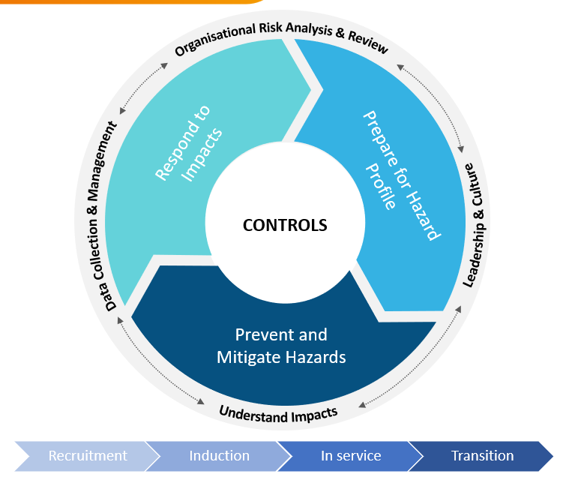
- Provided with a range of appropriate supports to address any effects of CT they may experience, in a timely and appropriate manner
Figure 2. Good practice model for managing and addressing CT

The model is underpinned by four key principles – organisational risk analysis, leadership and culture, understanding impacts, and data collection and management – to guide the implementation of all actions outlined in the framework.

Key Principles for Managing and Addressing CT
The key principles guide the tailored approach that each workplace can take to reduce and manage the risk of exposure to CT.
These principles include the foundational actions that underpin the effective management of CT, regardless of the unique risk profile and psychosocial risk maturity. The actions are underpinned by a strengths-based approach to healthy workplaces and actions may be offered in parallel or combined with multi-faceted approaches to support the diversity within each workforce. It is important to note that no single solution will be effective for all workplaces. Agencies should consider tailoring specific strategies to their individual setting.
Organisational Risk Analysis & Review
Each agency within the Victorian public sector has its own unique risk profile, consisting of various factors related to the organisation’s systems of work, the operational environment, and individual factors. An analysis of the hazards that are inherently present in each agency’s operational environment, as well as the surrounding systems and environments in which the work is performed should be conducted in close consultation with leadership and staff. Psychosocial factors rarely exist in isolation as factors often have compounding effects on staff and are experienced differently for individuals. Every individual will have their own risk profile for CT, as will each workplace and each agency as a whole. Some factors, or combination of factors, may protect or exacerbate any risk profile. The approach to assessing these hazards should be systemic and ongoing, as hazards are dynamic, and the impacts of CT may present at any given time.
Leadership and Culture
Leaders and managers play a critical role in reducing and controlling the risk of CT. Senior leaders create visions of positive workplace cultures where experiencing CT is not “part of the job”. Capable and well-informed managers and supervisors translate this vision into practice by buffering against some of the pressures faced in any role. Leaders should have the capability to recognise the signs that their staff may be struggling from CT and know how to best respond to promote natural recovery. Leaders are instrumental in creating psychologically safe environments where staff are encouraged to speak up if something isn’t right and seek help.
Leaders are not always those in formal leadership positions. Anyone can be a leader, and everyone has a role to place in reducing the stigma that can often be associated with seeking help. Leaders can make a big impact by sharing their experience in managing the compounding and often cumulating challenges at work. Each workplace is aware that the exposure to PTEs may be part of role expectations however experiencing psychological impact of CT is not.
Understand Impacts
Each agency and workplace should have the knowledge and supports in place to recognise that the experience of CT is different for everyone. Workplaces should strive towards creating a common language which differentiates the exposure to PTE from the experience being impacted by CT. Workplaces understand that CT is a collection of experiences and individual variables overtime which may influence how someone responds to a PTE in the moment, in the following weeks or months. Everyone is unique and following exposure, any one person may experience no effect, minimal, moderate, or significant impact. Impacts take many forms and not all impacts are the same. Workplaces should have appropriate supports in place which do not impact natural recovery, but rather promote connection and create supports for those with a sustained reaction to any given PTE.
Individuals bring their whole selves to work and it’s important to take a shared responsibility approach to supporting the mental health of each other. Talking about the impacts of CT should be integrated into regular conversations and it should be recognised that anyone can be affected. Everyone has a role to play in looking after themselves, their team, their agency, and the community.
Data Collection and Management
Data Collection Methods
- People Matters Survey Data
- Pulse surveys as appropriate
- Staff consultations and interviews
- Review of wellbeing service utilisation
- Engagement in CT-related initiatives and/or training programs?
- Worksafe metrics
Each organisation must have a comprehensive understanding of what the experience of CT is within each agency. The presence of CT is not always obvious, nor will staff always be aware that they are experiencing the impacts of CT. Organisations can formulate a comprehensive picture by drawing on a range of data sources to understand the current levels of CT and changing risk profiles. Agencies must consider all data available, including organisational data, and insights obtained by consulting with staff and line-managers. When taking a systemic approach to data collection, it’s important to consider organisational, team, and individual datapoints. For example, sudden changes in an individual’s behaviour may indicate the experience of impact from CT and prompting responsive intervention will be important before any lag metrics ensue, such as extended leave or a Workcover claim. It is important to continue to consult with staff to understand the experience on the ground is and what the overall picture is saying.
Data management should involve frequent assessment of changes in metrics that may indicate a change in the experience of CT. This should be assessed regularly and form part of continuous improvement practices.

Embedding the Framework: Areas of Action
This section identifies key actions that each agency can take to identify, manage and address cumulative trauma.
While each agency’s approach to CT will look different, the purpose of the framework is to highlight the culture, systems and processes that need to be in place to effectively manage CT. As such, there are core action areas that each agency needs to address when thinking about how they implement the framework. Many of the identified areas of action are also recognised as good organisational practice that underpin any effective organisation.

Getting Started
Before implementing the framework, it is important to first consider your organisation’s cumulative trauma maturity. That is, where are you spending most of your time operating?
Is your organisation:
- Reacting - Focusing on responding to impacts. CT in our organisation is addressed once impacts have been identified and the individual in question requires support. We have supports like Employee Assistance Programs, but we don’t tend to proactively identify or address CT.
- Developing – Primarily preventing and mitigating known hazards. We have some controls in place to protect our staff from some of the exposures and potentially impactful elements of their jobs.
- Maturing – Proactively preparing for hazard profile. We actively identify on an ongoing basis what our organisation’s risk profile is when it comes to CT and the unique factors that contribute to the experience of CT in our workforce. From this, we put in place resources across the promote, prevent and respond continuum to address CT.
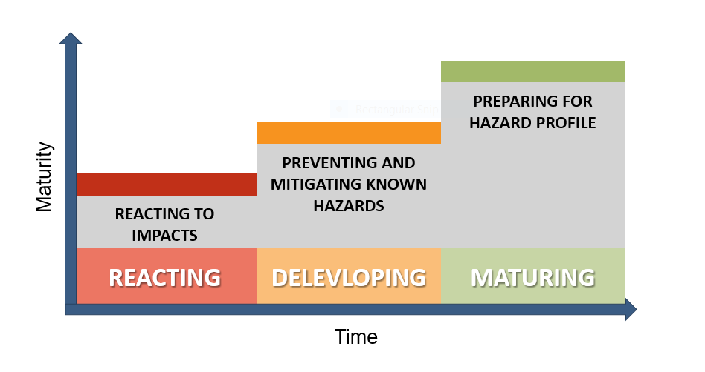
Figure 3 Cumulative trauma maturity framework

Every Victorian public sector agency and departments within those agencies will have varying levels of awareness, knowledge, and practices in place to address CT. Your workplace may not neatly fit into the one category. Understanding your organisation’s level of maturity will help inform the types of interventions and actions that are going to be most effective in the short-term and what strategic changes may need to occur in the long-term.
Recognising Cultural Trauma
Agencies should carefully consider the unique needs of their people and recognise the experience of cultural trauma across the workforce and the community. The Victorian public sector is committed to achieving sustainable improvement in Aboriginal and Torres Strait Islander employment outcomes. A range of resources and toolkits are available to support the achievement of a highly capable and diverse public sector that benefits from unique skills and experience Aboriginal employees bring into the workplace.
Agencies should be guided by, Barring Djinang [insert link], the Aboriginal Employment Strategy, when implementing the cumulative trauma framework to ensure the controls and actions initiated are culturally safe.

Guiding Principles: Suggested Actions
To effectively address and respond to CT, we must first get the foundations right. The guiding principles of the framework underscore the good organisational practices that each agency needs to put in place to enable the specific controls to work effectively.

Organisational Risk Analysis and Review
- Consider the combination of factors that contribute towards the overall risk profile of the agency, division/area, workplaces, team and individual. Factors include:
  - Operational factors and exposure risks (e.g., attending fatal road accidents, interacting with aggressive members of the public, exposure to traumatic case files and materials)
  - Environmental factors (e.g., working to impose restrictions in own community, working in a traumatised community, working remotely from home)
  - Individual factors (E.g., history of trauma, mental health and wellbeing levels, living with a disability)
- Establish and implement a risk register that includes the identification and management of psychosocial risks
- Embed hazard identification topic (physical and psychological) as a standing agenda item into supervision meetings, into team meetings and into agency-leadership meetings
- Establish an accountability framework to frequently review the effectiveness of controls to ensure they are working as intended
- Establish a CT working group within your workplace, tasked with the responsibility to monitor ongoing hazard profiles.

Leadership and Culture
- Encourage senior leaders to share their experiences of managing compounding impacts of work-related exposures and challenges.
- Develop capability by providing CT training for staff to understand what it is, how it develops, how to recognise signs that someone may be impact and how to seek support.
- Provide support to leaders to manage their own mental health and wellbeing to recognise that a source of their CT can be through supporting their staff
- Embed the roles and responsibility leaders for managing CT into role descriptions
- Develop the capability of Health and Safety Representatives (HSR)s to understand their role in managing CT in the workplace
- Develop manager and senior leader capability to create safe, inclusive and respectful workplaces

Understand Impacts
- Provide training to staff on CT and mental health and wellbeing in the workplace
- Promote recovery and advocate that most people do not experience the impacts of CT following a PTE, and those who do often recover
- Provide staff with training to understand what they can do to manage unnecessary exposure risks
- Review critical incident response practices to evaluate processes against leading practice
- Normalise talking about CT in everyday discussions - “Talk about it early and talk about it often”
- Recognise and put in place mechanisms to address the impacts that exposure to PTEs can have when working remotely
Best Practice Debriefing
Did you know that group psychological debriefing may not be as effective as once thought? While it may seem beneficial to have impacted staff come together and talk about the emotional impact of a PTE or a critical incident, research tells us that this actually has the opposite effect. Indeed, the World Health Organisation state that group psychological debriefing should “not be used for people exposed recently to a traumatic even as an intervention to reduce the risk of post-traumatic stress, anxiety or depressive symptoms.”
This is not to say that we shouldn’t bring teams together. Running an information session on the incident or an operational review that treats the event or exposure as an opportunity for learning and development can be quite beneficial. Here, the emphasis should be on covering the basic facts of the incident, addressing immediate safety needs, unpacking what happened and how people responded in line with current protocols. This will also present an opportunity to ensure staff have details of the supports available to them should they be impacted.

Data Collection and Management
- Report organisational and workplace CT data metrics
- Design pulse surveys to distribute to staff to understand vulnerabilities
- Include staff consultation as a key method of collecting data
- Proactively reach out to individuals or teams who have experienced repeated exposures to PTEs, as identified through risk management systems or through other data that may indicate the individual or team is at risk of impact
- Embed the assessment and review of hazard profiles into management’s job descriptions
- Use PMS data to inform the understanding of hazard profiles for the organisation

Data that can indicate the high risk or presence of CT
Lead data  - Engagement in services (e.g., EAP, peer support programs)  - Consultation with staff that that indicates staff feel fatigued, stressed, unmotivated, lack of concentration etc.  - Consultation with HSRs  - People Matters Survey Data  - Psychosocial safety scores  - Relationship with manager  - Workload management  - Decrease in productivity/reduced KPIs  - Incident and injury records | Lag data  - WorkCover Claims  - Unexplained leave/absenteeism  - Presenteeism  - Increase sick leave  - Turnover

Embedding Controls Across the Employee Lifecycle
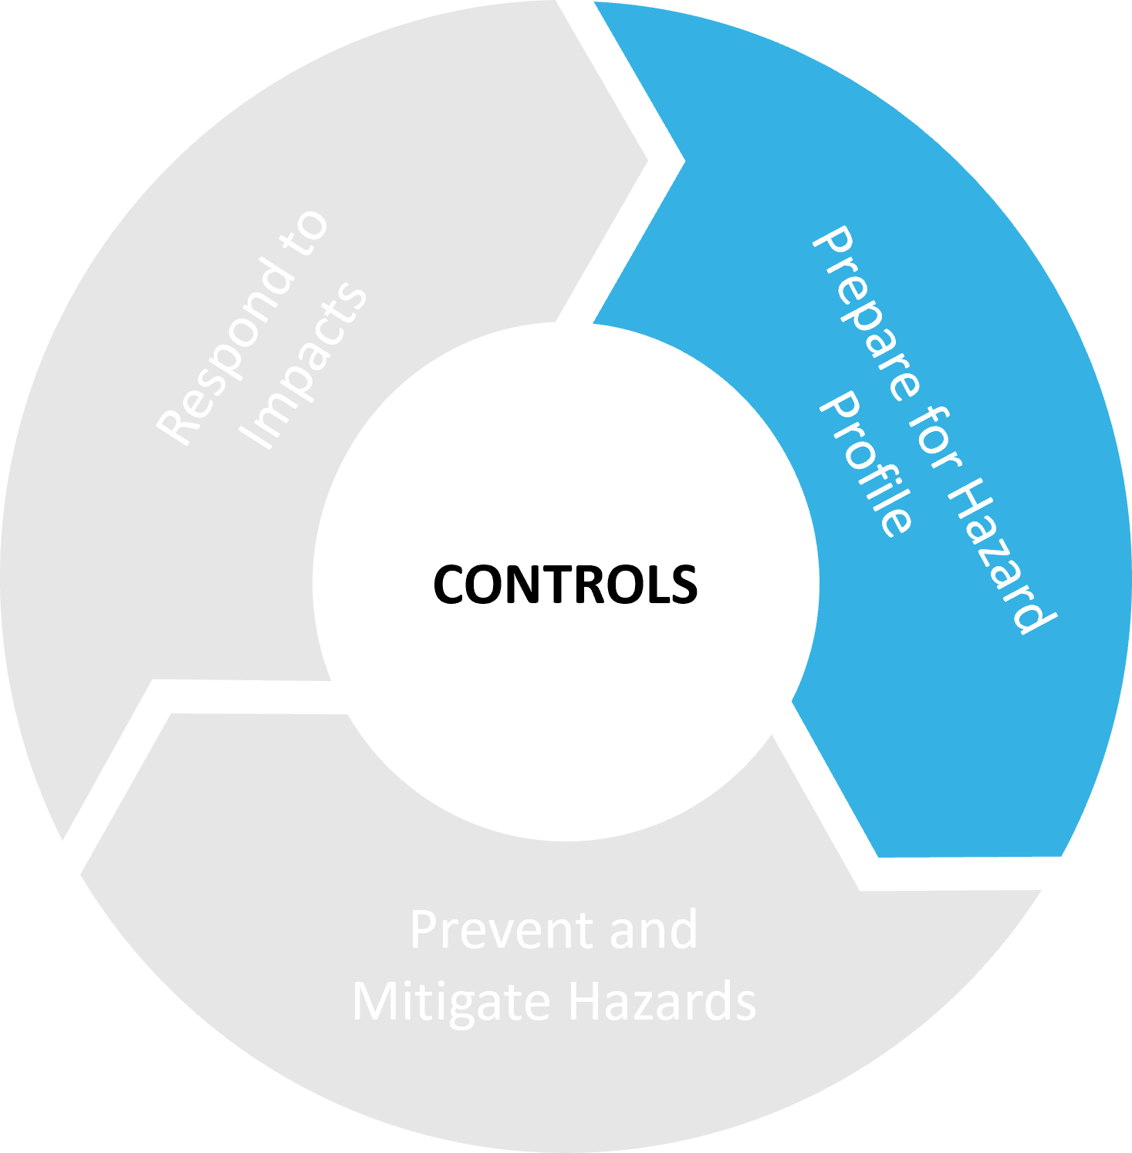
Detailed below are some suggested actions that could be put in place throughout the employee lifecycle to address each of the controls. Using an employee lifecycle approach allows organisations to understand the different points of intervention and controls that can be targeted to protect against the risk of experiencing CT.

Prepare for Hazard Profile
Preparing for hazard profile is about ensuring staff have the appropriate capabilities and are prepared to manage the known risks. This includes both organisational initiatives and individual capabilities to manage the identified psychosocial hazards specific to their role. To do this, organisations should consider:
Recruitment
- Advertise jobs realistically so prospective recruits are aware of what exposures and likely working environment (e.g., job demands, availability of supervisor etc) can be expected in the role
- Ask prospective recruits to share their understanding of anticipated challenges in the role
- Ask prospective recruits to provide examples of their own personal coping strategies
- Inform prospective recruits of the organisation’s strategies to address the challenges inherent in the role or work environment
- Recruiters are aware of some of the potential exposures from previous roles
Induction
- Train staff with the necessary skills and knowledge required to be successful in their role i.e., professional skills training
- Provide staff with a realistic job preview to understand how the nature of the role may impact them i.e., realistic position descriptions, behavioural interviewing questions to unpack people’s coping styles
- Provide staff with training to manage the most common or relevant situations that have the potential to impact their wellbeing
- Train staff to have the skills to recognising and manage CT
In-service
- Encourage managers to work with their teams to create systems of work that prevent unnecessary exposure (e.g., rotations, pace of work, debriefing spaces and “safe rooms”, and adequate resourcing to allow for regular breaks).
- Provide people leaders with training on topics such as recognising and supporting normal responses following PTEs, conducting wellbeing conversations, noticing changes in behaviour and functioning.
- Provide CT training to all staff to build awareness and understanding
Transition
- Train managers to be aware of the exposure risks that secondment or surge recruitment opportunities may include

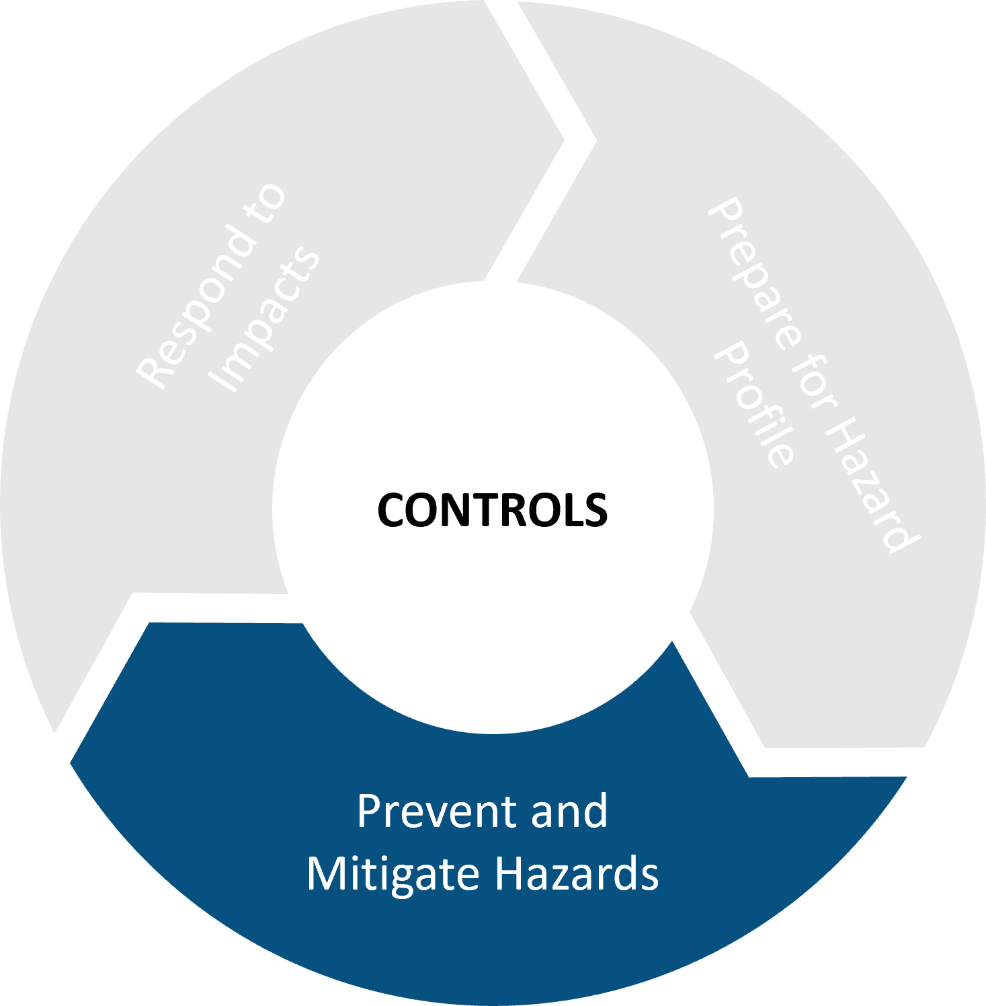
Prevent and Mitigate Hazards
Organisations have a responsibility to implement controls to prevent against unnecessary to CT risks and where not possible, controls are put into place to prevent against the psychological impact on employee wellbeing. To do this, organisations can:
Induction
- Provide staff with a strong understanding of the support resources available to them
- Proactively contact new starters and frequently check in on upon starting a new role
In Service
- Conduct a psychosocial risk assessment to understand the workplace factors that are a significant source of stress for staff (e.g., workload, flexibility, reward and recognition, relationship with manager). Agencies can then put in place strategies to modify these factors
- Afford staff the autonomy to be flexible with their work where practical to allow for rest and recovery between PTEs and to plan how work is structured. For example, options for more flexible rosters with consistent shifts, increasing transparency and consistency in the allocation of breaks and shifts, and providing flexible work arrangements for staff who are likely to be carrying additional loads such as Aboriginal Cultural Loads
- Implement professional supervision among peers and supervisors as part of ongoing professional development and a proactive approach to wellbeing
- Incorporate the reporting of PTEs into existing risk management systems or processes so they can be recorded as they occur so that others can check in
- Design processes for more frequent check in on staff who are working from home
- Implement a file flagging process on PTEs to avoid inadvertent exposure. For example, a colour coding system for particularly files that may have particularly distressing content
- Design policies and processes to guide the management of frustrated customers, with a focus on supporting staff following a difficult encounter
- Where possible and appropriate, put in place a ‘mental health moments’ system. These are short breaks, particularly for staff in client facing roles, to step away for 5 minutes after a distressing incident or difficult phone call.
Transition
- Support mangers to understand how transitions can impact remaining staff and teams, particularly around the change of leadership and involve staff in the planning process for a new or revised operation style
- Make agencies are aware of the responsibility they have in supporting staff to transition out of the role and back into their communities. For example, gradually reducing working hours as part of a phased approach to retirement.

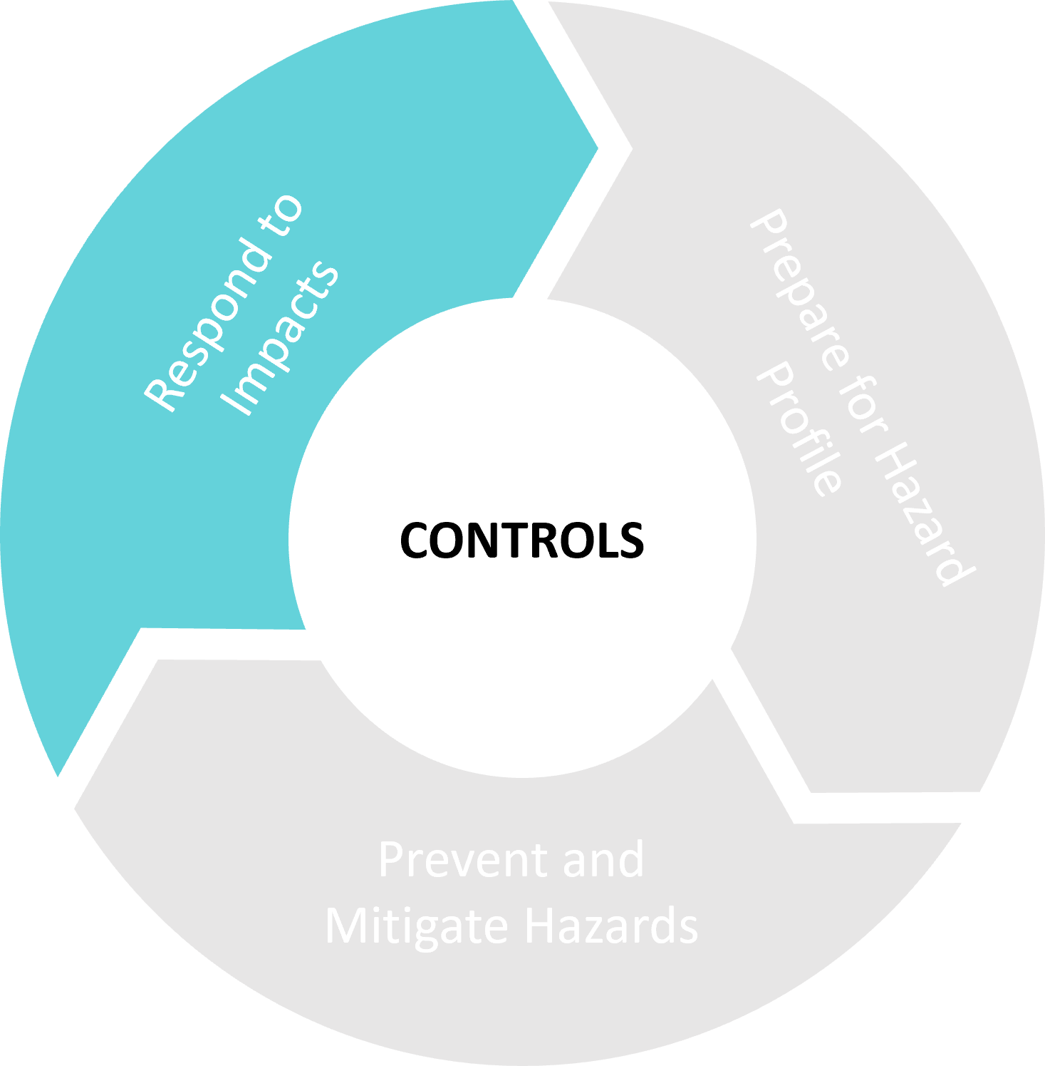
Respond to Impacts
Ultimately, there may be some employees who experience negative impacts as a result of exposures to PTEs or a cumulation of additional stressors. Agencies must provide staff with a range of appropriate supports to help them address these psychological impacts in a supportive environment. To do this, organisations can:
In Service
- Provide staff with the opportunity to debrief individually following exposure to a PTE, in accordance with best practice debriefing guidelines. Note: this should not be mandatory
- Encourage staff to recover at work or return to work in a timely manner following CT injury, recognising the important role the workplace has in recovery
- Ensure managers continue to connect with staff who are on leave and involve staff throughout the return-to-work process
- Frequently monitor staff wellbeing and for changes following exposure to PTEs.
- Remind staff of the resources and supports available to them i.e., Employee Assistance Program
- Encourage staff to connect with each other and their communities for support
Transition
- Encourage managers to conduct a wellbeing check in with staff returning from a period of planned absence (e.g., leave, secondment, etc) or unplanned absence
- Use exit interviews to understand the experience of cumulative trauma and effectiveness of workplace supports

Next Steps – what can you do?
To address CT, you will need to think about the specific needs of your agency and consider which strategies may be most useful to your unique context. To get started, consider the following actions you can take right now:
- Share this resource will your colleagues and leaders
Getting started can often be the hardest part. Enlist the help of your colleagues and start the conversation about addressing CT in your organisation.
- Review your current approach to addressing CT – are there already processes and practices in place to help manage and respond to CT?
Consider whether your organisation already has any practices in place that may help manage and address CT. Review existing controls, policies and procedures against the framework and consider areas of action you may need to expand upon or add.
- Develop an action plan
Determine the critical areas that your organisation need to address and identify which areas you will address first. Speak to colleagues, operational staff and HSRs to develop an action plan to start addressing CT.
- Take steps to involve and educate leaders
CT, and mental health generally, are often stigmatised in many workplaces. To address this, leaders have an important role to play. Involve your organisation’s leaders in the process – let start the conversation, educate them on CT, share your action plan and seek their input. Having visible leadership involvement will show your people that the organisation is committed to addressing and managing CT.

Recommended Resources
Department and Agency Resources
- Risk Management Policies and Procedures
- People Matter Survey Data
- Risk management frameworks
- Aboriginal Employment & Self-Determination Frameworks
- Disability Action Plans

Victorian Public Sector Commission Resources
- Leading the Way
- Barring Djinang Aboriginal Employment Strategy
- Aboriginal Cultural Capability Toolkit
- Getting to Work: Disability Employment Action Plan
- Wellbeing Toolkit
- Inclusive Employee Lifecycle Toolkit
- VTPAT Tool Kit (TBC)

Bonanno, G. A. (2004). Loss, trauma, and human resilience: Have we underestimated the human capacity to thrive after extremely aversive events?. American psychologist, 59(1), 20-28.
Lawrence, D., Kyron, M., Rikkers, W., Bartlett, J., Hafekost, K., Goodsell, B., & Cunneen, R. (2018). Answering the call: national survey: Beyond Blue's National Mental Health and Wellbeing Study of Police and Emergency Services-Final report.
AIHS (Australian Institute of Health and Safety). (2020). Psychological Health and Safety at Work. Retrieved from https://www.aihs.org.au/

