Public Entity Executive Remuneration Survey (PEERS)

Training Manual

The Victorian Government has vested the Victorian Public Sector Commission with functions designed to enhance the performance of the public sector – fostering the development of an efficient, integrated and responsive public sector which is highly ethical, accountable and professional in the ways it delivers services to the Victorian community.
The key functions of the Commission are to:
- strengthen the efficiency, effectiveness and capability of the public sector in order to meet existing and emerging needs and deliver high quality services; and
- maintain and advocate for public sector professionalism and integrity.
© State of Victoria (Victorian Public Sector Commission) 2022
This work is licensed under a Creative Commons Attribution 4.0 licence. You are free to re-use the work under that licence, on the condition that you credit the State of Victoria (Victorian Public Sector Commission) as author, indicate if changes were made and comply with the other licence terms. The licence does not apply to any branding, including the Victorian Government logo and the Victorian Public Sector Commission logo.
Copyright queries may be directed to info@vpsc.vic.gov.au

Currency
This is PEERS Training Manual 2022, version 1.0 published in June 2022
Always check the latest version of this document at https://vpsc.vic.gov.au/resources/data-collection- public-sector-executive/

Inquiries
3 Treasury Place
Melbourne 3002
Email: peers@vpsc.vic.gov.au
Phone: (03) 7004 7230 (Operating hours 9am to 5pm)
www.vpsc.vic.gov.au

Contents
1. What is PEERS? 5
2. Your Community Portal 5
What is the VPSC Community portal? 5
Log into the portal 6
Change your personal settings 6
My Profile 7
My Settings 7
3. Your survey 8
4. Begin the Survey 9
5. Complete the Survey 11
Edit a listed executive 11
Add an executive to the survey 13
6. Finalise the Survey 15
7. PEERS Quick Steps 16
Add an Executive 16
Edit an Executive 16
Change password 17
8. Troubleshooting 17

- What is PEERS?
The Public Entity Executive Remuneration Survey (PEERS) data is used to monitor and report on executive employment, remuneration and compliance with government executive employment policy.
The data collected is shared with the Victorian Independent Remuneration Tribunal (VIRT) to inform their monitoring of executive employment.
The PEERS collects data for each executive employed at any point since the last full pay period in June in the previous year to the end of the last full pay period in June in the current year.
Public sector entities are required to participate in the PEERS, reporting on the total remuneration packages and other key information on individuals covered by PEERS Policy.
For more information on executive employment in public entities visit: https://vpsc.vic.gov.au/resources/victorian-public-entity-executive-employment/
- Your Community Portal

What is the VPSC Community portal?
The Victorian Public Sector Commission (VPSC) has developed an online Community Portal, a secure cloud-based environment for data collections and data reports. Users can log in to their own secure account on the portal and submit their PEERS data. On this portal users will also have access to all the data collections that have been made available to them.
Important tip
Use Chrome, Safari, Edge or Firefox to log in to the portal. Internet Explorer will not work.

Log into the portal
All users are emailed a link to the portal when their account is first created. Use that link anytime to connect to the portal with your username and password.
A link to the community portal is provided here: https://vpsc.force.com
For convenience, save a shortcut to the portal on your desktop or add it to your favourites.
If you are already set up on the portal and are unsure what your password is, click the ‘Forgot Your Password?’ link at the bottom of the log in screen and you will be able to reset it.
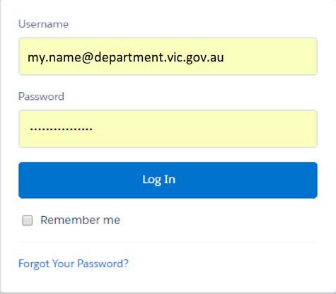

Change your personal settings
A personal menu appears when you click your name in the top right corner of the portal. From this menu you can choose the below options.
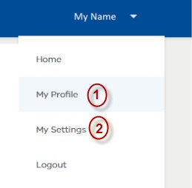

My Profile
Please choose this option to update your details.
- Click the Edit button in the top right of the profile screen to display the editable form. You can add or edit the information on your profile.
- Click Save to complete the changes.
Please note: do not use this option to set up an account for your colleagues. If your colleague needs to provide PEERS data, please contact VPSC so that an account can be created for them.

My Settings
Please choose this option to update your password.
- Please click on Change password. This will display a dialog box to update your password
- Click Save to finish changing your password.
In addition to above, this menu also has options to return to the Home screen and logging out of the portal.
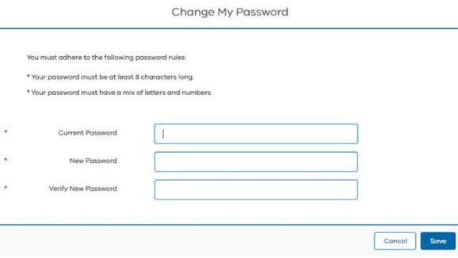
- Your survey
When PEERS has commenced, we will send you an email with a link to the survey. Alternatively, when you log into the portal you will see a link to PEERS in the home screen. From the home screen you can also link to the resources page or get contact details for the Victorian Public Sector Commission.
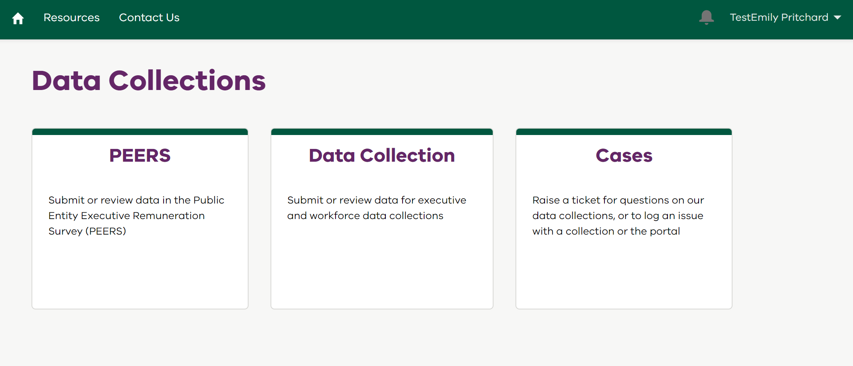
When you click on the PEERS link, the list view will show your active surveys.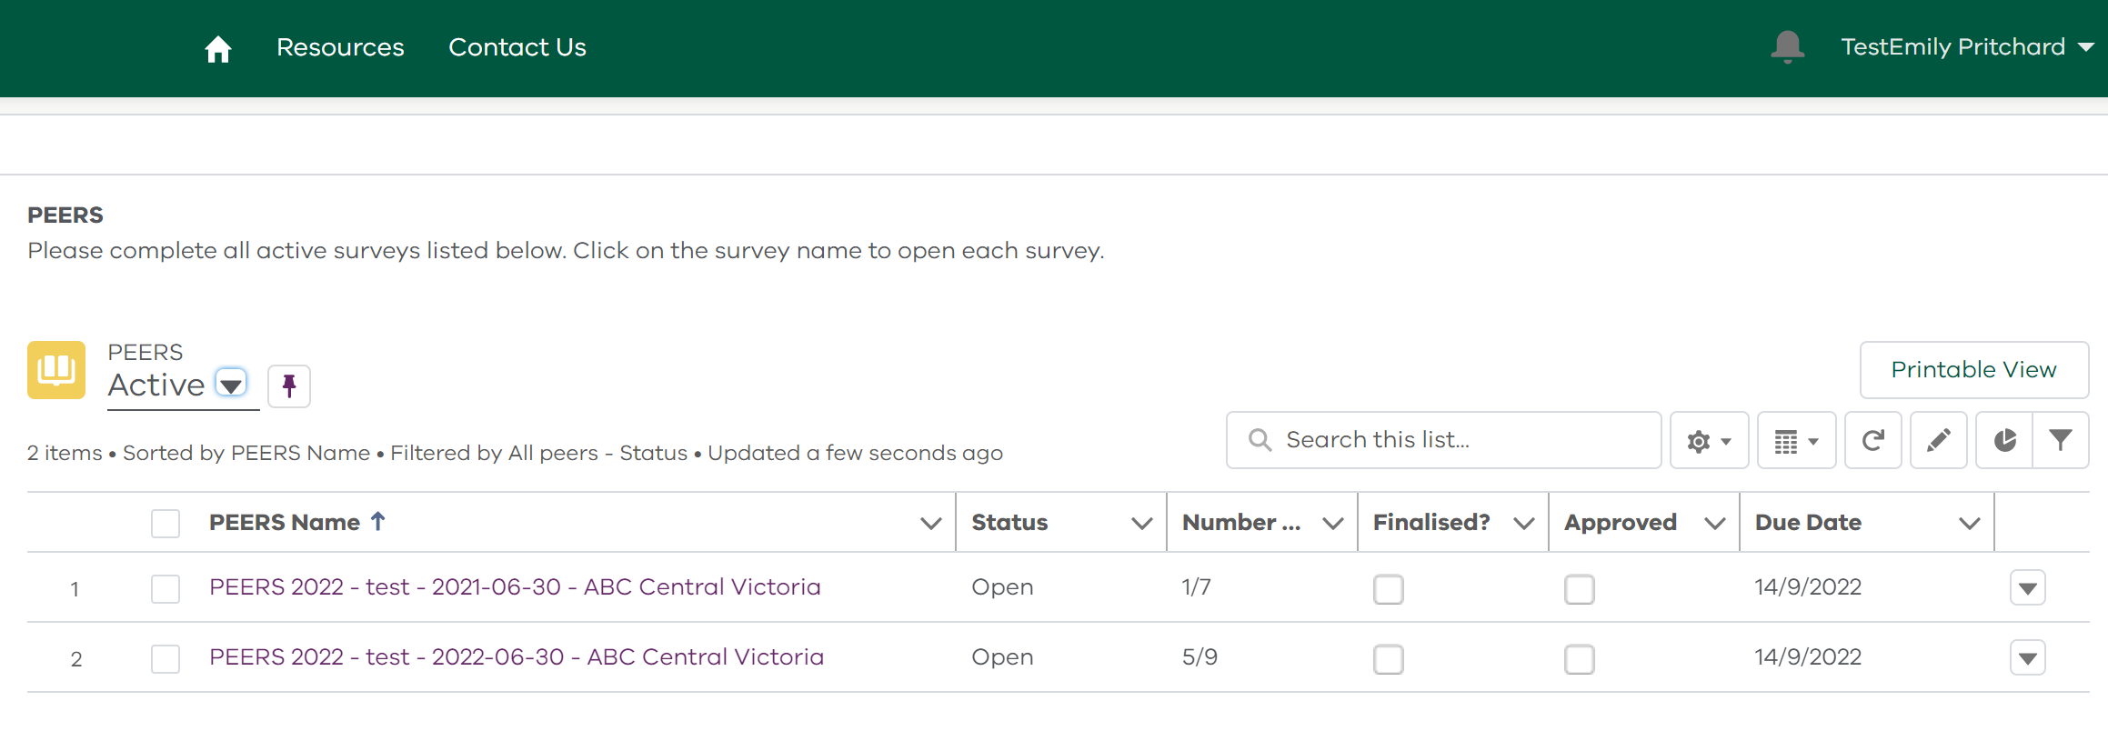
To view previous surveys, click the down arrow under PEERS and select ‘Historic’.
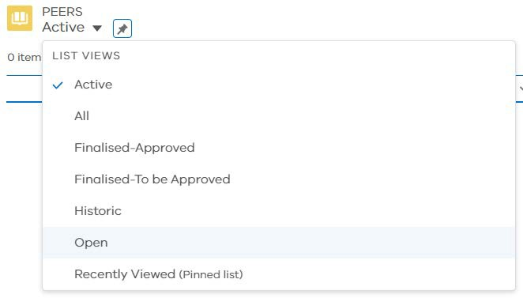
If you are responsible for completing PEERS for more than one organisation you will have a survey listed for each organisation. The survey table shows the name of each survey and its associated organisation. The ‘number submitted’ column shows the number of executives submitted so far in this survey out of the total number of executives reported for that organisation.
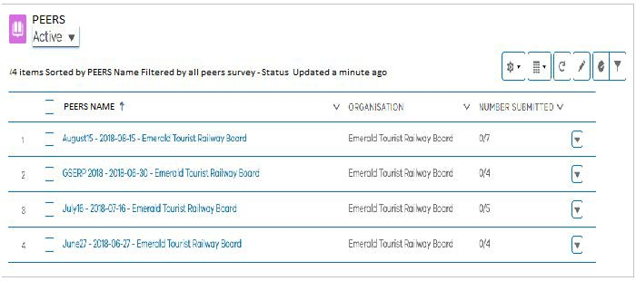
- Begin the Survey
- From the survey list, select an Active survey. You will then be provided with instructions and a list of executives that were reported in the previous survey. You will need to provide data for all executives who:
  - were employed and paid for work during the census period; and
  - meet the PEERS criteria
- Click on an executive in the list to update their details or use the Add Executive button to add an executive who is not listed but meets the criteria. For more information see Section 5 ‘Complete the survey’ and read the guidelines provided in the survey pages itself.
- When all details are correct for one executive click the ‘Submit Survey’ button.
- When all details are correct for all executives in your organisation that meet PEERS criteria click the ‘Finalise Survey’ button.
Important
Read the guidelines on each page. The guidelines contain important information that will help you complete the survey

Important
Use the ‘Save’ button whenever it appears in a survey. If you move to a new section without saving, you will lose the data you have entered. Once you have saved your work you can leave the survey and return to it later.

- Complete the Survey

Edit a listed executive
- From the ‘Executive List’ page click on the name of the executive to update.
- If the executive’s details are incorrect, contact peers@vpsc.vic.gov.au. You cannot change these details in the survey. After reviewing the executive’s details, click ‘Next’.
- On the ‘Position’ screen, review their position data. If details have changed, click the ‘Add New Position’ button and enter the correct details. Once updated, click ‘Save’ and ‘Next’.
- On the ‘Contract’ screen, review their contract data. If details have changed, click ‘Add New Contract’ and enter the correct details. Similarly, if the executive’s status has changed, update it. Once updated, click ‘Save’ and ‘Next’.
- On the Remuneration screen, review their remuneration data. If details have changed, click ‘Add New Remuneration’ and enter the correct details. Once updated, click ‘Save’ and ‘Next’. Please note, in the Remuneration screen complete/review the relevant fields for:
  - Non-Cash Benefits within TRP
  - TRP summary (if a discrepancy exists, provide a relevant reason)
  - Additional Benefits outside of TRP
  - Bonus paid during the specified period; and
  - Additional information (if, any)
Important
Hover over the below icon if you need more information to help you understand what is required.
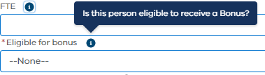
- Review the summary data. If anything is incorrect use the back button or the chevron workflow to navigate to the relevant screen to update.
- When all data for this executive is correct click the ‘Submit Survey’ button.

Add an executive to the survey
If an executive in your organisation fits the criteria for PEERS but is not listed in the survey records you should add them to the survey. Follow the steps below.

- Click the ‘Add Executive’ button.
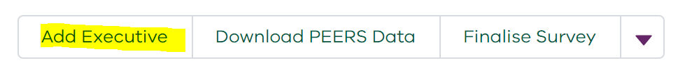
- Enter the executive’s name and click ‘Save’.
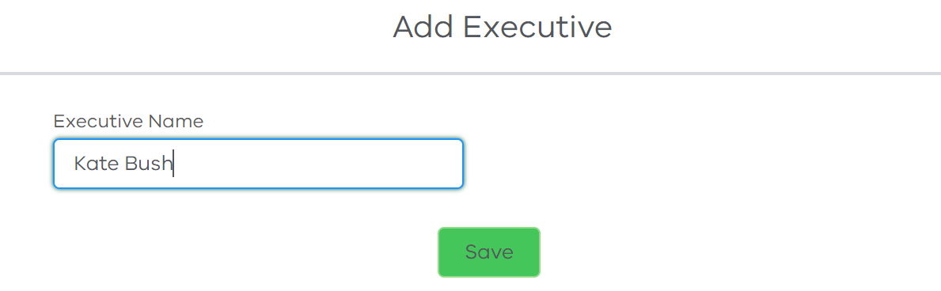
- Enter the executive’s details then click ‘Save’ and ‘Next’. 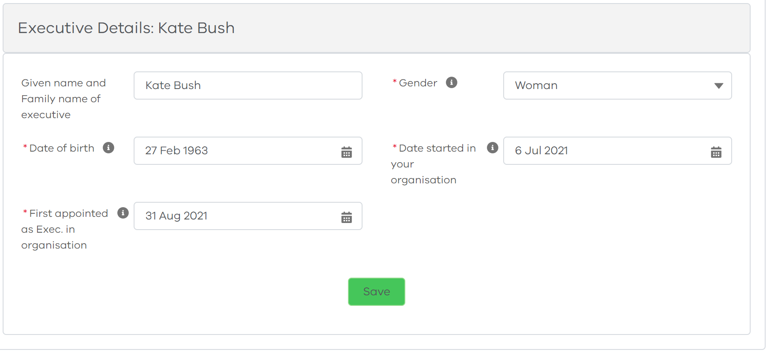
- Enter the executive’s current position details then click ‘Save’ and ‘Next’.
- Enter the executive’s current contract details then click ‘Save’ and ‘Next’.
- Enter details of remuneration at census period for the executive then click ‘Save’.
  - Once you save the remuneration details, the following fields will appear for completion:
  - Non-Cash Benefits within TRP
  - TRP summary – reason for discrepancy (if a discrepancy exists)
  - Additional Benefits outside of TRP
  - Bonus paid during the specified period; and
  - Additional information
Save each field when it is complete. Once updated, click ‘Next’.
- Please note, if there is an error or inconsistency in the data that you have entered a warning will display and you will have to correct it before you can progress.
- Review the summary data. If anything is incorrect use the back button or the chevron workflow to navigate to the relevant screen to update.
- When all data for this executive is correct click the Submit Survey button.
This icon indicates that you can edit that field
Important tip

If a field has a pencil
- Finalise the Survey
Once all the executives in your organisation who fit the PEERS criteria are accurately recorded in the survey and submitted, you are ready to finalise the survey. Please follow the steps below to ‘Finalise your survey’.
- Return to the executive list screen, if you are not already there.
- Confirm that all data entered is complete and correct.
- Confirm that all executives have been submitted. For example, if you have executives who fit the PEERS criteria, the ‘Number submitted’ field should show 7/7.
- Click the ‘Finalise survey’ button.
- Once the survey has been finalised, the status of the survey will change to ‘Closed’.
- If you are responsible for completing the PEERS survey for more than one organisation, follow the same process for each survey on your list of active surveys.
- PEERS Quick Steps

Add an Executive
Step 1. Click on Survey
Step 2. Click on the ‘Add Executive’ button
Step 3. Add Executive personal details & Save & Next
Step 4. Add position details & Save & Next
Step 5. Add Remuneration details & Save & Next
Step 6. Review Summary and then Submit Executive.

Edit an Executive
Step 1. Click on Survey
Step 2. Click on name of the executive from the ‘Executive List’
Step 3. Update personal details & Save & Next
Step 4. Update position details & Save & Next
Step 5. Update Remuneration details & Save & Next
Step 6. Review Summary and then Submit Executive.

Change password
Step 1. Click on Username
Step 2. Click on ‘My Settings’
Step 3. Click on ‘Change Password’
Step 4. Add current password, new password and verify new password.
Step 5. Click ‘Save’.
- Troubleshooting
Q. I only have Internet Explorer and I’m not allowed to install software on my computer.
You can install Google Chrome without admin rights.
Q. I accidentally selected the wrong year, and now I can’t change it.
Please choose the correct year and then pick up the date and month again, otherwise it will not update the date.
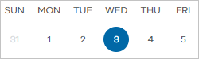
Q. I seem to have lost some of the information that I entered in the survey for an executive.
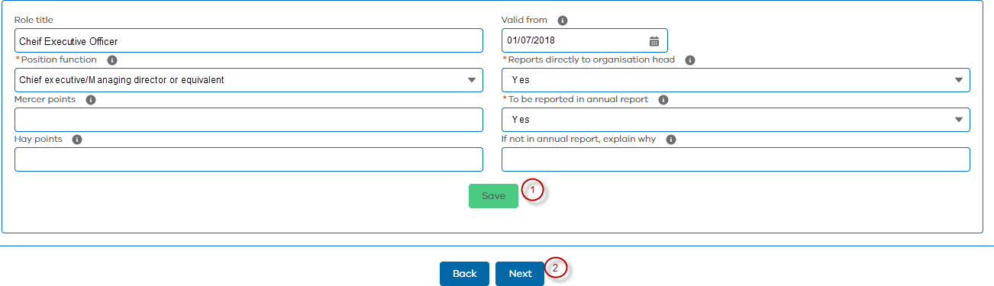
Make sure you always click on ‘Save’ before you move to the next screen.

