## Overview presentation

People matter survey 2023

**This document is part of the** [People matter survey 2023 resources](https://vpsc.vic.gov.au/data-and-research/about-the-people-matter-survey/prepare-for-the-2023-survey/)

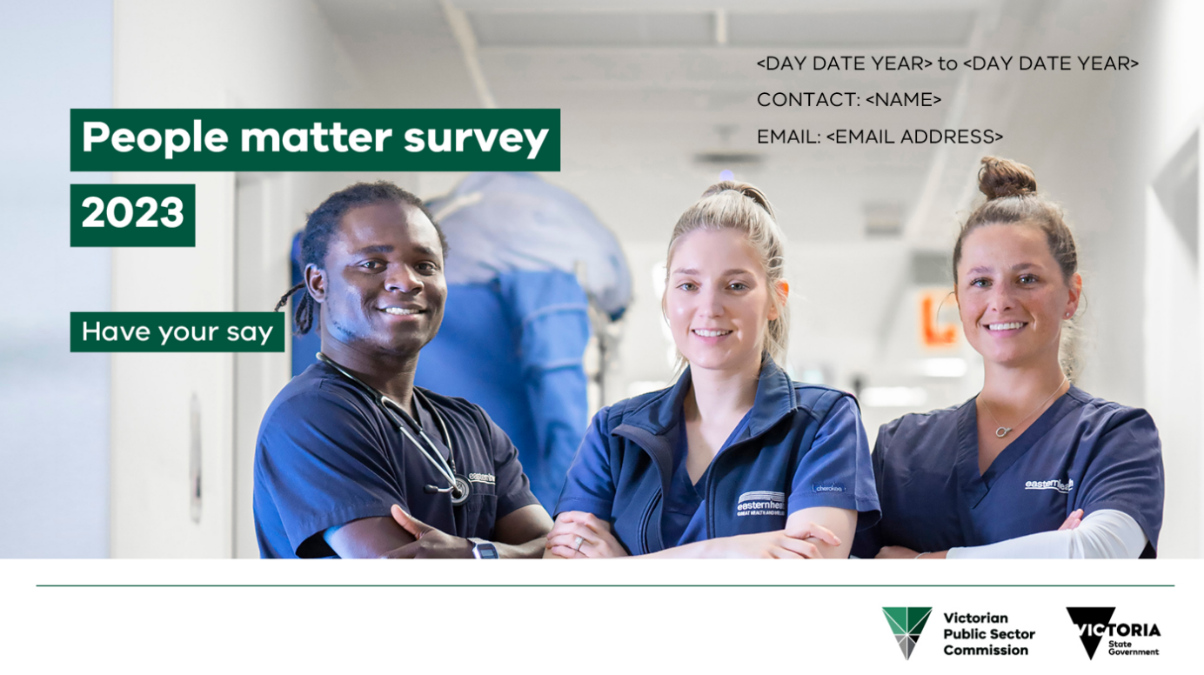

Here you’ll find the People matter survey 2023 overview presentation in an accessible Word format. Tailor this presentation to suit your organisation’s context as required. Promoting the value of the survey tells employees that their voice matters and encourages stronger participation.

#### [Slide 1] What is the People matter survey

* Your independent employee opinion survey run by the Victorian Public Sector Commission.
* Employees from Victorian public sector organisations can take part.
* In 2022, 87,178 people (42% of all eligible public sector employees) from 228 organisations completed the survey.
* People matter helps your organisation better understand employee engagement to provide the best possible work environment for you.

It asks questions about your experience of:

* career development
* diversity and inclusion
* flexible working
* equal opportunity employment
* manager support
* wellbeing
* workplace culture.

#### [Slide 2] Why do the People matter survey

Your organisation will use the survey to:

* support and listen to you
* gain valuable feedback on your workplace experience
* find out what it’s doing well and where it needs to focus on improvement to support your wellbeing.

Your organisation's survey results are:

* benchmarked within your organisation, and with similar organisations across the public sector
* publicly released on the Commission's website to promote transparency on the strengths of organisations and where they can improve.

Why your opinion matters:

* your responses help shape important decisions in your organisation and the Victorian public sector
* you’ll be asked how well our public sector values are practiced across your organisation
* it’s a safe and anonymous way for you to tell your organisation what you think about your workplace experience.

#### [Slide 3] What's new in 2023

Features of the 2023 survey:

* new questions supporting [Gender Equality Act 2020 audit and reporting requirements](https://www.genderequalitycommission.vic.gov.au/workplace-gender-auditing)
* improved question wording.

You can:

* access the survey via weblink or QR code
* use your mobile to complete the survey.

Key dates:

* survey runs from 16 October to 3 November 2023
* reports available to your organisation from late November 2023.

The survey should take 15 minutes to complete.

#### [Slide 4] Privacy and anonymity

##### What questions do we ask

The survey will ask questions:

* about where you work in your organisation
* about you, such as age and other demographic questions
* about your employment, such as management responsibility and salary.

We understand your answers to many of these questions are personal and private.

Which is why when you do the survey, we protect your anonymity and [privacy rights](https://ovic.vic.gov.au/privacy/your-privacy-rights/) in line with the [Privacy and Data Protection Act 2014](https://www.legislation.vic.gov.au/in-force/acts/privacy-and-data-protection-act-2014/027) and the [Health Records Act 2001](https://www.legislation.vic.gov.au/in-force/acts/health-records-act-2001/046).

#### [Slide 5] We ask about where you work in your organisation

##### What do we ask?

We ask for your:

* Division
* Department
* Function
* Region/section
* Area
* Branch

##### Why do we ask?

To help your organisation improve, it’s important to know what team you work in.

This will help your leadership assess and respond to risks and issues across the organisation.

#### [Slide 6] We ask questions about you

##### What do we ask?

We ask:

* about your age, gender and sexuality
* if you identify as a person with disability
* about your cultural identity
* if you identify as Aboriginal and/or Torres Strait Islander
* where in Victoria you work
* how you are employed and for how long.

##### Why do we ask?

Organisations use this data to improve diversity and inclusion in the public sector.

This can include things like how we support equal opportunity, reduce discrimination and promote fairer recruitment.

The data is used to support the work of organisations such as:

* Gender Equality Commission
* Victorian Multicultural Commission
* Victorian Equal Opportunity and Human Rights Commission,
* Office for Disability
* Commission for LGBTIQ+ Communities.

#### [Slide 7] How we protect your privacy and anonymity

##### Your answers are anonymous

Be confident to tell us about your experiences in your organisation.

Our data rules stop you being identified when we ask things about you, such as your age, gender and cultural identity.

##### We send you an anonymous survey link

Everyone uses the same anonymous link to take part in the survey.

##### We de-identify all data your organisation gets

We don't collect your name, date of birth or employee ID.

##### We separate open-text responses from other data

Your organisation won’t know you made the comments.

##### We never publish individual survey responses

This means your organisation can’t identify you when we report on the data.

##### We limit the data organisations get

If fewer than 30 people in your whole organisation do the survey, we don’t give a breakdown by any demographic group of how many people did the survey.

#### [Slide 8] 'I’m being asked for my age, my salary, my team, my gender, and a whole lot more. Will I identify myself?'

You can be confident to give these details, as we only give aggregated, overall results (e.g., % agree) for groups of 10 or more.

If fewer than 10 people in a team or demographic group do the survey, we don’t release employee experience results.

For example, a demographic group is ‘men in the same salary range’ or ‘women aged 40 to 49’.

An experience result is ‘90% of women aged 40 to 49 agreed their manager supports them’.

You’re encouraged to respond honestly about your individual experience.

And you always have the option to respond to questions such as age, gender, sexuality and cultural identity with ‘prefer not to say’.

However, by selecting ‘prefer not to say’, you reduce the survey’s ability to show whether different groups of people have different workplace experiences.

#### [Slide 9] Data collection

##### Data collection statement

The Commission’s [Data collection statement](http://vpsc.vic.gov.au/peoplematterprivacy) tells you:

* why we conduct the survey
* what data we collect
* how we collect, store and manage your data
* how we protect the anonymity of your survey responses

#### [Slide 10] Find out more

Find information and resources at:

<https://vpsc.vic.gov.au/data-and-research/about-the-people-matter-survey/>

Find information about results from the 2022 People matter survey at:

<https://vpsc.vic.gov.au/data-and-research/people-matter-survey-data/>

Contact us:

[people.matter@vpsc.vic.gov.au](mailto:people.matter@vpsc.vic.gov.au)